KPCA’s workforce program supports the future and practicing clinicians who care for Kentucky’s underserved communities. Our Workforce Program accomplishes this by connecting members with resources that assist in the recruitment, retention, and development of staff. Additionally, to meet the future needs of the primary care workforce KPCA encourages and facilitates health professional education and training in our community health centers and rural health clinics. Aligned with KPCA’s mission to promote access to comprehensive, community-oriented primary care health services for the underserved, workforce has been at the heart of our work since founded in 1976 but the program was formalized in 2020 with the addition of a KPCA team member dedicated to workforce development. Our workforce program has helped our members access loan repayment funding, develop new academic partnerships, secure federal funding to expand training opportunties, develop comprehensive workforce action plans and much more.
Kentucky Primary Care Workforce Landscape
According to 2019 HPSA designations, primary care shortages are found in all but seven counties in Kentucky (Health Resources & Services Administration, 2020). In fact, 94% of counties have a primary care shortage. A majority of the primary care HPSAs in the state are entire counties. Primary care HPSAs are found in all regions of Kentucky, with a concentration in western, southern, and eastern regions (Figure 1).
Figure 1: Primary care health professional shortage areas in Kentucky, 2019
Source: data.HRSA.gov
Dental care shortages are found in all but 40 counties in Kentucky (67% of the counties have a dental care shortage) (Health Resources & Services Administration, 2020). A majority of the dental care HPSAs in the state are entire counties. Dental care HPSAs are found in all regions of Kentucky, with a higher concentration in eastern Kentucky (Figure 2).

Figure 2: Dental care health professional shortage Areas in Kentucky, 2019
Source: data.HRSA.gov
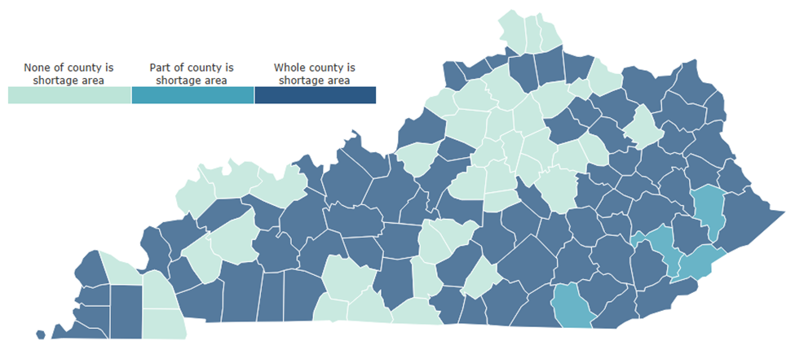

Mental health care shortages are found in all counties in Kentucky (100% of the counties have a mental health care shortage) (Health Resources & Services Administration, 2020). All of the mental health care HPSAs in the state cover entire counties (Figure 3).
Figure 3: Mental health care health professional shortage in Kentucky
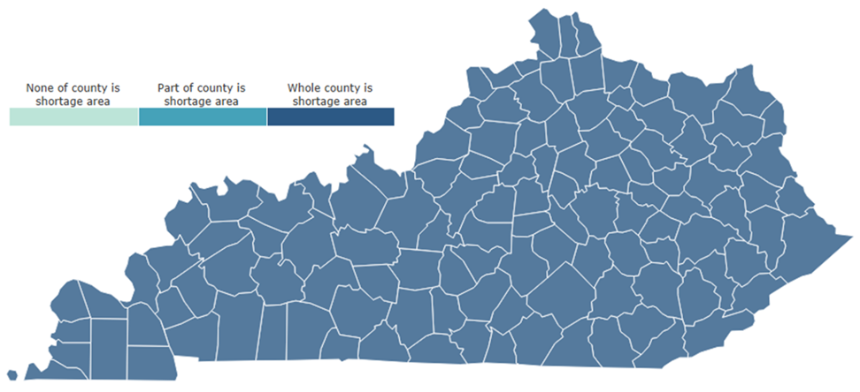
Source: data.HRSA.gov

Contact:
Ashley Gibson
Kentucky Primary Care Association
Workforce Development Director
(606) 831-8066
Agibson@kypca.net

