Kentucky State Cost Share Summary 2020
For Tobacco Settlement Oversight Committee
The program was originally established in 1994 and funded from General Funds and pesticide Product Registration Fees. Starting in 2000, the program was funded through Tobacco Master Settlement Agreement Funds. The cost share program provides financial assistance to farmers at a 75% reimbursement rate for those implementing best management practices on their farms with the assistance of local conservation districts.

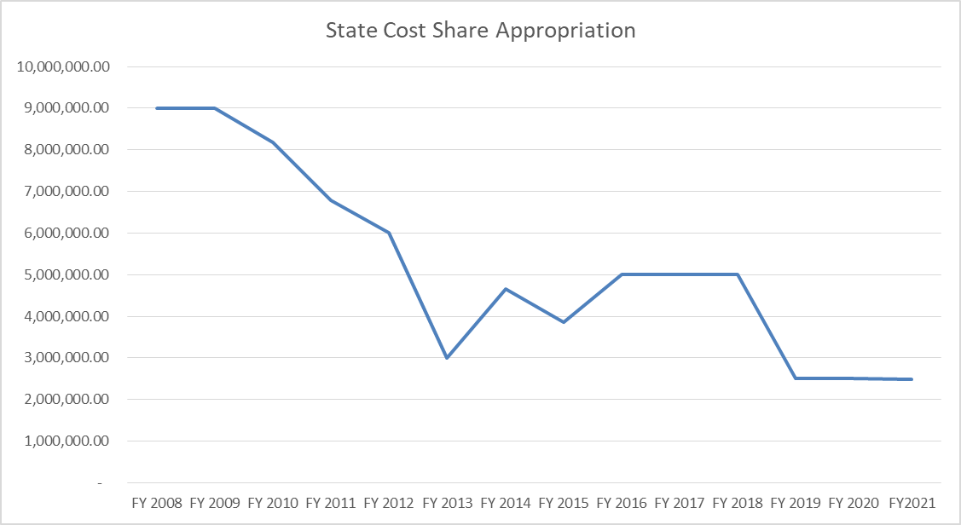

The FY21 budget appropriated $3,386,800 of Tobacco Settlements funds to the Division of Conservation including $2,479,500 for state cost share and $907,300 for Direct Aid to Conservation Districts.
The Soil and Water Conservation Commission approves the total amount of funding to be distributed. Since July 2018, the funding review has occurred every six months. The list of approved projects each year is larger than the appropriation because 20-35% of the previously approved projects cancel or overestimate the cost of the project and that money returns to the account.

FY17 Funds – approved September 2018
- Approved 942 individuals and $6,011,372
- At completion - 23% canceled, 70% paid, $479,877 still to be paid
FY18 Funds – approved February 2019
- Approved 403 individuals and $2,469,727
- At 20 months - 15% canceled, 52% paid, $861,344 still to be paid
FY19 Funds – approved July 2019
- Approved 722 individuals and $4,523,348
- At 15 months - 11% canceled, 47% paid, $1,044,743 still to be paid
FY20 Funds – approved January 2020
- Approved 705 individuals and $4,554,818
- At 10 months - 3% canceled, 20% paid, $3,583,857 still to be paid
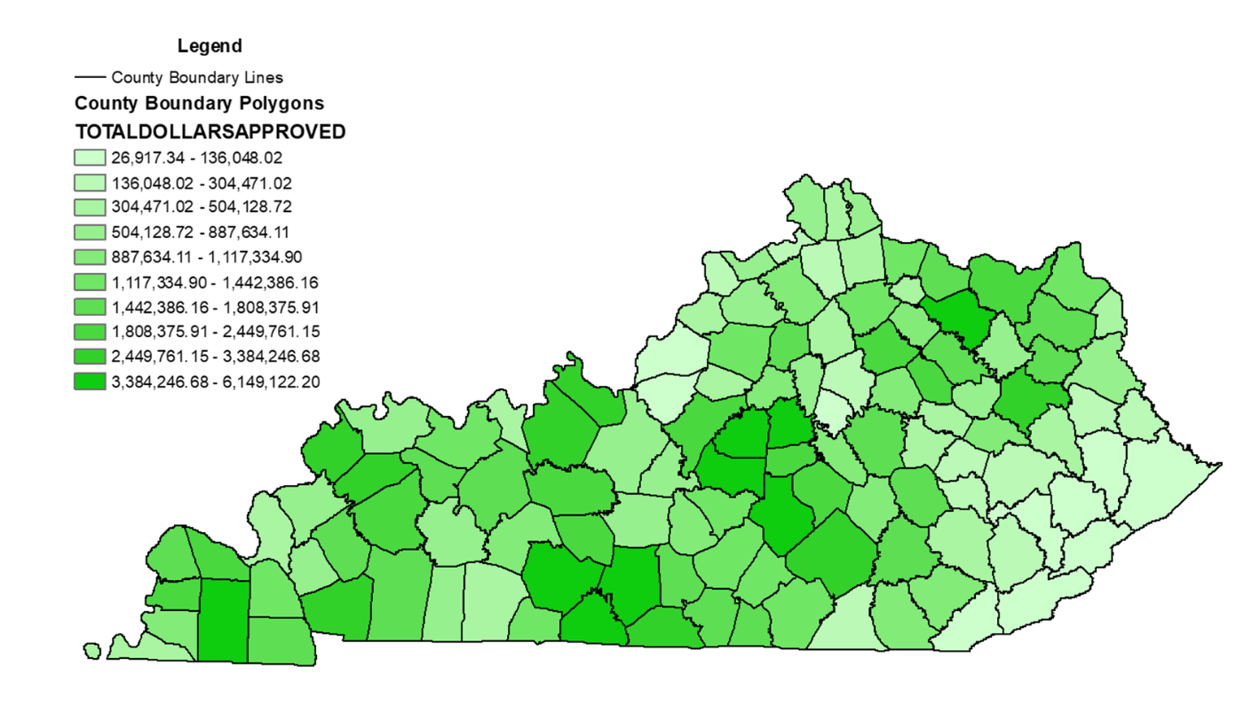
$12,288,678 currently in account
- $132,248 obligated Direct Aid to Conservation Districts
- $479,877 obligated from FY17
- $861,334 obligated from FY18
- $1,044,743 obligated from FY19
- $3,583,857 obligated from FY20
- $52,500 obligated RCPP Mud and Manure project
- $250,000 required contingency fund set aside
$5,884,119 available funds for February 2021 funding cycle

Demonstration of need –
Calendar year 2018
  - Requests 1242 individuals and $8,961,251
  - Approved 942 individuals and $6,011,372
Calendar year 2019
  - Requests 1325 individuals and $10,018,869
  - Approved 1125 individuals and $6,993,075
Calendar year 2020
  - Requests 864 individuals and $6,741,758
  - Approved 705 individuals and $4,554,818

