Kentucky State Cost Share Summary 2021
For Tobacco Settlement Oversight Committee
The program was originally established in 1994 and funded from General Funds and Pesticide Product Registration Fees. Starting in 2000, the program was funded through Tobacco Master Settlement Agreement Funds. The cost share program provides financial assistance to farmers at a 75% reimbursement rate for those implementing best management practices on their farms with the assistance of local conservation districts.
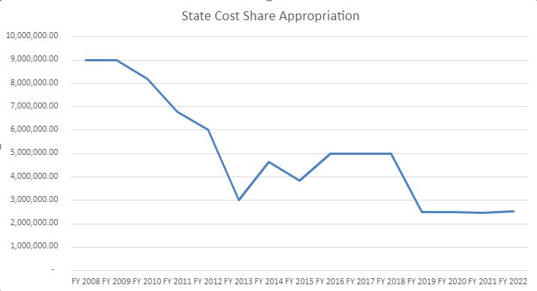

The FY21 budget appropriated $3,386,800 of Tobacco Settlement funds to the Division of Conservation including $2,479,500 for state cost share and $907,300 for Direct Aid to Conservation Districts.
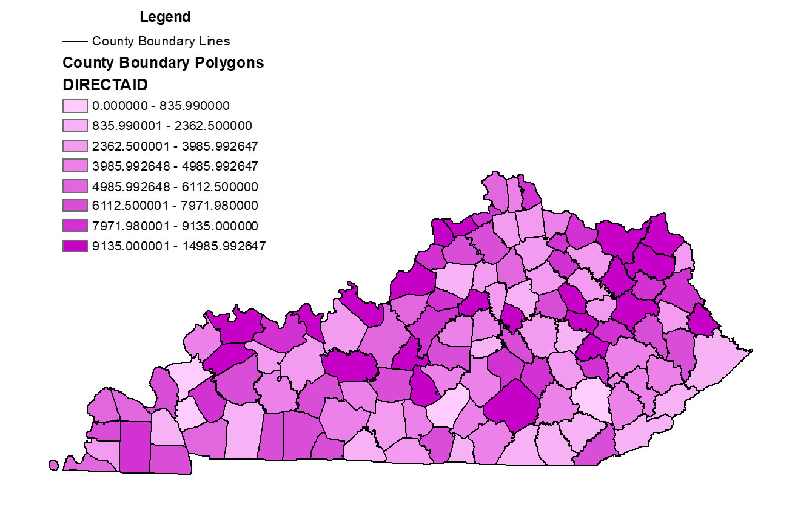
The Soil and Water Conservation Commission approves the total amount of funding to be distributed. Since July 2018, the funding review has occurred every six months. The list of approved projects each year is larger than the appropriation because 20-35% of the previously approved projects cancel or overestimate the cost of the project and that money returns to the account.

FY19 Funds – approved July 2019
- Approved 722 individuals and $4,523,348
- At 24 months - 18% canceled, 67% paid, $220,212.35 still to be paid
FY20 Funds – approved January 2020
- Approved 705 individuals and $4,554,818
- At 17 months - 15% canceled, 47% paid, $1,783,843.58 still to be paid
FY21 Funds – approved February 2021
- Approved 592 individuals and %5,920,643.90
- At 5 months – 2% canceled, 4% paid, $5,609,772.10 still to be paid
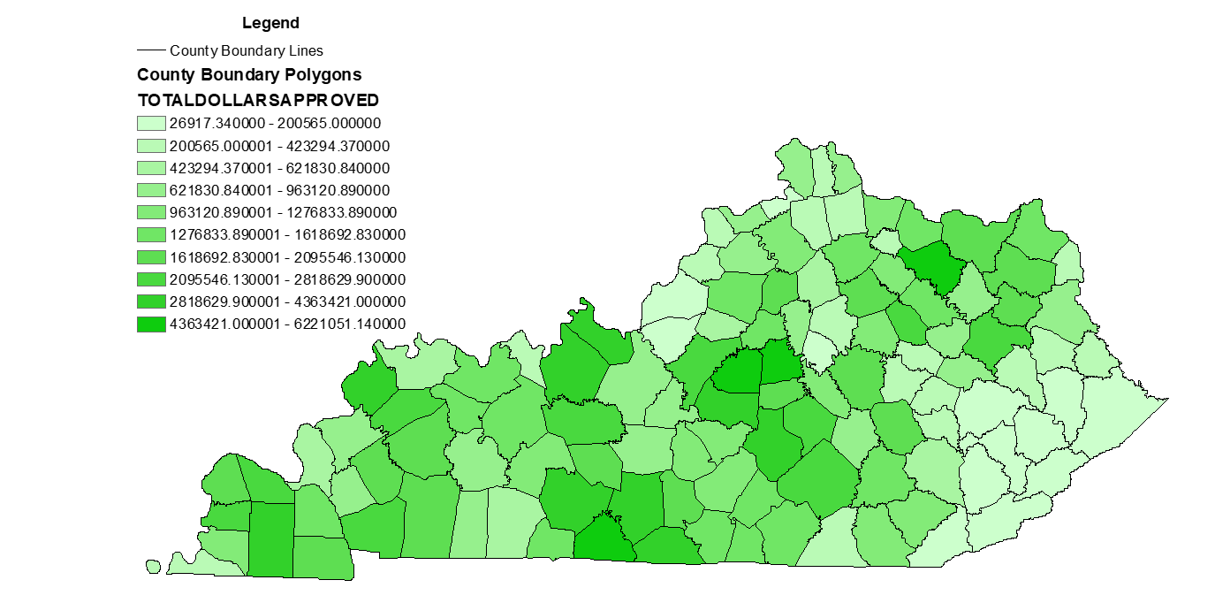
$12,967,056.51 currently in account
- $907,300 obligated Direct Aid to Conservation Districts
- $220,212.35 obligated from FY19
- $1,783,843.58 obligated from FY20
- $5,609,772.10 obligated from FY21
- $7,500 obligated RCPP Mud and Manure project
- $342,340 required contingency fund set aside
$4,096,088.48 available funds for January 2022 funding cycle

