Regional Summary:
The data included in this regional summary provides an overall backdrop.
Source: Emsi Q2 2018 Data Set www.economicmodeling.com
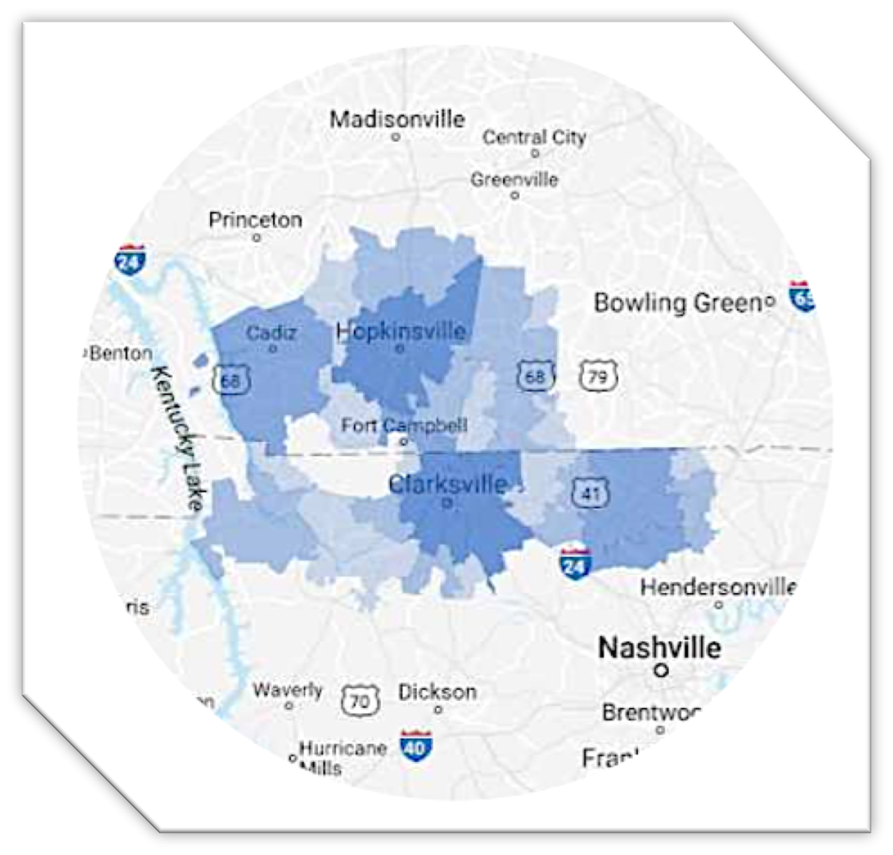

As of 2017, the region’s population increase by 3.4% since 2012, growing by 12,544. The population is expected to increase by 3.1% between 2017 and 2022 adding 11,901. With a total population of over 380,516 in 2017, the FCS region is certainly capable of supporting additional industries and is attractive to companies who require significant workforce.

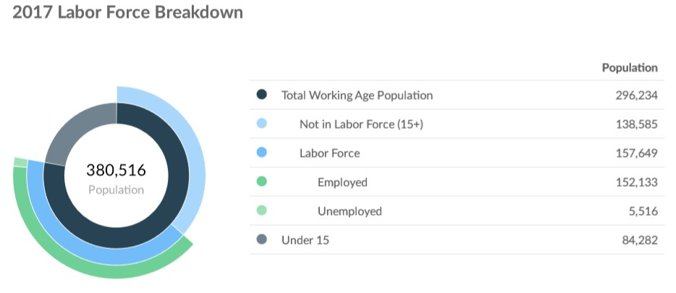
Source: Emsi Q2 2018 Data Set www.economicmodeling.com

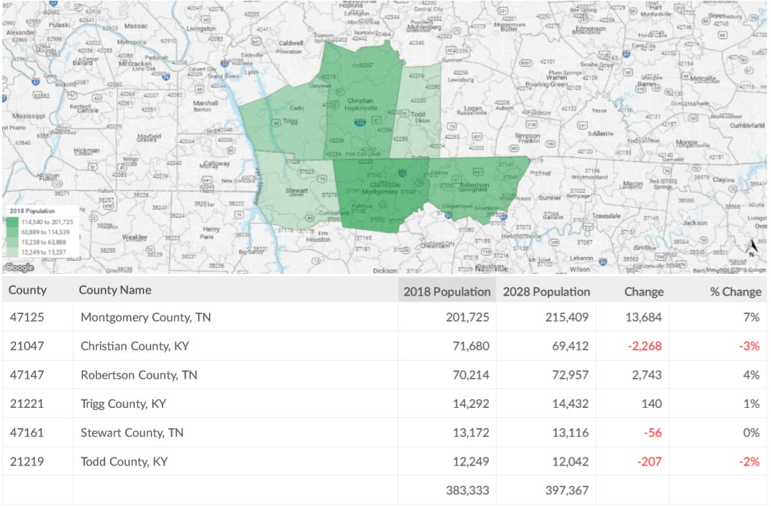
Source: Emsi Q2 2018 Data Set www.economicmodeling.com

With a deliberate focus on transitioning military it is realistic that these population numbers could increase beyond the current predictions. Fort Campbell transitions approximately 5000 service members a year who settle across the country. Approximately 30% of those transitioning service members remain in the region. Their ages range from 22-26 years old. Of those who remain in the region 60% are married and support families. Using these data points, 1650 veterans transition to the region annually. 990 are married. The average family size in the United States is 3.14. Therefore, 990x3.14 is an annual increase in population due to veteran transition in the region is 3109 veterans and families, plus 660 single veterans. An overall population increase of 3789 per year in the FCS region.

However, 3789 represents less than 1% of the total population. A goal of increasing the number of transitioning veterans by 20% per year would result in an overall increase of 1.2% per year impact on the population. Over the course of 10 years this increased effort could increase the total population by over 8000 new members of the community. While these numbers seem low relative to the whole, it is expected that the FCS region will have an overall +7% change in population over the next two years. This increase in effort with respect to veterans would have the impact of increasing this number 29.2% over a ten-year period.
Facts
▪▪ Over 10,000 soldiers from Fort Campbell transitioned in the last two years. Of those, more than 30% remained in the FCS region.
▪▪ 237,497 soldiers, retirees, civilians and Family members reside in the FCS region.
▪▪ 27,000+ active duty soldiers, 40,000+ Family members, 65,000 retirees with 95,000 Family members.
▪▪ Of the active duty soldiers and families, 70% live off Fort Campbell in the surrounding community.

▪▪ The presence of the 160 Special Operations Aviation Regiment and the 5th Special Forces Group enables soldiers to be stationed at Ft Campbell
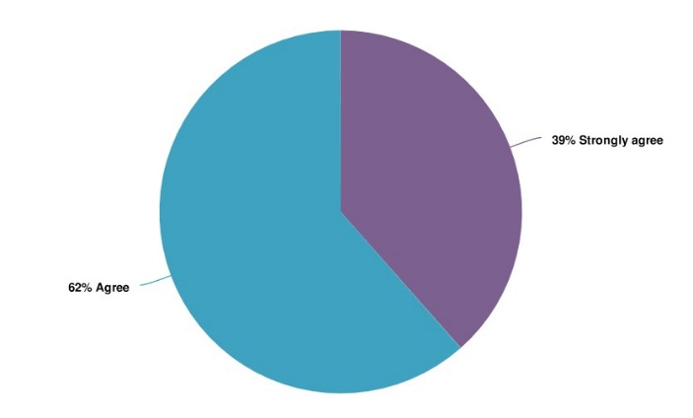
for multiple tours of duty.
▪▪ 62% of the regional partners agree that attracting veterans to the region should be a top priority.
▪  54% of FCS regional members are not satisfied with how their community enhances quality of life for active military, veterans, and families.
▪▪ 34% of soldiers reenlist in the Army to stay at Ft Campbell for additional, subsequent tours.

▪▪ 67% of Non-Commissioned Officers reenlist to remain assigned to Fort Campbell for additional, subsequent tours.
▪▪ According to a survey taken in 2017, three major
Attracting veterans to our community should be one of our top priorities
Source: Solutions 21 Survey

considerations influence where soldiers and families decide to live after transitioning; a) proximity to friend and family, b) employment opportunities, and c) moving back “home” to be near family.
▪▪ The timing of when transitioning soldiers are making their decisions is long. A survey taken in 2017 found that 69% of transitioning soldiers are making their decision greater than 10 months before they separate.
▪▪ Tennessee does not have a state income tax.
▪▪ Tennessee does have higher property taxes, in general, than Kentucky. As an example, Montgomery County pays $4.31 per $100 at 25% of assessed value. A home assessed at $175,000 is taxed at
$1,885.62.
▪▪ Tennessee has higher sales taxes at 9.5%, 8.5% for groceries.
▪▪ Kentucky has a state income tax.
▪▪ Kentucky property taxes in Christian County are $1.008 per $100 of assessed value. A home assessed at $175,000 is taxed at $1,764.
▪▪ Kentucky sales tax is 6%, 0% tax on groceries.
▪▪ Kentucky does not tax military retirement income below $41,100. Any military retirement above the
$41,100 limit is taxed.

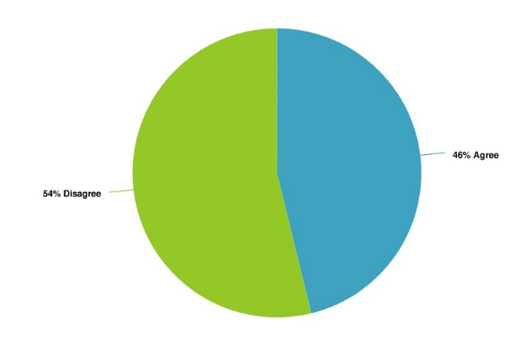
▪▪ Kentucky does not tax military pay on soldiers or the spouses of soldiers who are living in Kentucky due to their Soldier’s military assignment. Military pay for the Armed Forces are exempt from Kentucky Income Tax (KRS 141.010(10)(U)) after January 1, 2010. Military Spouses Residency Relief Act (MSRRA) Public Law 111-97 signed into law November 11, 2009, allows same residency benefits permitted to military personnel under the Servicemembers Civil Relief Act (SCRA). Four of six member counties of the FCS Defense Alliance have a link on their county website that enables veterans to gain assistance.

I am satisfied with how our community enhances quality of life for active military, veterans, and their families.
Source: Solutions 21 Survey

Analysis
▪▪ There is a general lack of understanding of the opportunities to soldiers and families in the region.
▪▪ Of the soldiers and families who live off the base, many are involved in the community. Their children attend schools, their families attend religious activities, and members of their families’ work in the communities in which they live.
▪▪ The majority of the communities understand the additional benefits of having military in the communities and actively work to attract them to the region.
▪▪ The quality of life focus of the region helps soldiers and families want to return to the region or stay here and retire.
▪▪ There is a significant lack of understanding of the difference in taxes between Kentucky and Tennessee. This lack of understanding, particularly with respect to income taxes, contributes to soldiers and families making under-informed decisions about where they choose to permanently reside if they choose to remain in the FCS region.
▪▪ The emphasis by communities to enhance the quality of life for soldiers, veterans, and families is effective and makes them want to return to the FCS region for additional assignments and retirement. This is true despite the fact that 54% disagree that they are doing enough.
▪▪ With only four of six counties having links to veteran services, there is not a centralized effort or message that would specifically target and attract veterans to the region.

Economic Development:
Analysis
▪▪ Both Kentucky and Tennessee have important investments they make annually to develop their relationships with aerospace and defense industries, their story is not being told accurately in all cases. At least 70% of the off-post active duty military at Fort Campbell resides in the state of Tennessee, but DODOEA counts those residents in the state of Kentucky. This results in a less than accurate portrayal of the defense personnel and spending as a result of residency and will have an impact on the conditions considered by defense industries as they look at where they might find workforce, space, industry partners, etc.
▪▪ An inaccurate portrayal of the facts could inadvertently cause site selectors to dismiss sites in both KY and TN. While they are looking for favorable tax conditions, space, and workforce together, looking at this DODOEA report they may dismiss TN locations due to workforce, and KY sites due to space or tax conditions or a combination of the three that is inaccurate. The DODOEA report needs to accurately portray reality in each state.
▪▪ Supply chain analysis of Middle Tennessee and Western Kentucky is necessary to accurately portray gaps that either need to be, or could be filled, by defense related industry partners. While the states may have done them for other geographic locations in the past, one needs to be done for the FCS region to help regional economic development agencies best pursue those industries that will benefit the growth of the region.
▪ With 20,000 additional millennials in the FCS region above and beyond the national norm, the conditions that are attractive for future growth and economic development are favorable and provides an advantage over other parts of middle TN and western KY.
▪▪ The consolidation of major defense industries to five major companies enables a focused, concentrated effort for researching the needs of the defense industry within the region.
▪ With 5 major industries controlling the majority of defense industry needs, and subcontracting 60-75% of their business, there is significant opportunity to create conditions profitable for small and medium size companies in the FCS region.
▪▪ The higher salaries traditionally paid by defense contractors will help boost the FCS regional economy.
▪▪ Participating in the aerospace and defense industry market will provide the following opportunities:
- Support investment in research and development, facilities and infrastructure across the region
- Create jobs
- Export goods nationally and internationally
- Attract and retain top-tier talent resulting in overall increase in spending across the region
- Provides a stable industry partner
- Enhances networking and partnership with supporting agencies across the region.
▪▪ The grants that Kentucky and New Jersey pursued with DODOEA are good examples of potential efforts to enhance defense industry growth within the FCS region.
▪▪ In a survey sponsored by Fort Campbell in 2017, over 350 soldiers were interviewed about their opinions on transitioning from the military. Of those surveyed, 69.5% started planning their transition at least 10 months before their transition. 30.5% set-aside only nine months or less planning their post – Army opportunities.
▪ The SFL-TAP enables soldiers to begin their planning or transition as much as two years prior to separation.
▪▪ In the same survey, when asked how they chose their state of residence after transitioning 44.56% based their location on employment
opportunities, 46% on proximity to family and friends, and 43% decided based on proximity to family. 32% strongly considered potential wages and 29.8% considered the city or town size.
▪▪ In a 2016 survey on veterans in the workplace sponsored by the US Chamber of Commerce Foundation, 400 HR managers and
1000 veterans were interviewed regarding their views on transitioning and their first year of civilian employment. They had some interesting findings;
54% of HR professionals had little knowledge of rank and structure for those who have served in the military.
4 out of 5 companies lack formal training to help civilian employees relate to veterans.
The biggest challenges for transitioning veterans included deciding what career path to pursue (61%), followed by not receiving feedback from any kind of hiring managers (56%), not having the necessary resources or contacts (53%), and networking with hiring managers or employers (52%).
44% of veterans surveyed left their first post military job within one year.
Of those who remained at their job, higher pay and clear opportunities were their reasons for staying. 65% said it was due to increased pay, 55% said a clear path for career growth, 43% said increase management opportunities, and 41% said on-the-job training opportunities were important.
Veterans who spent the most time preparing were proportionally rewarded for their efforts. Higher preparation equaled higher pay.

Enable Military Spouse Employment Opportunities:
Empower military spouses by providing a network of regional partners willing to help them pursue their professional ambitions, maximizing their experience, and provide economic growth for the region.

Facts
▪▪ According to Blue Star Families (https://bluestarfam.org/)
43% of military spouses are not in the labor force compared to 25.5% of civilian spouses, the ratio for unemployment is 12.04% for military spouses versus 7.74% for civilian spouses.
▪▪ In 2012 the rate of unemployment for armed forces spouses ages 18-24 was 30.3% and with civilian spouses it was 10.5%, for those 25-44 years old it was 14.7% vs 5.8%.
▪▪ In 2010 the comparison of military to civilian spouse unemployment was 12.04% to 7.74%.
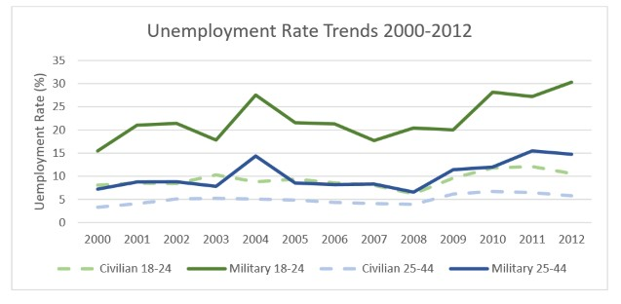
▪▪ In 2006 it was 7% to 6%.
▪▪ The unemployment rate for Army spouses is higher than the other services in the DOD.
▪▪ Underemployment for military spouses is 35-40%.
Underemployment relative to their level of education is 38% for military spouses as compared to 6% for

civilian spouses.
▪▪ In a 2010 RAND Study it was found that the lack of military spouse
Source: Blue Star Families.See references below.

participation in the workforce cost the United States between $710M and $1Billion. This was a function of reduced labor force participation, underemployment, and unemployment. Contributing to these numbers were also lost income taxes, payment of unemployment benefits, and healthcare benefits paid. Lost income tax revenue was the largest percentage of this number at 81.4%.
▪▪ The Institute for Veterans and Military Families (IVMF) at Syracuse University is focused on the social, economic, education, and policy issues impacting veterans and their families. They have expertise in professional training and education programs, research, and policies to help communities access and deliver services/care for military families. They sponsor a Career Skills Program at Fort Campbell called Onward to Opportunity Veterans Career Transition Program. They have expertise to help develop programs for military spouses and connect veterans and spouses to opportunities in the workplace.
▪▪ The U.S. Chamber of Commerce Foundation Hiring Our Heroes Military Spouse Professional Network helps military spouses network in communities around the world. This is done by 40 local chapters throughout the United States and Europe that connect spouses with networks, local business leaders, peers, mentors and support groups. According to their website a chapter exists for Fort Campbell.
▪▪ The U.S. Chamber of Commerce Foundation and Hiring Our Heroes sponsors a program called “Amplify.” The Amplify events are conducted for military spouses across the United States to provide career preparation and development. The 2-day sessions enable spouses to improve their resumes, take professional photos, and create quality LinkedIn profiles. Participants have the opportunity to work with a mentor, attend sessions on salary negotiation, networking, PCS strategies, and moving a business as a military spouse. These sessions are held across the country and in 2018 they were held in Hampton Roads, VA; Joint Base Lewis-McChord, WA; San Diego, CA; San Antonio, TX (Fort Sam Houston); Fort Bragg, NC; Colorado Springs, CO (Fort Carson).
▪▪ “The Paradigm Switch” is a non-profit organization comprised of military spouses that started in 2017 for veterans and spouses and provides scholarships for skill-based programs. Important data from their website:
45,000 organizations serve veterans and transitioning service members.
35 of the 45,000 focus on military spouses
Military spouse unemployment is 3 to 5 times higher than veteran unemployment
In 2013, 90% of employed female spouses were underemployed
In 2016, of those employed some were earning less than $20,000/year despite having experience and education that would enable them to earn more.
Their goals:
▪▪ Build an online networking community dedicated to helping military spouses
▪▪ Help spouses connect and reach their career goals
▪▪ Empower spouses

Analysis
▪▪ Military Spouse Employment needs to be a deliberate area of focus.
▪▪ Military Spouses represent a significant source of untapped talent across the United States.
▪▪ Deliberate efforts to employ military spouses would directly impact income taxes (where applicable), decrease unemployment benefit costs, and decrease healthcare costs.
▪▪ Increased engagement with military spouses will increase the number of transitioning veterans willing to remain in the FCS region as permanent residents.

Support Efforts to Create a Regional Veterans Education Facility That Expands Opportunities for Skills Certification, Enables Industry Interface, and Creates Regional Growth
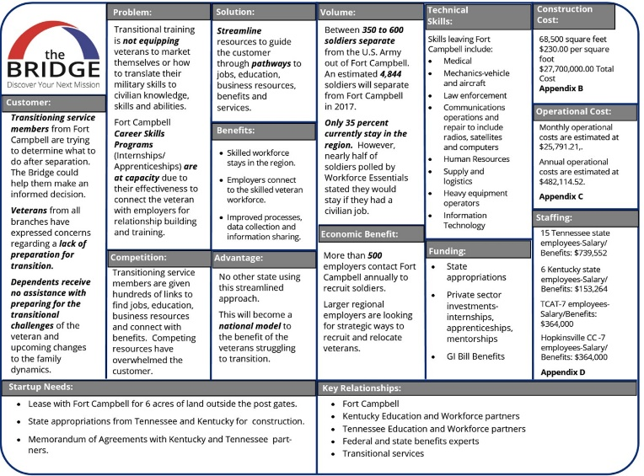
Provide a veteran focus regional transition center that educates veterans in certification producing trades necessary for region+B33:C33al growth, industry focus workforce development, career producing opportunities, and retention of quality citizens in the FCS region.

The chart below lays out important considerations explained in greater detail in the business plan developed by the Tennessee Department of Veterans Services.

