Command Sergeant Major Jesse S. Withers
State Command Sergeant Major
Kentucky Joint Force Headquarters
Frankfort, KY
Since: June 2020

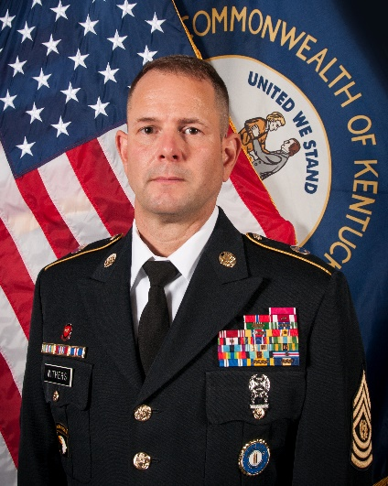
Command Sergeant Major Jesse S. Withers assumed the responsibilities as Command Sergeant Major, Kentucky Army National Guard, Frankfort, Kentucky on 1 June 2020.
Command Sergeant Major is a native of Cynthiana, Kentucky, and enlisted in the Kentucky Army National Guard on February 27, 1990. He completed Basic Combat Training and Advanced Individual Training as a 12B (Combat Engineer) Fort Leonard Wood, Missouri.
Throughout his career, he has held numerous leadership positions ranging team leader to brigade command sergeant major. He served as the Kentucky National Guard G3 sergeant major, command sergeant major for the 149th Military Engagement Team, brigade command sergeant major for the 149th Maneuver Enhancement Brigade, battalion command sergeant major for the 201st Engineer Battalion, first sergeant 149th Vertical Construction Company, first sergeant Headquarters and Headquarters Company 201st Engineer Battalion, and first sergeant Bravo Company 201st Engineer Battalion.
Command Sergeant Major Withers’ deployments include one tour in Kuwait and one in Afghanistan, both in support of Operation Enduring Freedom. Command Sergeant Major Withers has attended all levels of the Noncommissioned Officers Professional Development System to include the Nominative Leaders Course.
His awards and decorations include the Valorous Unit Award, Joint Meritorious Unit Award, Legion of Merit, Bronze Star, Meritorious Service Medal, and the bronze De Fleury Medal.
Command Sergeant Major and his wife, Angie, reside in Winchester, Kentucky with one daughter, Kyleigh.

