TO: Veterans, Military Affairs and Public Protection (VMAPP)

FROM: Commissioner Whitney P. Allen

DATE: November 23, 2021

SUBJECT: Report by Kentucky Department of Veterans Affairs (KDVA): Unemployment Insurance Claims (UIC)

1. Background:

On May 1, 2020, KDVA received a call from the Personnel Cabinet requesting employees to assist the Education & Workforce Development Cabinet (EWDC), Unemployment Insurance Branch with processing claims. Kentucky started responding to the COVID-19 Pandemic in March of 2020. Prior to the pandemic, Kentucky had record low unemployment and only had approximately a dozen unemployment insurance adjudicators. The pandemic caused a record increase in unemployment claims. As the year continued, many people made multiple claims due to being placed off work each time the pandemic surged. This greatly overwhelmed the EWDC Unemployment Insurance Branch, causing the governor to request assistance from other state agencies. KDVA was to ask to provide as many employees to assist as possible.

On May 1, 2020, the Personnel Cabinet sent a list of eligible job titles to KDVA that could be trained quickly on the unemployment claims process. KDVA Benefits Branch was identified for sending employees to EWDC. 15 KDVA employees were identified for special duty at the EWDC Unemployment Insurance Branch.

On May 11, 2020, KDVA detailed 15 employees to special duty with the EWDC Unemployment Insurance Branch for up to 90 days.

On August 15, 2020, the KDVA employees were reverted back to KDVA and 9 KDVA employees were detailed a second time to the Labor Cabinet Unemployment Insurance Branch on August 16, 2020, for up to 90 more days. Unemployment Insurance had moved from the EWDC to the Labor Cabinet. The reduction in KDVA employees being detailed was achieved through negotiation with the Governor’s Office, to allow KDVA to handle veteran benefit claims.

On November 14, 2020, the KDVA employees were reverted back to KDVA and 5 KDVA employees were detailed a third time to the Labor Cabinet Unemployment Insurance Branch on November 14, 2020, for up to 90 more days. The reduction in KDVA employees being detailed was accomplish through further negotiation with the Governor’s Office, to allow KDVA to handle veteran benefit claims.

On January 1, 2021, the KDVA employees were reverted back to KDVA.

KDVA Employees Detailed to U/I 2020
# | Employee Name | Position Num. | Grade | Date Detailed | Date Reverted | Total Months
1 | Day, Edward | 30006440 | 15 | 5/11/2020 | 6/8/2020 | 1
2 | King , Hope B | 30006437 | 13 | 5/11/2020 | 7/27/2020 | 2
3 | Melton , Jonathan D | 31066470 | 13 | 5/11/2020 | 7/30/2020 | 2
4 | Roach , Larrissa | 31089836 | 11 | 5/11/2020 | 8/15/2020 | 3
5 | Ashby , Darrell | 31101290 | 11 | 5/11/2020 | 8/15/2020 | 3
6 | Buford , Stephen E | 31010882 | 13 | 5/11/2020 | 8/15/2020 | 3
7 | Monk , Patrick M | 31091201 | 11 | 5/11/2020 | 11/14/2020 | 6
8 | Livingston , Carol A | 30006445 | 13 | 5/11/2020 | 11/14/2020 | 6
9 | Tew , Ashley | 31105136 | 13 | 5/11/2020 | 11/14/2020 | 6
10 | Maxwell, Wendi | 31027433 | 13 | 5/11/2020 | 11/14/2020 | 6
11 | Howson , Charles E | 31091170 | 11 | 5/11/2020 | 1/1/2021 | 7.5
12 | Sinay , Jacquelyn | 31105139 | 11 | 5/11/2020 | 1/1/2021 | 7.5
13 | Webster , Shyela | 31105899 | 11 | 5/11/2020 | 1/1/2021 | 7.5
14 | Hanner , Thomas G | 31024845 | 13 | 5/11/2020 | 1/1/2021 | 7.5
15 | Acob, Monica | 30006457 | 15 | 5/11/2020 | 1/1/2021 | 7.5

On April 14, 2021, the governor’s office requested that other state agencies assist the Labor Cabinet Unemployment Insurance Branch, with a high volume of fraudulent unemployment claims. In order to help eliminate fraudulent claims, all access was deleted to the unemployment system and claimants had to set up a new pin number for access. KDVA employees assisted claimants with this process by detailing 5 employees to special duty for one month.

On May 14, 2021 the KDVA employees reverted back to KDVA.

KDVA Employees Detailed to U/I to help with fraud 2021
# | Employee Name | Position Number | Grade | Date Detailed | Date Reverted | Total Months
1 | Howson, Charles | 31091170 | 13 | 4/14/2021 | 5/14/2021 | 1
2 | Hanner, Thomas | 31024845 | 13 | 4/14/2021 | 5/14/2021 | 1
3 | Tew, Ashley | 31105136 | 13 | 4/14/2021 | 5/14/2021 | 1
4 | Livingston, Carol | 30006445 | 13 | 4/14/2021 | 5/14/2021 | 1
5 | Monk, Patrick | 31091201 | 13 | 4/14/2021 | 5/14/2021 | 1

2. Impact on Benefits Branch:
- COVID-19’s most immediate impact was the elimination of face-to-face contact with veterans and family members since March. This necessitated a significant change in the way we communicate and gather evidence and prepare benefits claims. Since all our Benefits Representatives have the ability to operate remotely, it was an easy task to shift to operating from home, however this presented many challenges. The shift to having records and forms exchanged exclusively via email and fax-to-mail was simple for our younger and more tech-savvy veterans but proved difficult for older veterans. Some have family members checking on them periodically that were able to lend a hand, some were able to use cell phones to photograph and text documents, and for the rest we had to revert to old fashioned snail mail via the U.S. Postal Service. This hurdle led to a reduction in the number of claims that we were able to submit per month.

By April, the number of claims submitted to the USDVA each month declined by two-thirds of KDVA’s normal claims output (refer to Table 2 below). In May, the transfer of 13 Field Representatives and two Regional Administrators to the office of Unemployment Insurance (UI) had a profound impact on our ability to serve our veterans and generate claims. This was due to the reduced number of representatives available to prepare claims, the technical challenges in exchanging documents, and the sheer volume of telephone calls that the remaining staff of seven including the Branch Manager were called upon to return. All of the telephones for the 13 UI detailed field representatives were forwarded to teammates that stayed with KDVA.

Six of our detailed Field Representatives were returned in mid-August, which accounts for the uptick in the number of claims submitted. The impact of subsequent returns of Field Representatives resulted in increases in the number of claims submitted. When the original detail ended in January and our final three Field Reps were returned the positive impact was delayed because these were our newest and least experienced Field Representatives when they were detailed. As described below, there was a retraining period before productivity increased. We lost momentum again when 5 Field Representatives were detailed again for 30 days to assist with establishing PINs and the number of claims that we were able to file dropped again. We also saw the loss of several Field Representatives due to unrelated reasons in March 2021.

We anticipate a return to full manning by February 2022 with 23 Field Representatives, three Regional Administrators, and a dedicated Appeals Specialist in addition to the Assistant Director and Admin Specialist III. It takes several months before a new Field Representative can prepare and submit claims independently so the positive impact of the additional staff will lag accordingly.

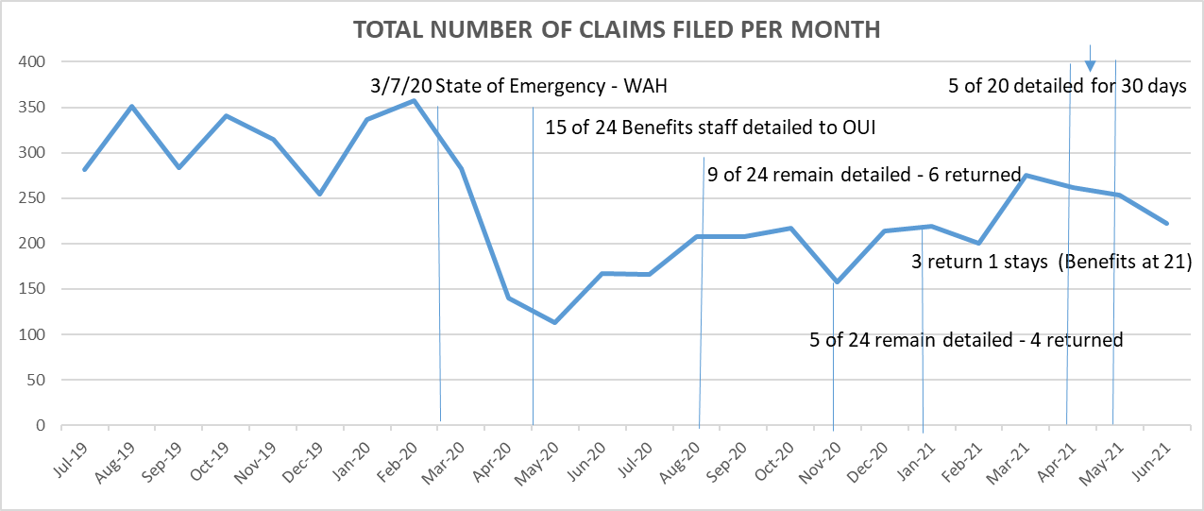
Table 2 - Total USDVA Claims Submitted per Month
- In terms of financial impact on the Commonwealth, KDVA saw a dramatic drop in the rate of increase in the running awards to the veterans we represent. Money from the USDVA comes via four income streams, Service-Connected Compensation,
Non-service-Connected Pension, Dependency and Indemnity Compensation and the Improved Death Pension. From May 2020 to November 2020, we saw the combined compensation and pension rate drop $120,000. Even more significant, however, is the lost opportunity for the continued growth we normally see each month. We would have reasonably expected the total amount of compensation to continue to grow if we had been able to maintain our normal volume of claims submissions. There was obviously a time lag between when KDVA was able to resume increased claims submissions with the return of detailed personnel but the increase in the monthly compensation rates in subsequent months speaks volumes.

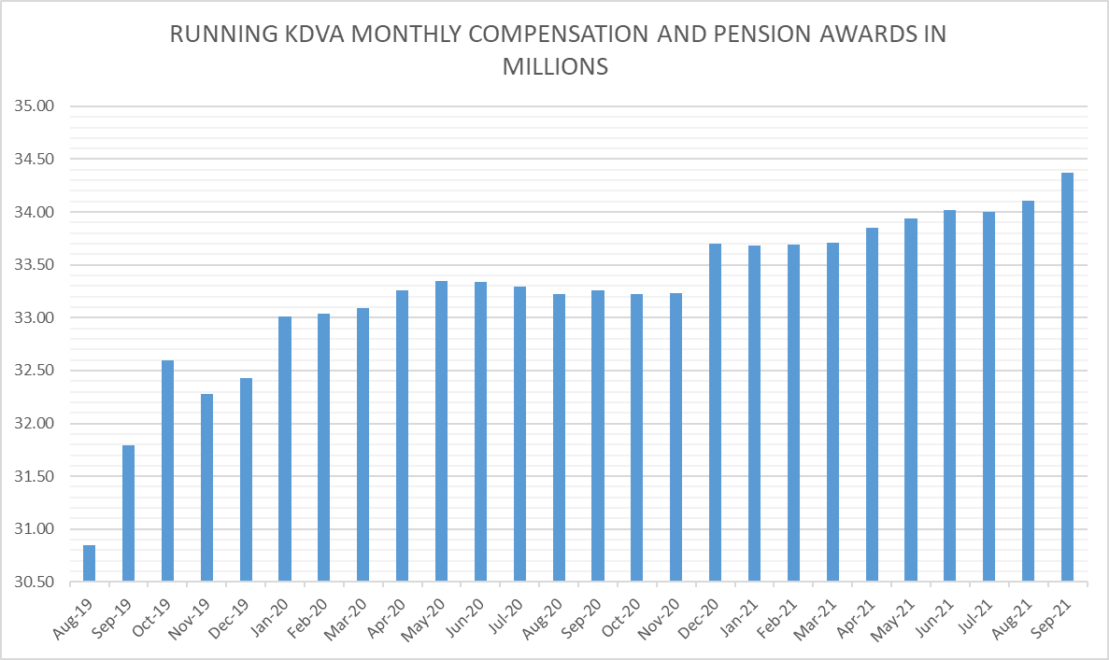
Table 3 – Monthly running compensation and pension awards from KDVA claims (in millions)

c. The decreased manning during the OUI detail definitely took a toll on our customer service. It was virtually impossible to return all telephone calls in a timely manner with over 63% of our Benefits staff detailed to OUI. That challenge was compounded by the fact that one of our KY National Guard Field Representatives was recalled to active duty in March 2020 and remains on active duty for another year. Our Admin Specialist III was on extended maternity leave for most of the same period and then resigned in August 2021. The timeliness of our responses to calls and emails has steadily improved as personnel were returned to KDVA.
d. Finally, the reduction in workforce has created delays and a backlog of fully developed claims being filed. Although a VA Form 21-0966 (Intent to File a Claim for Compensation and/or Pension, or Survivors Pension and/or DIC) is usually filed during the first veteran engagement with a Field Representative, a fully developed claim can take hours or days of research and preparation. The intent-to-file process allows KDVA and the veteran additional time to collect all the information needed to support their claim while protecting the earliest possible effective date for any award of benefits or increased benefits resulting from the claim. The date the Veterans Benefit Administration (VBA) receives the VA Form 21-0966 will be protected as their claim effective date as long as the application is completed and submitted within 1 year. While the effective date of the claim is protected, the consequence of this waiting period is a delay in potential compensation being awarded to the veteran.

