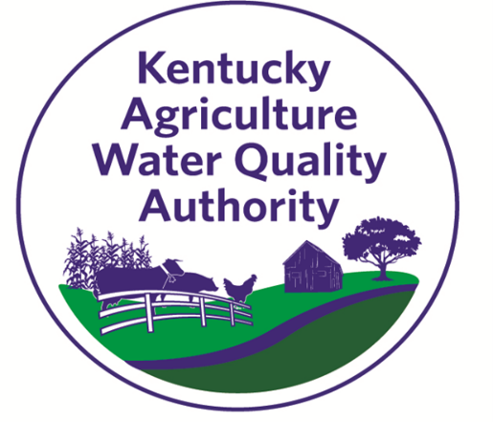
Kentucky Agriculture Water Quality Authority
Biennial Report for State Fiscal Years 2019 and 2020
The Agriculture Water Quality Act, KRS 224.71-100 through 224.71-140, was passed by the Kentucky General Assembly in 1994. The primary objective of this act is to protect surface water and groundwater resources from pollution as a result of agriculture and silviculture activities. This legislation has elevated the Commonwealth of Kentucky as a model by developing agriculture policy and farming practices to protect the quality of the water.
The Agriculture Water Quality Act applies to all landowners with 10 or more contiguous acres engaged in agriculture or silviculture production.

Current Kentucky Agriculture Water Quality Authority Members
Randy McCallon (Kentucky Association of Conservation Districts), Larry Thomas (Kentucky Farm Bureau), Amanda Gumbert (University of Kentucky College of Agriculture, Food and Environment), Vacant (Kentucky Geological Survey), Paulette Akers (Kentucky Division of Conservation), Vacant (Kentucky Division of Forestry), Paul Miller (Kentucky Division of Water), Angela Billings (Kentucky Division of Public Health), Vacant (Kentucky Department of Agriculture), Brian Lacefield (USDA Farm Service Agency), Greg Stone (USDA Natural Resources Conservation Service), Ron Brunty (Environmental Organizations), Joseph Sisk (Member-at-Large from Ag Operation), Todd Clark (Member-at-Large from Ag Operation), and Mark Burnett (Member-at-Large from Ag Operation)

Statewide Agriculture Water Quality Plan
The Statewide Agriculture Water Quality Plan is divided into sections covering Silviculture, Pesticides and Fertilizers, Farmstead, Crops, Livestock, and Streams and Other Waters. Best management practices (BMPs) that were revised in this 2 year period include and update of all of Streams and Other Waters, Farmstead #1-5, as well as all of the Livestock and Crops BMPs. The plan also underwent an entire update to add hyperlinks for online resources.
The Statewide Agriculture Water Quality Plan is available on the Division of Conservation webpage.

Kentucky Soil Erosion and Water Quality Cost Share
The Kentucky Soil Erosion and Water Quality Cost Share Program was established by the 1994 General Assembly and responsibility of the program was given to conservation districts and the Kentucky Soil and Water Conservation Commission. The program assists agriculture and silviculture producers in Kentucky with the implementation of the Agriculture Water Quality Act. The program encourages clean water through reducing sediment loading, nutrients and pesticides in streams, rivers and lakes across Kentucky.

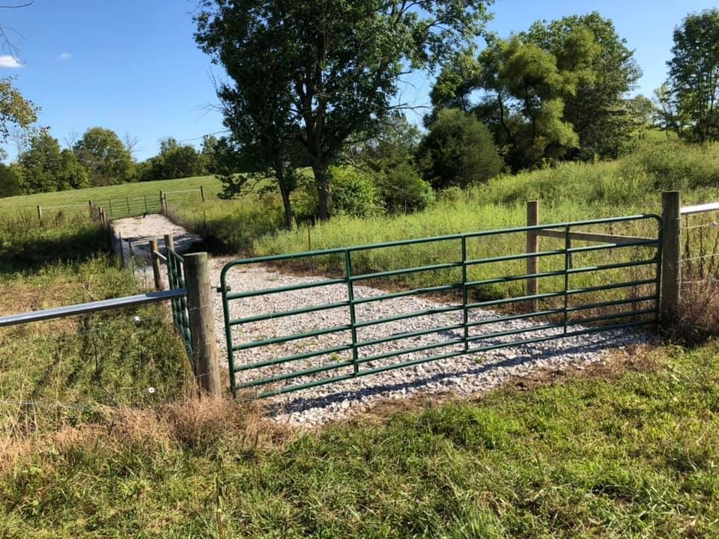
The funds from the FY18, FY19 and FY20 were all obligated during the FY19-FY20 biennial. The Kentucky Division of Conservation received 2,189 applications requesting $16.7 million in financial assistance for cost share projects. During this period of time, the Kentucky Soil and Water Conservation Commission gave formal approval on 1,830 applications for a total $11.5 million. The best management practices funded through the Kentucky Soil Erosion and Water Quality Cost Share Program help reduce animal waste nutrients, prevents the loss of topsoil, and minimizes sediment and other nonpoint source pollutants in Kentucky's streams, rivers, lakes, and groundwater supplies.

Education and Outreach
To assist farmers in completing their Agriculture Water Quality Plan, the Authority in partnership with the University of Kentucky developed an Agriculture Water Quality Plan Workbook. It is available online at www.uky.edu/bae/awqp. Additionally, those with livestock should complete a Nutrient Management Plan or have a plan from the Natural Resources Conservation Service. The Kentucky Nutrient Management Planning tool is also available on this page.

KY Agriculture Water Quality Plan training opportunities were provided for conservation district supervisors and staff at the 2018 and 2019 KACD Annual Conventions. Twelve other training opportunities were offered to Division of Conservation field representatives, conservation district staff, and Extension agents focused on KY Ag Water Quality plan and nutrient management plan development and implementation. Authority representatives also delivered KY Agriculture Water Quality information to high school students participating in the 2019 Envirothon competition.

For more information contact
Kentucky Division of Conservation
300 Sower Blvd
Frankfort, KY 40601
Conservation@ky.gov

