Status of Chronic Wasting Disease (CWD)

and Wildlife Diseases

Report Required by KRS 150.740(6)

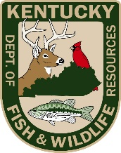

Kentucky Department of Fish and Wildlife Resources

November 1, 2023

The Kentucky Department of Fish and Wildlife Resources’ mission is to conserve, protect and enhance Kentucky’s fish and wildlife resources and provide outstanding opportunities for hunting, fishing, trapping, boating, shooting sports, wildlife viewing, and related activities.

Table of Contents:

Purpose……………………………………………………………………………………………………………………………………..1

Definition and Statute…….………….……………………………………………….…………………………………………….1

Notifiable Emerging Infectious Diseases

Chronic Wasting Disease (CWD)………………………………………………………………………………………1

SARS-CoV-2 (Covid-19)……………………………………………………………………………………………………6

Hemorrhagic Disease (HD)………………………………………………………………………………………………6

Highly Pathogenic Avian Influenza (HPAI)………………………………………………………………………..7

West Nile Virus (WNV)……………………………………………………………………………………………………8

Foreign Animal Disease

Rabbit Hemorrhagic Disease Virus (RHDV-2)…………………………………………………………………..8

Species-Specific Disease Concerns

Elk and Meningeal Worm (Brainworm)……………………………………………………………………………9

Turkey and Oncogenic Viruses………………………………………………………………………………………..9

Bats and White-nose Syndrome (WNS)…………………………………………………………………………10

Wild Pig Eradication and Disease Concerns……………………………………………………………………10

Other
Multistate Mortality and Morbidity Event in Songbirds………………………………………………..11
Fish Health……………………………………………………………………………………………………………………11
Tick Surveillance…………………………………………………………………………………………………………..12

Purpose:

Kentucky Department of Fish and Wildlife Resources (KDFWR) investigates wildlife disease issues in a diversity of species across the Commonwealth. The following is a summary of a few of the major disease related health issues facing wildlife in Kentucky.

Definition and Statute:

Defined as “wildlife” in KRS 150.010, captive cervids are regulated by both KDFWR and KDA. Unlike traditional livestock, captive deer and elk are indistinguishable from wild deer and elk, and thus pose a unique disease risk to native wild herds. Minimization of this risk dictates the need for strict holding and transportation regulations and animal identification requirements.
KRS 150.740 requires both the KDFWR and the Kentucky Department of Agriculture (KDA) to issue reports to the Interim Joint Committee on Agriculture and Natural Resources regarding the status of Chronic Wasting Disease (CWD) in deer and elk (Family Cervidae). These reports may include the status of other animal diseases.

Notifiable Emerging Infectious Diseases

Chronic Wasting Disease (CWD)

Chronic wasting disease (CWD) is a neurologic disease of cervids related to bovine spongiform encephalopathy (“mad cow disease”) in cattle and scrapie in sheep. The disease is caused by an infectious protein, called a prion, which is abnormally folded and can be transmitted through direct or indirect contact among cervids. The prion is extremely resistant to degradation, allowing them to persist on the landscape and serve as a source of environmental contamination. The disease causes a wasting syndrome in cervids and has been shown to cause population declines of white-tailed deer, elk, and mule deer in areas where the disease is endemic. Efforts to eradicate and control the disease on behalf of both federal and state agriculture and wildlife management agencies have been largely unsuccessful.

It is believed that risk of transmission to livestock and humans is low; however, because there is still a significant lack of data, the World Health Organization does not recommend eating any CWD infected meat.
- To date, CWD has been documented in deer and/or elk in 31 states and 4 Canadian provinces: Alabama, Arkansas, Colorado, Florida, Idaho, Illinois, Iowa, Kansas, Louisiana, Maryland, Michigan, Minnesota, Mississippi, Missouri, Montana, Nebraska, New Mexico, New York, North Carolina, North Dakota, Ohio, Oklahoma, Pennsylvania, South Dakota, Tennessee, Texas, Utah, Virginia, West Virginia, Wisconsin, Wyoming, and the Canadian Provinces of Alberta, Manitoba, Quebec, and Saskatchewan. It is worth noting, 6 of Kentucky’s 7 border states have CWD. However, chronic wasting disease has not been detected in Kentucky.

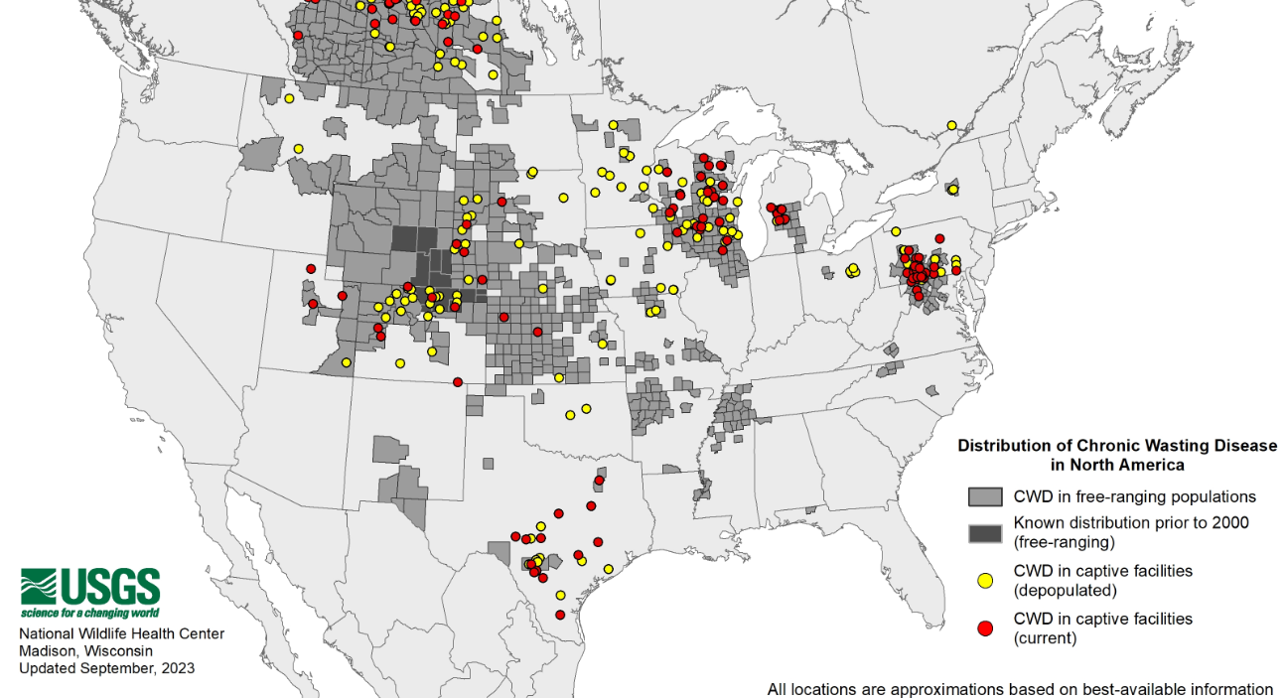

- The USDA reported 19 new CWD positive captive cervid facilities across the United States (18 white-tailed deer, 1 elk) in the Fiscal Year 2023. Seven herds were certified in the Federal Herd Certification Program (HCP), two were enrolled in the HCP but not certified, and ten were not participants in the HCP. Eleven of the newly identified herds were in areas where CWD had not previously detected in the immediate surrounding area. CWD detections in HCP herds is common and reported annually. These detections often lead to trace-outs which can negatively impact facilities that may have received animals from positive facilities. The current statute prohibiting the importation of captive cervids from CWD know positive states greatly reduces the risk of CWD introduction into Kentucky as this program does not prevent CWD transmission among infected cervids.

- CWD has now been detected in every bordering state of Kentucky, except for Indiana. The nearest detections of CWD to Kentucky are 8 miles from Henry County, Tennessee (wild deer), 16 miles from Weakley County, Tennessee (wild deer), 65 miles from Perry County, Missouri (wild deer), 135 miles from Millersburg, Ohio (captive deer), 90 miles from Randolph County, Arkansas (wild deer), and 90 miles from Montgomery County, Virginia.

- The detection of CWD within 8 miles of the Kentucky border triggered the activation of the KDFWR’s CWD Response Plan in September 2021. A five-county CWD Surveillance Zone was created covering the following counties: Calloway, Fulton, Graves, Hickman, and Marshall. Within the CWD Surveillance Zone, five regulations were immediately authorized:
  - a ban on baiting and feeding wildlife,
  - a ban on the transportation of high-risk carcass parts,
  - mandatory check of deer during two deer seasons; early muzzleloader season in October and modern gun season in November
  - mandatory release of rehabilitated deer, and
  - a ban on the rehabilitation of deer

- Following a successful first year of sampling in 2021 without a detection, mandatory CWD check stations were reduced to the three weekends of modern firearms deer season in 2022. All CWD regulations (e.g., baiting and carcass transportation bans) remained in effect.

- Due to the proximity of CWD in 6 of the 7 bordering states of Kentucky, KDFWR has increased CWD sampling efforts not just within the counties near the border of the Tennessee CWD zone, but within all of the Kentucky bordering counties.

- Current regulations enacted by the KDFWR and KDA include a ban on importation of live cervids from CWD positive states. KDA is currently only accepting captive cervids imported from Indiana. In 2014-2015, Indiana received trace-outs of CWD exposed animals shipped from CWD exposed facilities in Pennsylvania and Ohio. The detection of CWD in wild deer in the eastern part of Illinois warrants concern regarding possible transmission to neighboring wild herds in Indiana. The captive cervid industry in Tennessee is not required to be enrolled in the Federal Herd Certification Program, unlike Kentucky where all captive cervid facilities are required to be enrolled in this program.

- Pursuant to 301 KAR 2:095, Kentucky has implemented a ban on the importation of all carcasses and carcass parts that have the head or spinal column attached. Currently hunters may only bring the following into Kentucky;
  - Antlers
  - Antlers that are attached to a clean skull plate
  - A clean skull
  - Clean upper canine teeth
  - A finished taxidermy product
  - The hide
  - Deboned meat

- As of 2023, the KDFWR Wildlife Health Program and Deer Program oversees the surveillance of CWD in free ranging cervids. Since 2002, KDFWR has tested more than 48,000 free-ranging deer and ~1,000 elk for CWD. To date, the disease has never been detected within the state of Kentucky.

- A Deer Sample Collection Station program was initiated in September 2020 to provide hunters with the opportunity to submit their harvested deer heads or lymph nodes for CWD testing. There are currently 27 freezers distributed across the state.

- The Kentucky Department of Agriculture continues to require testing of most captive cervids that die in the state of Kentucky.
As one of the few remaining states where CWD has not been detected KDFWR urges a review of current live cervid transportation practices in Kentucky. The introduction of the disease through movement will significantly impact both wild and captive cervids. KDFWR recommends taking a proactive approach using the precautionary principle to review of current regulations and consideration of additional testing requirements on the importation of live cervids from the state of Indiana.

The KDFWR CWD Response Plan was revised in 2019. The goal of this plan is to provide a logical method to manage issues related to CWD based on the current understanding of the disease. This document describes the efforts to provide education and prevent the occurrence of CWD within the state. It also delineates KDFWR’s planned course of action should a CWD-positive case be diagnosed in either wild or captive cervids within Kentucky or within 30 miles of its borders.

A CWD-specific risk model was implemented in June of 2012 to guide surveillance. The KDFWR surveillance strategy focuses on attributes of the landscape, environment, or animals associated with a greater probability of CWD. These “risk factors” are calculated by county and include deer and/or elk density, number of captive cervid herds, concentration of captive cervids, interstate movement of live cervids, number of taxidermists and deer processors, and proximity to CWD positive areas. In September of 2020, KDFWR incorporated a weighted surveillance approach, using points associated with deer demographics. The Department works with Cornell University’s Surveillance Optimization Project for Chronic Wasting Disease (SOP4CWD) to annually to re-evaluate and update KDFWR’s surveillance plan.

Effective surveillance strategies require the use of a variety of methods and approaches to reach sampling goals. One such approach is “targeted surveillance” which concentrates surveillance efforts on areas with high risk, road killed animals, and sick animals. Road killed and sick or “target animals” are more likely to be infected, thereby increasing the probability of detection. The goal of targeted surveillance is to locate and test the animals most likely to be infected, thereby reducing surveillance cost while simultaneously enabling coverage of a large geographic area. This model encourages biologists and technicians to collect the majority of CWD samples from those animals of greater risk of disease, such as older males, road killed deer and elk, and animals displaying signs of the disease.

Discovery of CWD in Kentucky could result in the loss of tens of millions of dollars to Kentucky’s economy. CWD also presents serious threats to private business interests and agriculture in Kentucky. To minimize the risk of introduction of CWD into KY through the movement of live cervids, KDFWR recommends a complete ban on importation of live captive cervids and high-risk parts from all states and mandatory testing of all deceased cervids harvested from Kentucky’s hunting preserves, which are under the jurisdiction of the KDA.

SARS-CoV-2 (Covid-19) in White-Tailed Deer

Following preliminary data collected by the United States Department of Agriculture (USDA) a multistate SARS-CoV-2 surveillance project in free ranging white-tailed deer was initiated in 2021.
The primary objective of the collaborative surveillance effort between APHIS, WS and states is to maximize our ability to gain a greater understanding of susceptibility, prevalence, transmission, and disease processes of SARS-CoV-2 in white-tailed deer populations to protect human and animal health, and to facilitate the future development of mitigation strategies as warranted.
Kentucky Department of Fish and Wildlife Resources (KDFWR) collaborated with USDA to collect samples from white-tailed deer in 2022 and 2023. In the first year of sampling a total of 126 swabs. There were 8 confirmed positives based on PCR from 3 counties (Christian, Daviess, and Shelby). In the second year of sampling approximately 400 samples were collected. Of these only 3 were presumptive positives from two counties Owen and Scott. The USDA has no planned surveillance of captive cervids at this time, despite preliminary research that detected the disease in captive cervid facilities in Texas.
In response to recent evidence suggesting the widespread exposure of white-tailed deer to SARS-CoV-2, KDFWR developed hunter guidance for handling and field dressing deer which can be found on our website at fw.ky.gov. Additionally, KDFWR updated its recommendations for various stakeholder groups including nuisance wildlife control operators (NWCOs), wildlife rehabilitators, and environmental consultants who work with potentially susceptible species including bats, felids, mustelids, and cervids. Letters were sent to these groups and provided various recommendations depending on the risk of exposure.

Hemorrhagic Disease (HD)

There were 83 reports of sick animals from the public in 2022. Of the 23 samples submitted to the Southeastern Cooperative Wildlife Disease Study (SCWDS) for diagnostics, 12 were positive from nine counties in 2022. These counties were spread across the state in the northern (Boone, Kenton, Campbell, Jefferson, Mason) and west-central (Allen, Monroe, Warren, Union) portions of Kentucky. Epizootic Hemorrhagic Disease Virus 2 (EHDV-2) was recovered from nine samples, two isolates were identified as Epizootic Hemorrhagic Disease Virus but could not be serotyped, and one isolate from Allen County was identified as Blue Tongue Virus (BTV). In the summer and fall of 2023, there was an increase in the number of sick and dead deer reports across the state, with the most reports in counties from the western and central parts of Kentucky. KDFWR has received approximately 20 reports submitted via the online public reporting platform and biologists have responded to an additional 40 reports from landowners since July 2023. Thus far, 14 samples have been submitted to SCWDS, seven were positive from six counties. Epizootic Hemorrhagic Disease Virus 2 (EHDV-2) was recovered from two samples, two samples were unable to be serotyped, and virus isolation results are pending from five samples.
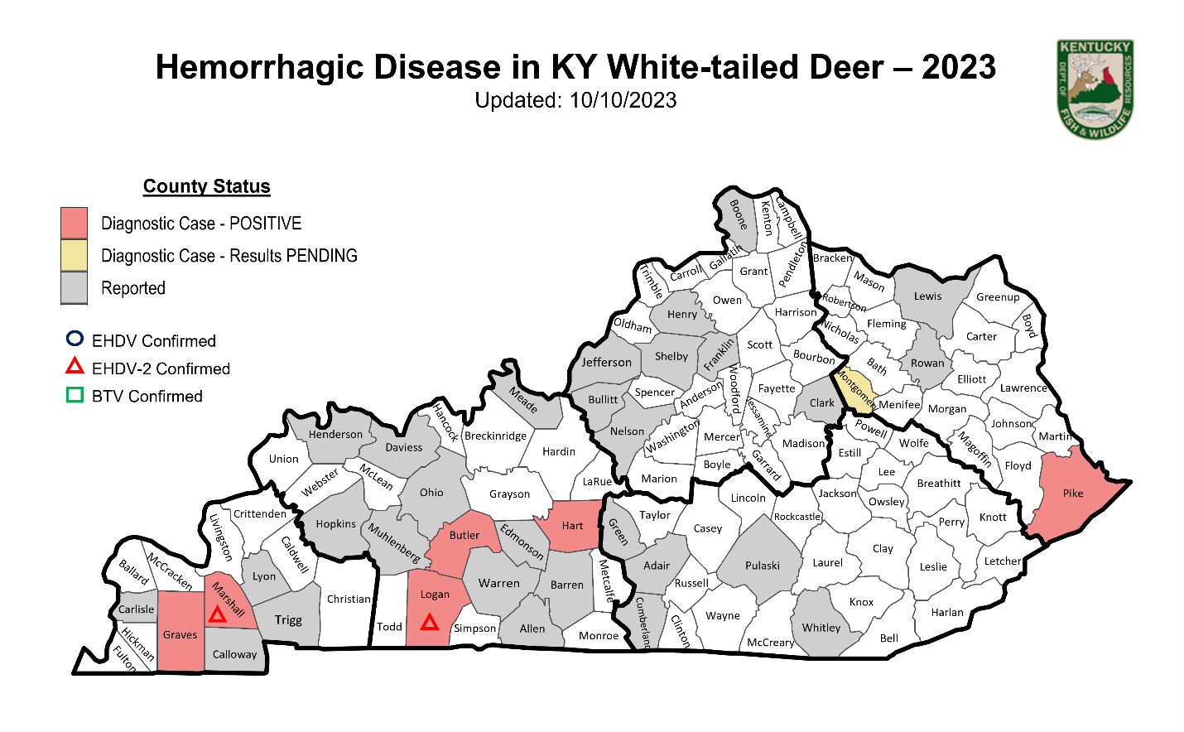

Highly Pathogenic Avian Influenza (HPAI)

In the Fall of 2021 USDA and State Wildlife and Animal Health Officials were preparing for a likely introduction of a Eurasian lineage goose/Guangdong H5 clade 2.3.4.4b highly pathogenic avian influence (HPAI). In December of 2021 the virus was detected in the Canadian Maritimes and subsequently detected in the Atlantic Flyway in January of 2022. In February of 2022 highly pathogenic avian influence (HPAI) was detected in 2 snow geese from Ballard County. This detection represented the first report in wild birds from the Mississippi Flyway. In response to this detection, KDFWR opened a public reporting system and followed up on calls regarding suspicious mortalities in waterfowl, bald eagles, raptors, and other avian scavengers. Following the initial detection in KY, only one additional case was confirmed in May of 2022 in a Bald Eagle from McClean County. The KDFWR Wildlife Health Program conducted Avian Influenza surveillance efforts through the summer of 2022 to determine if the virus was still circulating in resident waterfowl. Over 100 samples from Canada Geese were collected from multiple locations in Jefferson and Fayette County in late June of 2022. No virus was detected in any of these samples. Additional surveillance in collaboration with USDA Wildlife Services was done in August of 2022. Over 150 samples were collected in August from both wood ducks and mallards in Barren, Daviess, and Henderson Counties. No virus was detected in any of these samples.

In addition to the wild bird detections there have also been several mixed backyard flock detections. Backyard flocks are considered domestic and referred to the Kentucky Department of Agriculture. From January 2022 to February 2023, KDFWR tested 32 wild birds, 8 of which were positive for HPAI. Kentucky’s last HPAI case in a wild bird occurred in a Red-tailed Hawk in February of 2023.

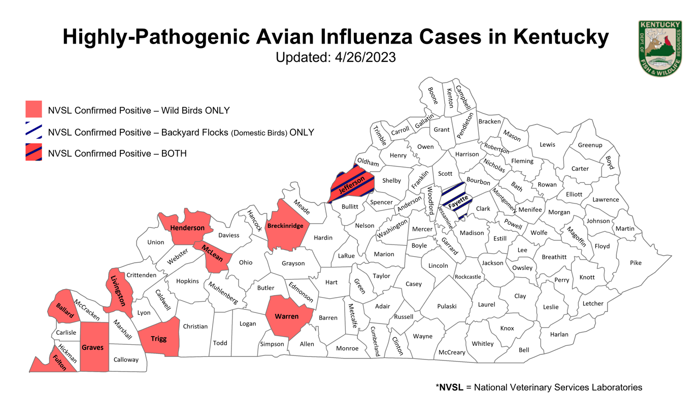

West Nile Virus (WNV)

West Nile Virus is endemic and routinely detected in the Commonwealth. West Nile virus was first detected in a wild bird in New York in 1999 and has since spread through North America, primarily infecting horses, wild birds, and humans. Over 250 species of birds can be infected with West Nile virus, but the most susceptible species include crows and blue jays, followed by owls and raptors. There is a seasonality associated with this disease where cases are commonly reported in late summer through fall. Since the start of 2023, West Nile virus has been detected in all of Kentucky’s neighboring states. In late August, Kentucky recorded its first detections in a free-ranging wild American Crow in Warren County. Additional detections in Great-horned owls have been confirmed in Calloway and Union County and several others are still pending. Our Public Health Partners have been notified of these wild bird detections, as detections in wildlife can inform human health surveillance and mitigation efforts.

Foreign Animal Disease

Rabbit Hemorrhagic Disease Virus (RHDV-2)

Following the initial detection of RHDV-2 in the Southwestern United States in the Spring of 2020, KDFWR started taking precautionary measures to minimize the risk of introduction. KDFWR identified important stakeholder groups and meet with Kentucky Department of Agriculture (KDA) regarding state regulatory authority over domestic rabbit. Unfortunately, KDA has no regulatory authority and is unable to assist with domestic rabbit and RHDV-2 concerns. KDFWR has passed amendments to regulations 301 KAR 2:081 and 301 KAR 2:082 to prohibit the importation of live native and non-native wild rabbits and/ or carcasses.
In December of 2021, the Kentucky office of USDA APHIS Veterinary Services received a report of suspicious mortalities in multiple domestic rabbits in Jefferson County, KY. Two of the domestic rabbits were submitted for diagnostics and confirmed positive for RHDV-2 by the Foreign Animal Disease Diagnostic Laboratory (FADDL). USDA Veterinary Services conducted an epidemiological investigation; however, the source of the introduction was not determined. USDA has no quarantine authority, and the owner was unwilling to surrender the remaining rabbits for euthanasia. KDFWR completed a survey of the area in 5-mile buffer around the positive pen looking for sick or dead rabbits and requested the public assistance with reporting any suspicious rabbit mortalities. KDFWR participated in the Association of Fish and Wildlife Agencies (AFWA) funded human dimensions project at the University of Georgia and utilized educational material for various stakeholders produced for this project.

Species-Specific Disease Concerns

Elk and Meningeal Worm (Brainworm)

In 2022, 23 animals were submitted to SCWDS as suspect P. tenuis cases. This is much higher than the number of cases submitted in the previous year, 13 animals. Of the cases submitted in 2022, P. tenuis was confirmed in eight animals and suspected, but not confirmed in seven animals. Most cases have had a copper deficiency comorbidity. Copper deficiency was often seen with an elevated thiosulfate level detected from ocular fluid. The role of a potential sulfur toxicity is still being evaluated. The public are strongly encouraged to report any sick or dead elk to the local biologists so they can respond and collect samples for the appropriate tests. KDFWR will continue to monitor meningeal worm cases in elk in Eastern Kentucky, especially since the symptoms may present similarly to those caused by Chronic Wasting Disease (CWD).

Turkey and Oncogenic Viruses

Prior to 2019 there was very little disease monitoring and surveillance done in wild turkeys. The Wildlife Health Program is interested in understanding the impact Lymphoproliferative disease virus (LPDV) and Reticuloendotheliosis virus (REV) may be having on turkey populations as these two viruses can cause tumor formation in turkeys. For the past two years KDFWR has been collecting carcasses of birds with classic Avian Pox lesions for diagnostics. In 2019, 8 of 13 birds (61.5%) were positive for LPDV. In 2020, 6 of 8 birds (75%) were positive LPDV. In 2021, 61.5% of the turkeys collected were positive for LPDV, 38.5% of the turkeys were positive for REV, and 7.7% of the turkeys had coinfections with both viruses. Of the turkeys collected in 2022, 53% were positive for LPDV, 17.6% were positive for REV, and 6% had coinfections with both viruses.
To gain a better understanding of the impact these diseases are having on wild turkeys in KY, the KDFWR Commission approved a three-year project with a health assessment component. KDFWR established a sampling goal of 100 birds from 3 geographically distinct regions of Kentucky, where multiple biological samples will be collected for pathogen screening. The pathogens of interest include lymphoproliferative disease virus (LPDV), reticuloendotheliosis virus (REV), Avian Influenza, West Nile Virus (WNV), Mycoplasma, Borellia spp., Toxoplasmagondii, and various Hemoparasites. The Spring of 2022 was the first year of sampling and samples from 189 birds were collected and submitted to SCWDS (results are still pending).

Bats and White-nose Syndrome (WNS)

White-nose syndrome (WNS) is a devastating disease that has resulted in unprecedented mortality in cave bats, more than six million lost. A fungus, Pseudogymnoascus destructans (Pd), grows on exposed parts (e.g., nose, wings, ears) of hibernating bats becoming an irritant that causes bats to wake up repeatedly and subsequently burn up the fat reserves necessary to survive the winter. First discovered in New York in 2007, the disease has spread to more than half of the US, as well as many provinces in Canada. WNS was first identified in Kentucky on 4/1/2011 at Cool Springs Cave, in Trigg County. The number of newly infected Kentucky sites peaked at 40 in 2014. No additional sites were discovered since 2017. To date, WNS has been documented at 120 sites in 27 counties and just the fungus Pd (i.e., no symptomatic bats) has been identified on bats in two additional caves (see map.) Kentucky is now considered to be within the WNS Endemic Management Area. Endemic states are represented by those where Pd has been widespread for multiple years, and where the fungus is assumed present in most hibernacula (White-nose Syndrome Disease Management Working Group 2020).

In general, declines have stabilized since WNS was first detected in Kentucky. Tricolor bats, little brown bats, and northern long-eared bats have experienced the most significant declines. A formal analysis is pending but estimates for those three species are likely to be well over 50% and potential over 80%. Indiana bat populations have experienced some declines but not to the extent the other three species listed above have. Some caves, including a few on Pine Mountain and one at Mammoth Cave National Park have experienced significant declines (as much as 90%). Although there is early indication Pine Mountain cave populations are starting to rebound.

Wild Pig Eradication and Disease Concerns

Wild pigs are an invasive species that pose serious threats to native wildlife and their habitats throughout the Commonwealth. Wild pigs outcompete, displace, and prey upon many native wildlife species. Much to the dismay of our sportsmen and women, white-tailed deer and turkey leave the area when pigs are present. Wild pigs cause severe ecological damage and significantly affect sensitive ecosystems, forest regeneration, and riparian areas. Wild pig rooting alters aquatic communities by degrading water quality and physically damaging native plants, providing a competitive advantage to exotic plants. Pigs also serve as common vectors for a myriad of diseases that are transmissible to wildlife, livestock, and humans, including pseudorabies, swine brucellosis, and bovine tuberculosis.
The Kentucky Department of Fish and Wildlife Resources in partnership with USDA Wildlife Services has made great strides in wild pig eradication over the last few years. Wild pig numbers are at the lowest level in the last decade. All breeding populations of pigs in KY have been significantly reduced. For the past two years there have been no detections of Swine Brucellosis (n=34). In 2021, pseudorabies was detected in 2 animals. However, in 2022 there were no detections. Eradication numbers continue to decline which is indicative of shrinking populations due to the success of trapping efforts and an aggressive campaign that includes monitoring, communication, and increased public support for wild pig removal.
A new and increasingly common issue is the releasing of domestic pigs into captive cervid pens for shooting activities. This poses a significant disease risk as swine are considered susceptible to Chronic Wasting Disease (CWD) and should not be allowed to comingle with cervid species. Currently KDFWR and KDA officials are conducting discussions on this matter.

Other

Canine Distemper in Wildlife
Canine Distemper is a virus that can infect a variety of wildlife and cause neurologic symptoms. Because these symptoms can mimic rabies and Kentucky is considered an Enhanced Rabies Surveillance zone for the raccoon variant of rabies it is extremely important to follow-up on these suspect cases. Additionally, there is concern that canine distemper may be contributing to population declines in gray foxes which are highly susceptible to this virus. It is important to identify comorbidities or co-infections to understand how this virus may be impacting wildlife populations. In the late winter/early spring of 2023, the Wildlife Health Program began receiving calls regarding sick raccoons, skunks, and foxes primarily from Central Kentucky. Since January 2023, a total of 14 cases of canine distemper have been confirmed from 13 counties. Traditionally, canine distemper outbreaks are in late winter and early spring. However, 2023 was an abnormal year and we received distemper calls throughout the summer of 2023.

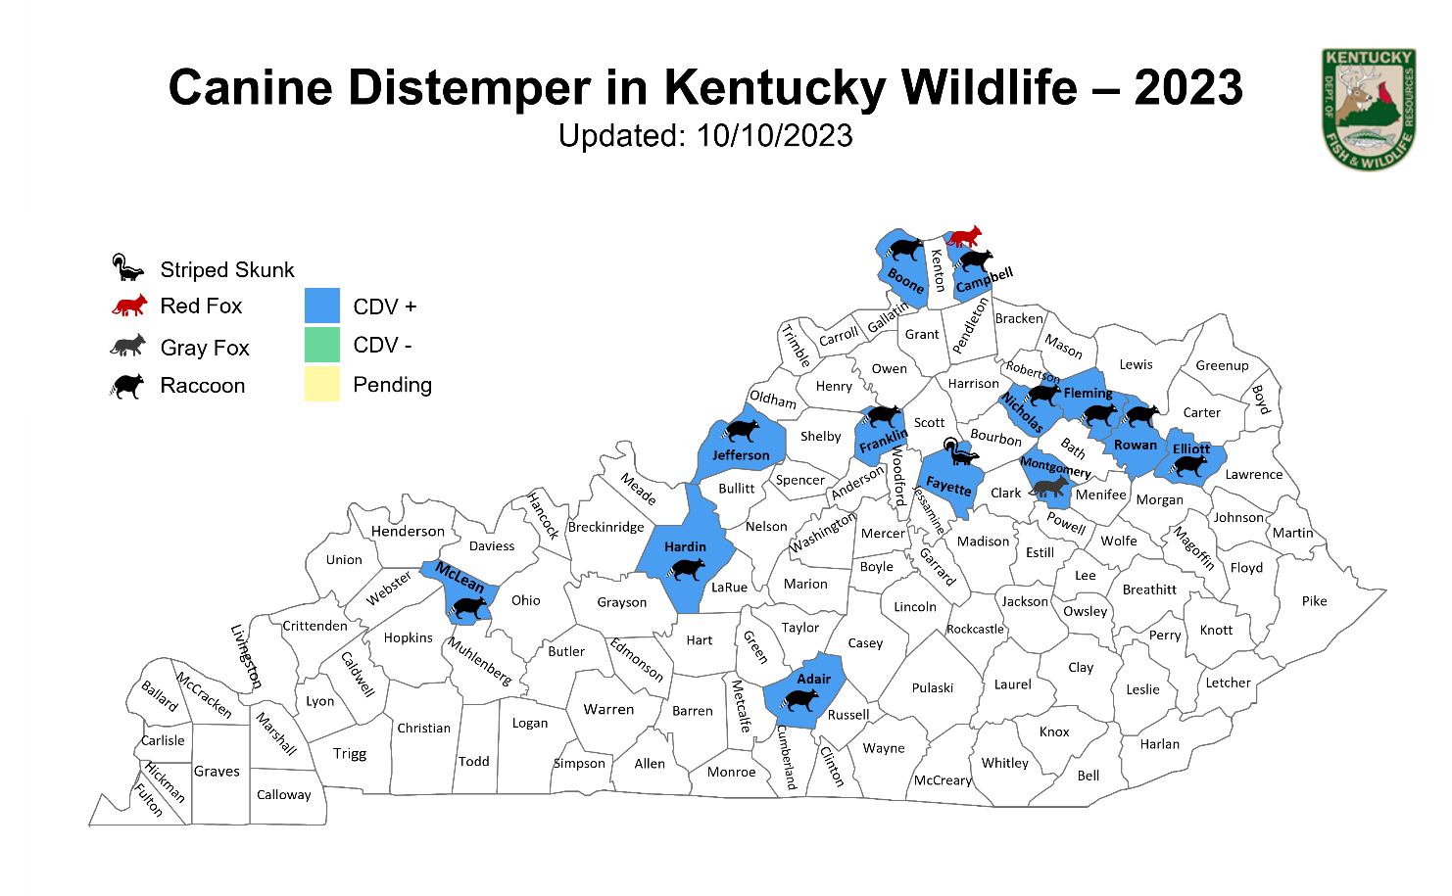

Fish Health

In late May through early June of 2022 there was a large die-off of common carp in Rowan County Kentucky. Samples were collected and submitted for virology. Initially, tests came back negative. Currently the cause of the die-off is unknown, but a viral pathogen is suspect. Tissue was saved in formalin for microscopic evaluation but currently there is no state contract in place with a diagnostic lab that can perform the tissue evaluation.

Additional concerns for fish and human health were highlighted in 2022 when the Environmental Protection Agency updated their guidance on life-time consumption concentrations of per- and polyfluoroalkyl substances (PFAS). PFAS are a large group of manufactured chemicals that have been widely used for decades. They tend to break down very slowly and can build up in people, wildlife, and the environment. Studies have shown that higher levels of PFAS exposure over time are associated with a wide range of human health effects such a lower birth weights, decreased fertility, thyroid disease, liver damage, and cancer.

The U.S. Environmental Protection Agency (EPA) does not have a water or fish tissue regulatory standard for PFAS but recently issued interim lifetime health advisories for PFOA and PFOS in drinking water that reduced their previous advisory levels of 70 parts per trillion (ppt). The EPA health advisory for PFOA now is 0.02 ppt and PFOS now is 0.004 ppt. This is significant because testing in water and fish in Kentucky have revealed levels greater than recommended.

Tick Surveillance

Kentucky initiated a statewide tick surveillance program in 2015 in partnership with SCWDS in response to the expansion of several tick vector species into Kentucky. Additionally, KDFWR has partnered with the KY Department of Public Health to continue long-term surveillance of tick populations in Kentucky. The Asian longhorned tick (Heamaphysalis longicornis) was initial recovered from an elk in Martin County in July 2018. However, an older HL detection was confirmed from a Floyd County black bear in June 2017. In 2020, the first report of HL in a domestic species was reported from a bull in Metacalfe County and then from a dead emaciated cow in Boone County, KY. One tick was recovered from a human in Madison County, KY. In the summer of 2021, two ticks were collected from elk calves in Perry and Breathitt County. Since then, H. longicornis has also been found on livestock in Garrard, Laurel, and Barren counties. In August of 2022, a novel pathogen, Theileria orientalis Ikeda (T. Ikdea), associated with the Asian Longhorned tick was recently detected in cattle in two counties, Fleming and Green, and has since been detected in livestock serum in Allen, LaRue, and Lyon counties. This pathogen is not native to North America and was likely introduced with this non-native tick with significant health impacts for cattle.

