November 1, 2024

Senator Brandon Smith, Co-Chair
Representative Jim Gooch Jr., Co-Chair
c/o Stefan Kasacavage
Natural Resources & Energy Interim Joint Committee
Legislative Research Commission
Capitol Annex
Frankfort, Kentucky 40601

RE: KDFWR 2024 CWD and Other Wildlife Disease Report

Dear Co-Chairs:

Pursuant to KRS 150.740(6), each year the Kentucky Department of Fish and Wildlife Resources is required to file a report on the status of Chronic Wasting Disease (CWD) and other wildlife diseases by November 1 with the Interim Joint Committee on Natural Resources & Energy. Please contact my office at (502) 892-4555 if you have any questions regarding the report. Thank you for your support of fish and wildlife conservation and disease management.

Sincerely,

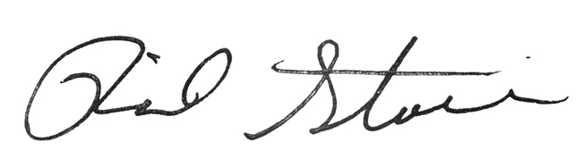

Rich Storm
Commissioner
Department of Fish and Wildlife Resources
#1 Sportsman's Lane
Frankfort, Kentucky 40601

