House Bill (HB) 187, passed in 2018 by the General Assembly, amended KRS 158.305 to require the Kentucky Department of Education (KDE) to provide an annual report to the Interim Joint Committee on Education (IJCE) to include survey data on the types of evidence-based interventions being implemented by districts in reading, writing, mathematics and behavior in kindergarten through grade 3.

K-3 Intervention Survey Data
Fall 2019, the KDE published an online K-3 Intervention Survey for completion by all of Kentucky’s 172 districts. All districts completed the survey. The survey required districts to report, for kindergarten through grade 3, the names of the intervention programs provided for reading and writing, math and behavior. While districts could select, and frequently use, more than one program, below are the top five intervention programs districts reported; additionally, the following link provides the survey responses for each district.
https://docs.google.com/forms/d/1lwP9rp6q_F1nHQgt2fbW-3FSXRmLq1DKHZnajAzSA_I/edit?ts=5d8a55fe#responses

K-3 Intervention Reading/Writing Survey Response
The top five most reported programs for K-3 reading and writing interventions were:
- Lexia Reading – 50.9%
- Reading A to Z – 50.9%
- Orton Gillingham Reading – 43.4%
- Reading Recovery – 40.6%
- Moby Max Reading – 39.4%

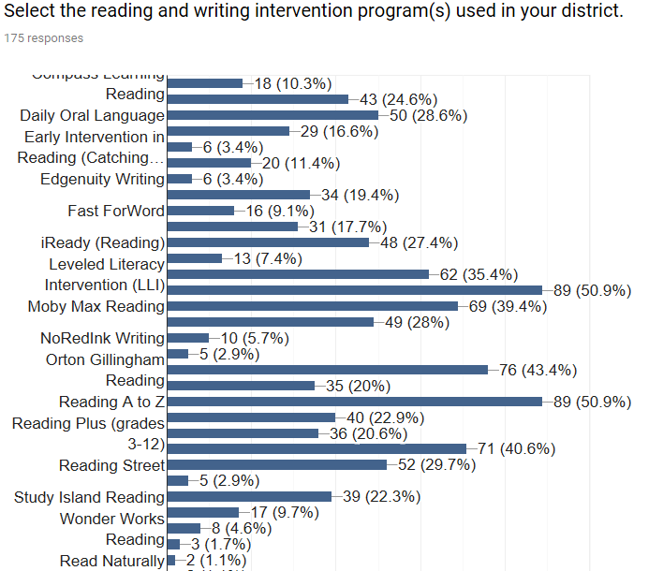
K-3 Intervention Math Survey Response
The top five most reported programs for K-3 mathematics interventions were:
- Moby Max Math – 54.3%
- IXL Math – 52%
- KHAN Academy Math – 45.7%
- Envision Math – 30.3%
- iReady (Math) – 27.4%

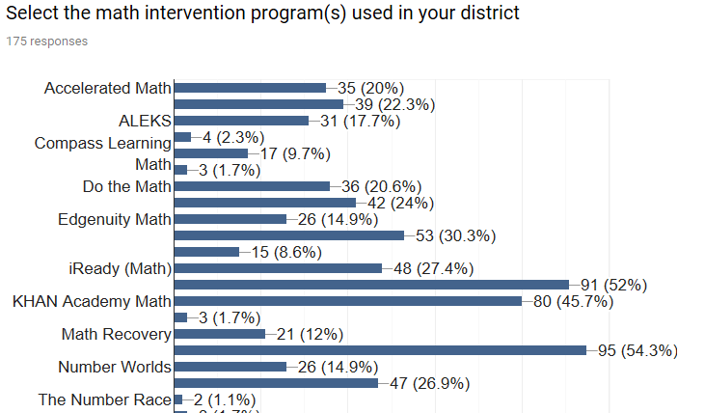
K-3 Intervention Behavior Survey Response
The top five most reported programs for behavior interventions were:
- Positive Behavioral Intervention System – 89.7%
- Trauma Informed Care (TIC) – 48.6%
- Check-In, Check-Out – 37.7%
- CHAMPS – 37.1%
- The Leader in Me – 36.6%

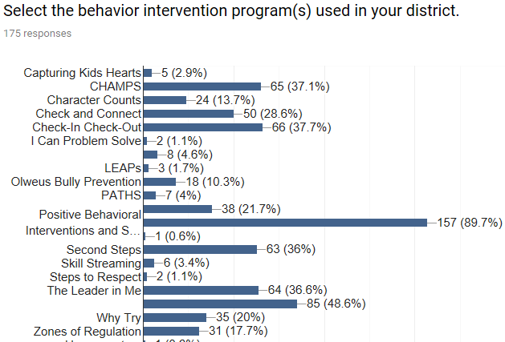

Note: Percentages may be higher than indicated because of the survey respondent writing in an intervention rather than marking it from the list provided.

