KCTCS Response to LRC Artificial Intelligence Request:

Artificial Intelligence (AI) Policies that have been implemented or are in the process of implementation, especially as it relates to educator preparation programs …

Topics for Response:
- AI policies for faculty and staff.
None at this time, however an Artificial Intelligence Guidance document has been created and is linked below.
- Any training/guidance your institution provides on AI.
Artificial Intelligence Guidance: See Attachment 1.
  - Hosted a system-wide AI conference in Spring 2024
  - KCTCS Technology Solutions will host an AI week in Fall 2024
  - System-wide AI Faculty Challenge
    - Spring 2024
    - Fall 2024
    - Spring 2025
  - Sent 5 staff/faculty to AI training provided by MIT (this one was complex and required programming)
  - 50 spots for an ACUE training for faculty (Fall 2024)
  - Teaching & Learning Peer Team designed 9 AI teaching challenges to deliver at their colleges
  - A group of colleges developed an Intro to AI course that is being piloted this year for students.
- Links to any AI resources on your website.
AI @ KCTCS: AI @ KCTCS - Home (sharepoint.com)
See Attachment 2
- Information about task forces, committees, etc. related to AI.
In Spring 2023, an Artificial Intelligence (AI) Workgroup was convened to address growing concerns and opportunities related to AI in the KCTCS educational system. The AI Workgroup’s charge was to determine if there should be anything in the KCTCS Student Code of Conduct regarding AI. The AI Workgroup determined that the Student Code of Conduct sufficiently covered cheating and plagiarism. A SharePoint site was created for faculty with AI resources, including sample syllabi statements.
Building on the effort of the AI Workgroup, the KCTCS AI Steering Committee was convened in Fall 2023 to continue the work. The Steering Committee’s charge was to establish cross-functional teams that would focus on a particular priority area of AI as determined by faculty, staff, and leadership. The priority areas include faculty and staff guidance on the appropriate use of AI, policies, and procedures around the use of AI, and the use of AI to drive efficiency.
The following workgroups have or will be convened:
    - AI in Academics Workgroup: This group met from April through September 2024 to develop recommendations for teaching and learning with AI. Those recommendations centered around five topics: faculty development, modeling AI, AI in the curriculum, Student use of AI, and AI for faculty-related processes. This group also wrote three sample syllabus statements that faculty may include in their syllabus.
    - AI in Student Affairs Workgroup: The group has identified nine areas of interest for AI in Student Affairs. The areas of interest include the use of AI for: Prediction, Recruitment, Marketing, Degree planning, Advising, Student experiences, Admissions, Financial Aid, and Disability/accessibility.
Currently, the group is working toward answering questions about the potential impact of AI in each area. The questions focus on the impact of AI on student success, how AI will help KCTCS achieve its strategic goals, how adoption of AI may augment, displace, or fill needed student service roles, and how AI can be used to help offset nonacademic barriers like student disengagement and college navigation.
- AI in Technology Solutions was charged with the following:
  - Define the AI landscape at KCTCS:
    - Identify and document existing AI tools available to KCTCS faculty, staff, and students
    - Create data classification levels for appropriate use of various AI tools and develop guidelines and a review process for classifying future tools
      - Develop guidelines and considerations for procuring and implementing tools
  - Increase AI Literacy
    - Provide education on appropriate use of AI tools in the enterprise and methods of using AI to increase efficiencies
    - Plan and deliver an AI Summit in Fall 2024
  - Launch an AI Hub
    - Develop a central hub for sharing AI news, available tools, events, and other documentation for faculty and staff
- AI in Advising to be convened soon.
- AI in Workforce to be convened soon. There are no specific policies or changes currently in KCTCS Workforce Solutions. KCTCS Workforce continues to see a steady increase in requests for training as it relates to AI and new programs/products are developed and implemented in Kentucky companies.

- Information specifically about AI in teacher prep programs.
- Anything else (including a narrative) you would like to include in the information packet.
Attachment 1

TO: KCTCS Faculty, Staff and Students
FR: KCTCS Artificial Intelligence Steering Committee
Dr. Reneau Waggoner, Acting Provost
Dr. Leah Simpson, Executive Director of Online Learning & Faculty Development
Dr. Roderick Jones, Statistician
Christopher Hockenberry, Student Services Coordinator
Dr. Christopher Howes, Chief Information Officer
Jeremy Miller, Assistant Vice President of Enterprise Systems
Chelsea Young, Staff Attorney
RE: Artificial Intelligence Guidance
DA: June 28, 2024

In Spring 2023, an Artificial Intelligence (AI) Workgroup was convened to address growing concerns and opportunities related to AI in the KCTCS educational system. The AI Workgroup’s charge was to determine if there should be anything in the KCTCS Student Code of Conduct regarding AI. The AI Workgroup determined that the Student Code of Conduct sufficiently covered cheating and plagiarism. A SharePoint site was created for faculty with AI resources, including sample syllabi statements.
Building on the effort of the AI Workgroup, the KCTCS AI Steering Committee was convened in Fall 2023 to continue the work. The Steering Committee’s charge was to establish cross-functional teams that would focus on a particular priority area of AI as determined by faculty, staff, and leadership. The priority areas include faculty and staff guidance on the appropriate use of AI, policies, and procedures around the use of AI, and the use of AI to drive efficiency.
KCTCS is committed to fostering an environment of innovation and efficiency while maintaining a strong sense of responsibility. As such, KCTCS recognizes the transformative potential of AI tools to enhance educational experiences and to improve administrative processes. KCTCS encourages the thoughtful integration of AI technologies across the system, and recognizes their capacity to streamline tasks, personalize learning experiences, and unlock new opportunities for students, faculty, and staff. However, KCTCS also emphasizes the importance of responsible AI usage. AI raises a number of legal and ethical issues. This guidance outlines what should be considered prior to using AI and current best practices for the use of AI.

- Is AI allowed?
The first consideration should always be whether the assignment or task allows for the use of AI. Students should refer to the syllabus in each of their courses to determine whether AI is allowed on a particular assignment or in the course. For other instances, KCTCS leadership, faculty and staff should set appropriate expectations for the use of AI up front and encourage a conversation about its use. AI can be used if it is not explicitly prohibited for an assignment or task. However, the legal and ethical issues in this guidance document should be considered before proceeding. That is, fact check your work, cite your use of AI in formal writing, do not disclose confidential information with AI tools that have not been properly vetted by KCTCS (see [HYPERLINK LIST ON SHAREPOINT]) and ensure you are following all applicable policies and procedures. Fact Check
Always review any AI generated content for accuracy prior to sharing or otherwise using the data provided. This would include verifying with multiple sources. AI is a powerful tool, but its responses are based on a combination of data that it has been trained on and live searches, which means the content can be biased, inaccurate, misleading, negative, or even disparaging (sometimes referred to as “hallucinations”). Be aware that hallucinations generated by AI can be harmful to you or those you share data with, which is why it is important to verify information and to be aware of both personal and professional risks.
- Citation
The use of AI should always be cited according to the governing styles in assignments and formal writing. Currently, there is no standard citation for AI, but other disciplinary or professional style guides (e.g., MLA, APA) should be used to determine the best way to cite AI. Generally, the citation should include which AI model was used, how it was used, and when it was used.
- Equity Considerations
As with any innovative technology, not everyone will have access to the more advanced AI tools (some require a paid subscription) and if they do have access, they may not know how to properly utilize the tool. This is an important consideration, especially for faculty who are considering using AI in their classroom.
While it may not be possible to ensure equitable access for all students, faculty should: (1) set expectations about which AI tool students can use (for example: ChatGPT 3 and not ChatGPT 4), (2) share how to use AI tools properly and ethically with their students, and (3) explain the limitations of the technology with students. Faculty can also provide reliable resources to aid students in their use of AI.

- Confidential Information
Avoid sharing confidential information when using AI. Data shared with AI language models may be stored temporarily for processing or used to further train the model. Therefore, it is important to refrain from inputting or sharing any data that is considered confidential or proprietary. This includes but is not limited to personal identification numbers, student information, personnel information, financial information, health records, intellectual property, or any other sensitive data that should not be disclosed publicly.
There are some AI tools that may require confidential information as part of their core function (e.g., advising, registration). Before sharing confidential information in any AI tool, ensure that it has been properly vetted by KCTCS Technology Solutions. Please review the [HYPERLINK LIST ON SHAREPOINT] for AI tools that have been vetted and are secure.
While AI is designed to be helpful and informative, it is not immune to security risks. Do not share information, such as usernames or passwords, which could compromise the privacy or security of individuals or entities associated with KCTCS.
- KCTCS Policies and Procedures
Current KCTCS policies and procedures can be applied to the use of AI. The most relevant policies and procedures are highlighted below. For questions regarding the interpretation of a KCTCS policy or procedure, please contact the KCTCS Office of General Counsel.
- Information and Information Technology Responsible Use [Policy 4.2.5]
Generative AI has made it possible to create sophisticated scams at a far greater scale than ever before. Always follow the KCTCS Secure Information Handling Best Practices, lessons from Cyber Security Awareness Training, and stay aware of emerging threats or guidance in Security Sense.
Prior to procuring any AI tool, contact Technology Solutions at your College or the System Office to ensure the tool has the appropriate privacy and security protections. Additionally, KCTCS may have similar tools already available without additional purchase.
- Employee Responsibilities & Corrective Action [Policy 2.0.2, Procedure 2.0.2-P]
- Core Values and Ethical Conduct [Procedure 5.1.20-P]
KCTCS expects its employees to be accountable for their actions, put forth honest effort in the performance of their duties, think critically, use innovation, maintain open communication, protect confidential information, and follow all laws, policies, procedures, and guidelines established by KCTCS. Failure to comply with these standards may result in progressive discipline.
- Code of Student Conduct
KCTCS expects its students to adhere to the highest standards of academic honesty and integrity and to support a campus environment that is conducive to learning and scholarship. This means that any form of cheating, plagiarism, fabrication, aiding and abetting, misuse or falsification, as outlined in the Code of Student Conduct, may result in sanctions for the student. More specifically, if a faculty member has a stated “no AI policy” for the course or for a particular assignment, and the student uses AI, that is considered cheating under the Code of Student Conduct. Article III Procedures for Reporting and Investigating Code Violations and Article IV Sanctions for Standards of Conduct Violations should be followed for allegations of cheating involving AI.
- Family Educational Rights and Privacy Act [Policy 6.2]
FERPA protects the privacy of student education records. As such, it is vital not to share any information in a prompt that could identify individual students or their academic records when using AI. For more information about what constitutes a student record, please see Policy 6.2.
- Intellectual Property [Policy 3.3.5]
Current law surrounding intellectual property is based on the premise that humans, not an AI tool, created the work. While there are cases working their way through the court system, it is not clear what, if anything, will be protected if it is created using AI. The US Copyright Office has indicated that it may depend on the extent to which AI was used in the creation. The US Patent and Trademark Office has stated that only natural persons can be named as an inventor, though the office has not precluded AI assisted inventions entirely. With that in mind, anything you submit to an AI tool could lose intellectual property protection. You should only input non-confidential, public information.
- Employing People with Disabilities [Policy 3.1.1]
- Student Disability Support Services [Policy 6.5]
Another way that AI tools may be used is to support individuals with mental, physical, visual or hearing impairments. As more AI tools are developed, the more accessible these tools will be for employees or students who may need assistive technologies in their work or school. The KCTCS processes outlined in established policy have not changed based on the emergence of AI tools; however, depending on the facts, AI tools may be an appropriate accommodation. Please review Policies 3.1.1 and 6.5 and contact your Student Disabilities Support Services or Human Resources Department with questions regarding the accommodation process.
- AI Detection Technology
KCTCS does not endorse the use of AI detectors at this time. There is currently no reliable AI detection technology. AI detectors often produce false positives and can be easily manipulated, thereby providing inaccurate results. In addition, research from Standford University has found that AI detection software introduces bias against certain learners, including non-native speakers. As previously outlined, KCTCS policies and procedures as well as the Student Code of Conduct can be used to address unauthorized AI use and/or plagiarism.

This guidance is subject to change as the landscape around AI use in higher education changes. This guidance was developed using resources from the University of Kentucky and Arizona State University.

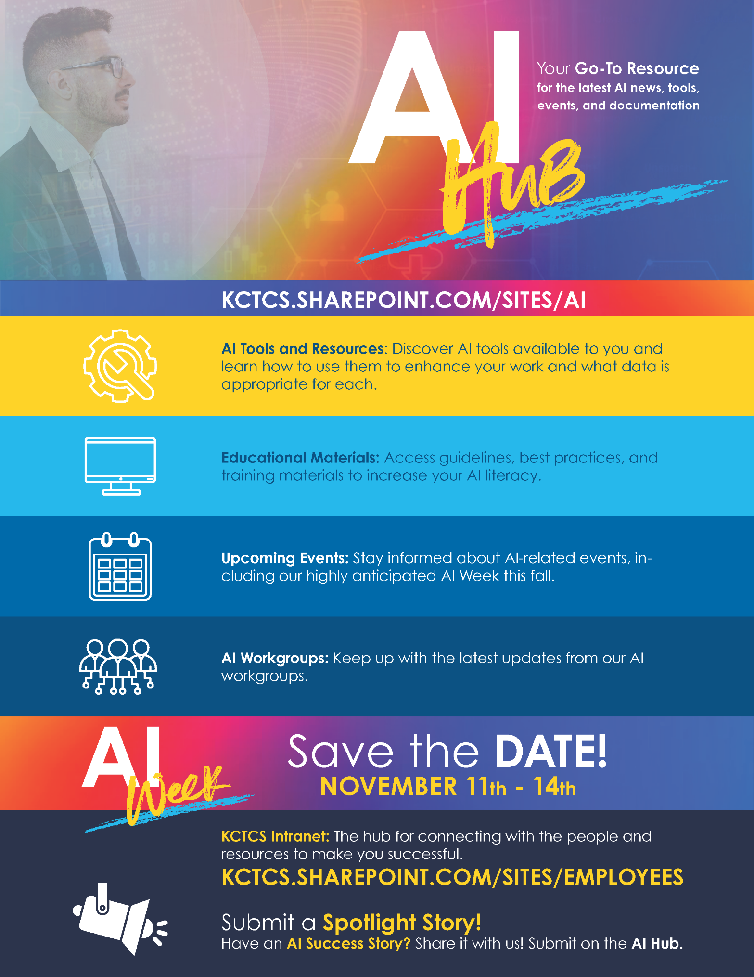
Attachment 2

https://kctcs.sharepoint.com/sites/KCTCSOnline/SitePages/AI-Workgroup-Resources.aspx
https://guides.lib.purdue.edu/c.php?g=1371380&p=10135074
https://policies.kctcs.edu/administrative-policies/4-2-5.aspx
https://policies.kctcs.edu/administrative-policies/2-0-2.aspx, https://policies.kctcs.edu/administrative-procedures/2-0-2-P.aspx
https://policies.kctcs.edu/administrative-procedures/5-1-20-P.aspx
https://policies.kctcs.edu/code-of-conduct/index.aspx
https://policies.kctcs.edu/administrative-policies/6-2.aspx
https://policies.kctcs.edu/administrative-policies/3-3-5.aspx
https://public-inspection.federalregister.gov/2023-05321.pdf
https://www.federalregister.gov/documents/2024/02/13/2024-02623/inventorship-guidance-for-ai-assisted-inventions
https://policies.kctcs.edu/administrative-policies/3-1-1.aspx
https://policies.kctcs.edu/administrative-policies/6-5.aspx
https://www.forbes.com/sites/forbesbusinesscouncil/2023/06/16/empowering-individuals-with-disabilities-through-ai-technology/?sh=338161116c73
https://hai.stanford.edu/news/ai-detectors-biased-against-non-native-english-writers

