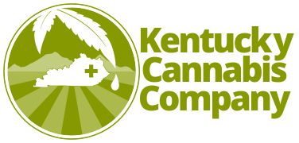

February 9, 2021

To the Esteemed members of the House Standing Committee on Health and Family Services,

Kentucky Cannabis Company requests your support of House Bill 307, which will amend Kentucky law to allow for the research of hemp derived cannabinoid products. While cannabidiol has been found to be the most therapeutic cannabinoid, preliminary research has shown that other cannabinoids found in hemp also have therapeutic value – especially when in the presence of all naturally occurring compounds. The ability to research unhindered is necessary to continue to move the industry forward.

Kentucky Cannabis Company is the legislative leader of the hemp industry in Kentucky and remains vertically integrated while creating full-spectrum hemp extracts and CBD infused products for consumers under the name of Bluegrass Hemp Oil.

Respectfully,

Adriane Polyniak, Executive Director
Sam Cox, Govt Affairs Representative

Kentucky Cannabis Company
230 N Gratz St
Midway, KY 40327

