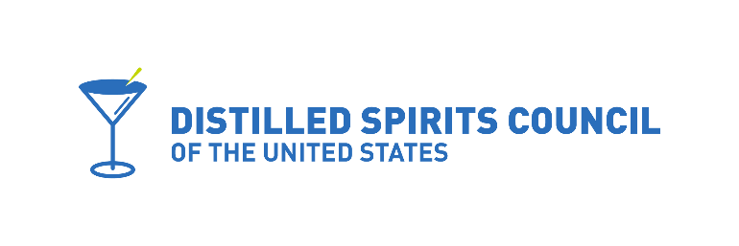

February 9, 2021
Hon. Adam Koenig, Chairman
Kentucky House Committee on Licensing,
Occupations, & Administrative Regulations
Kentucky General Assembly
Kentucky State Capitol
700 Capitol Ave.
Frankfort, KY 40601

Dear Representative Koenig:
These comments are submitted on behalf of the Distilled Spirits Council of the United States, Inc. (DISCUS), a national trade association representing producers and marketers of distilled spirits and importers of wines sold in the United States. We welcome the opportunity to provide our views regarding the proposed revisions to HB415, the direct-to-consumer shipping legislation adopted in 2020.
As you know, we expressed concerns during the rule-making process regarding three issues that were included in the ABC’s promulgation of regulations.
- Requiring an out-of-state direct ship applicant or licensee to have “ownership or possession” of its direct ship licensed premise.

We believe this has been addressed and the changes in the revised bill will now allow the use of third-party logistical fulfillment providers, which is common practice throughout the industry.

- The prohibition by direct ship applicants from having an ownership interest in a retail alcohol business in another state.

It was our position that if this ownership interest were allowed under another state’s laws that should be satisfactory for Kentucky. The revised bill addresses this concern.

- Requiring an out of state distiller to have a minimum 600-gallon production limit.

Similar to #2 above, it was our position that nothing in the adopted statute allowed this discrimination if the applicant met the standards in the legislation. It was an inappropriate attempt to govern extraterritorially and the revised language addresses this concern.
Kentucky House Committee on Licensing,
Occupations, & Administrative Regulations
February 9, 2021
Page two

In closing, we commend you and Committee staff for the continued dedication to improving the legislation and making Kentucky a leader on the issue of direct-to-consumer shipping of beer, wine and spirits. It may be of interest to the Committee that nearly a dozen states -- large and small – are currently considering legislation that would allow the direct to consumer shipping of spirits, which would greatly expand the marketplace reach of Kentucky’s premier bourbon industry.
Thank you for the opportunity to present our views. We urge the Committee’s strong support for the revised legislation.
Sincerely,
Jay M. Hibbard
Vice President Government Relations

cc: Members of the Kentucky House Committee on Licensing,
Occupations, & Administrative Regulations

