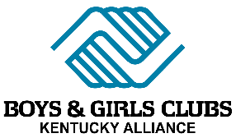

Kentucky’s Kids
Supporting literacy, academic achievement
and workforce development

Background
Boys & Girls Clubs (BGC) have a strong and vibrant presence in the Bluegrass State, serving 25,000 youth. Thirteen BGC organizations currently operate throughout Kentucky, each independently operated yet tied together through the Kentucky Alliance of Boys & Girls Clubs statewide coalition. These organizations operate 30 sites across the following Counties: Harlan, McCracken, Butler, Mason, Jefferson, Fayette, Christian, Barren, Simpson, Mead, Bullitt, Allen, Daviess, Knox, Kenton, Campbell, and Warren. Clubs provide year-round, out-of-school programming for youth ages 6-18. The Clubs’ focus on providing programming during “out-of-school time” helps bridge the gap between school and home and ensures that Kentucky’s youth have access to programs and mentors that will challenge them to achieve in school, develop a strong moral compass and make healthy lifestyle choices. We have Clubs located in public schools, local communities, and across rural, suburban and urban areas. Boys & Girls Clubs are one of the largest providers of afterschool programs in rural Kentucky.

Why Afterschool?
Afterschool program participation is correlated with benchmarks such as increased attendance and engagement in school, higher achievement levels, and graduating with the skills, knowledge and exposure to pursue postsecondary options or careers. Increasing access to high quality afterschool and summer programs for all youth, especially disadvantaged youth, increases their likelihood of success. Municipal leaders have long known that afterschool is a prevention and youth development strategy that complements intervention and law enforcement work in cities. Research shows that afterschool programs can keep children safe, support working parents, reduce negative behaviors that impact public safety, and keep young people on track for a successful adulthood.

Return on Investment
In 2018, Kentucky Boys & Girls Clubs raised over $8 million dollars for youth programming, with less than 5% coming from the Commonwealth. Clubs can utilize their high-profile community presence to acquire additional resources, because for every $1 invested the Club returns $14.56 in economic benefit.

Case Study: Indiana’s Kids Program
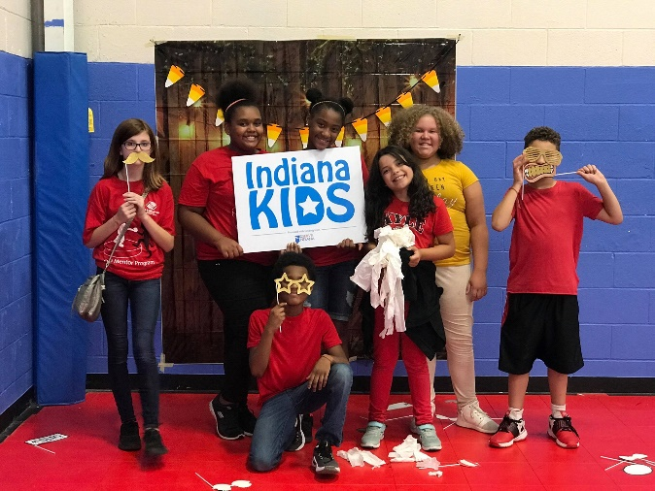
The Indiana Alliance of Boys & Girls Clubs has been operating the Indiana Kids program since January 2006. Through the years they have served a total of 54,433 children and youth. The overall goal of the program was to increase children’s scores on the reading and math fluency sub-tests. Children will make the number of month's improvement in reading and math as compared to the number of months in the program. Children are also learning about college, career, job readiness, workforce skill development, leadership development and volunteerism. Pre-post tests (utilizing the Woodcock-Johnson Tests of Achievement Math and Reading Fluency sub-tests) were administered.
Our actual performance through December 2018:

48% average increase in Reading Fluency Scores
53% average increase in Math Fluency Scores

Why Boys & Girls Clubs
- Our scale, scope and reach enables us to annually impacting 25,000 youth at 30 sites, offering programs weekdays and during the summer
- Existing data and outcomes show our clubs are making a difference, both academically, as well as across a variety of outcome areas
- Clubs provide individualized instruction in a fun, engaging, afterschool setting. Students receive highly focused, attentive instruction, aimed at meeting them at their skill level and pace.
- Staff and mentors at the Club form positive relationships, where coaching ensures the program is offering the highest level of support to Club youth.
- The Clubs ongoing connection to schools and parents enables us to have up-to-date data on student performance, as well as wrap-around style approach to addressing academic and behavioral needs
- Clubs provide additional services such as food/meals, mentoring, exercise, and other targeted programs

Request
Kentucky Boys & Girls Clubs request an investment of $500,000 to expand our proven academic programs, targeting youth in at-need areas throughout the state. A strong, early foundation in literacy is needed to prevent kids from dropping out of high school and sets them on the path toward success in education and future careers. Kentucky’s Kids is a holistic approach: improve academic performance, drive youth workforce readiness and provide safe places that reduce juvenile justice involvement and preventing adult incarceration.

Program Focus Areas:
- Academic Support targeting school year and summer learning through three BGC programs: Power Hour, Project Learn and Brain Gain
- Workforce Development targeting teens through three BGC programs: Career Launch, Money Matters and Jr. Staff.

Club Participation: Expand programs at 20 locations across Kentucky, with focus on school based sites.

Performance Measure Summary:
- At least 1,000 youth will enroll in KY Kids participating in Academic Supports and/or Workforce Development programs
- At least 70% of youth completing at minimum of 30 school year academic supports will increase their reading fluency and/or math fluency scores by at least 15% utilizing the Woodcock- Johnson assessments.
- At least 75% of youth participating in Workforce development programs will increase their knowledge of careers and job readiness skills.

Program Service | # of youth and parents served
Intake and Assessment- Includes basic demographic and educational information and Reading Fluency, Math Fluency, and/or Math Calculation on a minimum of 1,000 youth participants utilizing Woodcock Johnson assessment tools. | 1,000
School Year- Includes Homework help, Education Remediation and Tutoring with a focus on improvement of reading and math skills. Youth will participate in a minimum of 30 30-45-minute sessions. Youth in all age groups will participate utilizing the Power Hour and Project Learn curriculums, in addition to tutoring as needed. | 500
Summer- Includes Summer Educational Enhancement and/or remediation with focus on improvement of reading and math skills. Youth will participate in a minimum of 15 30-45 minute sessions for all age groups utilizing Summer Brain Gain curriculum of compatible program. | 500
Post Test - Upon completion of the school year or the 30 school year homework sessions (which every comes first), youth take a Post Test in Reading Fluency, and/or Math Fluency utilizing the Woodcock Johnson assessment tools. Each youth reported will increase a minimum of 15% improvement in their raw score on one or both subtests (reading and/or math). Available to all youth that complete a minimum of the 30 homework sessions. | 350
Workforce Development Skills through College and Career Exploration - youth participate and complete 10 45-minute career education sessions via the Career Launch curriculum. The focus of the curriculum is on job readiness activities such as exercises in entrepreneurship, interviewing, resume writing, skills for job success, and career exploration. College tours and college prep activities included. Exposure to various post-secondary options including four-year, two-year, and job training programs is included. The financial literacy program, Money Matters, is also offered. These curriculums are offered to youth 13 and older. | 220
Junior Staff – Middle School and High school age youth will complete a minimum of 60 hours of employment or internship at the Club. They will complete the Junior Staff job application, weekly timesheets, training, and at least 60 service hours. Available for all youth ages 13 and older. | 100

