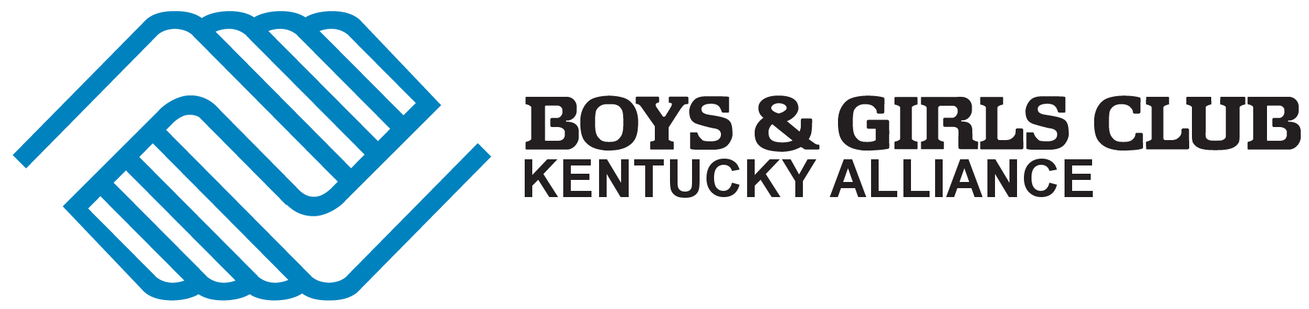
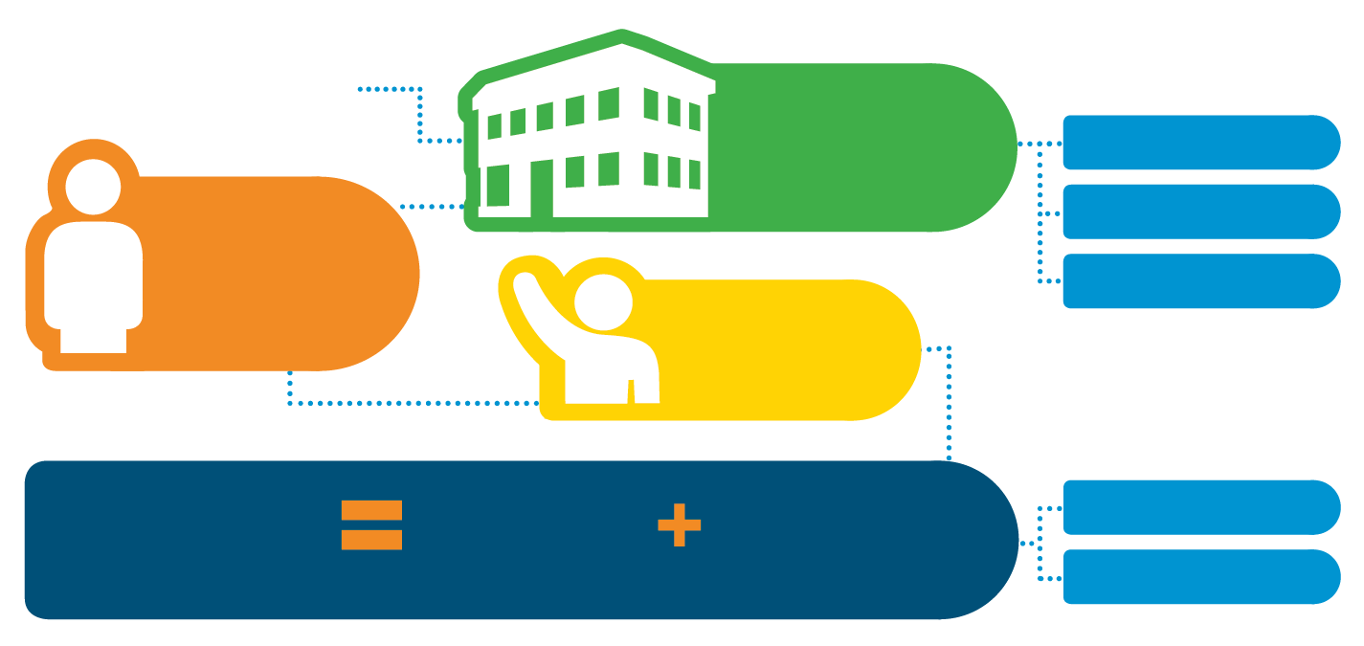
KENTUCKY FACT SHEET
Minority Races or Ethnicities

59%

1%

0%

13%

4%

41%

38%

Caucasian
Hispanic/
Latino
African-American
Multi-racial
Asian-
American
Native American

Member Demographics
.

Female

Male

Ages 12
and Younger

Live in
Single-Parent Households

Qualify for Free or Reduced-Price School Lunch
56%
37%

68%

43%

34%
65%
The Need in Our State
Every day 126,622 kids in Kentucky leave school with nowhere to go¹. They risk being unsupervised, unguided and unsafe.
.

10,270
Youth Served Through Community Outreach
14,146
Registered Members
24,416
Youth Served
2,480
Volunteers
30
Boys & Girls Club Sites in Kentucky
Location of Club Facilities
Annual number of Meals/
Snacks Served at no cost
281,799
277,945
Meals
Snacks
Rural
27%
23%
27%
Urban
Suburban
Rural
267
Adult Staff
Our Reach
.

Our Mission
Our mission is to enable all young people, especially those who need us most, to reach their full potential as productive, caring, responsible citizens.

$8,132,586 Total State Income
15%
From Government Sources
(Federal, State, Local, and Tribal)
2017 Club Operating Income
.

Every dollar invested in the Boys & Girls Clubs returns $9.60 in current and future earnings and cost-savings to their communities.
2019

“Being at the Club has opened my eyes and has driven me to fight and advocate for the rights of children to ensure they live up to their full potential.”
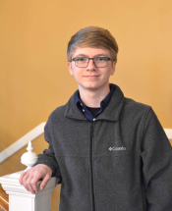

Barbourville
Bowling Green
Clarksville
Covington
Erlanger
Fort Campbell
Fort Knox
Franklin
Glasgow
Harlan
Hopkinsville
Lexington
Louisville
Maysville
Morgantown
Newport
Owensboro
Paducah
Shepherdsville

The Club Experience
Boys & Girls Clubs fill the gap between school and home. We provide welcoming, positive environments in which kids and teens have fun, participate in life-changing programs and experiences, and build supportive relationships with peers and caring adults.
.

John G
Kentucky
Youth of the Year
Club Locations
Multi Club Cities are capitalized, Military Bases are italicized
Teens
(13-19)

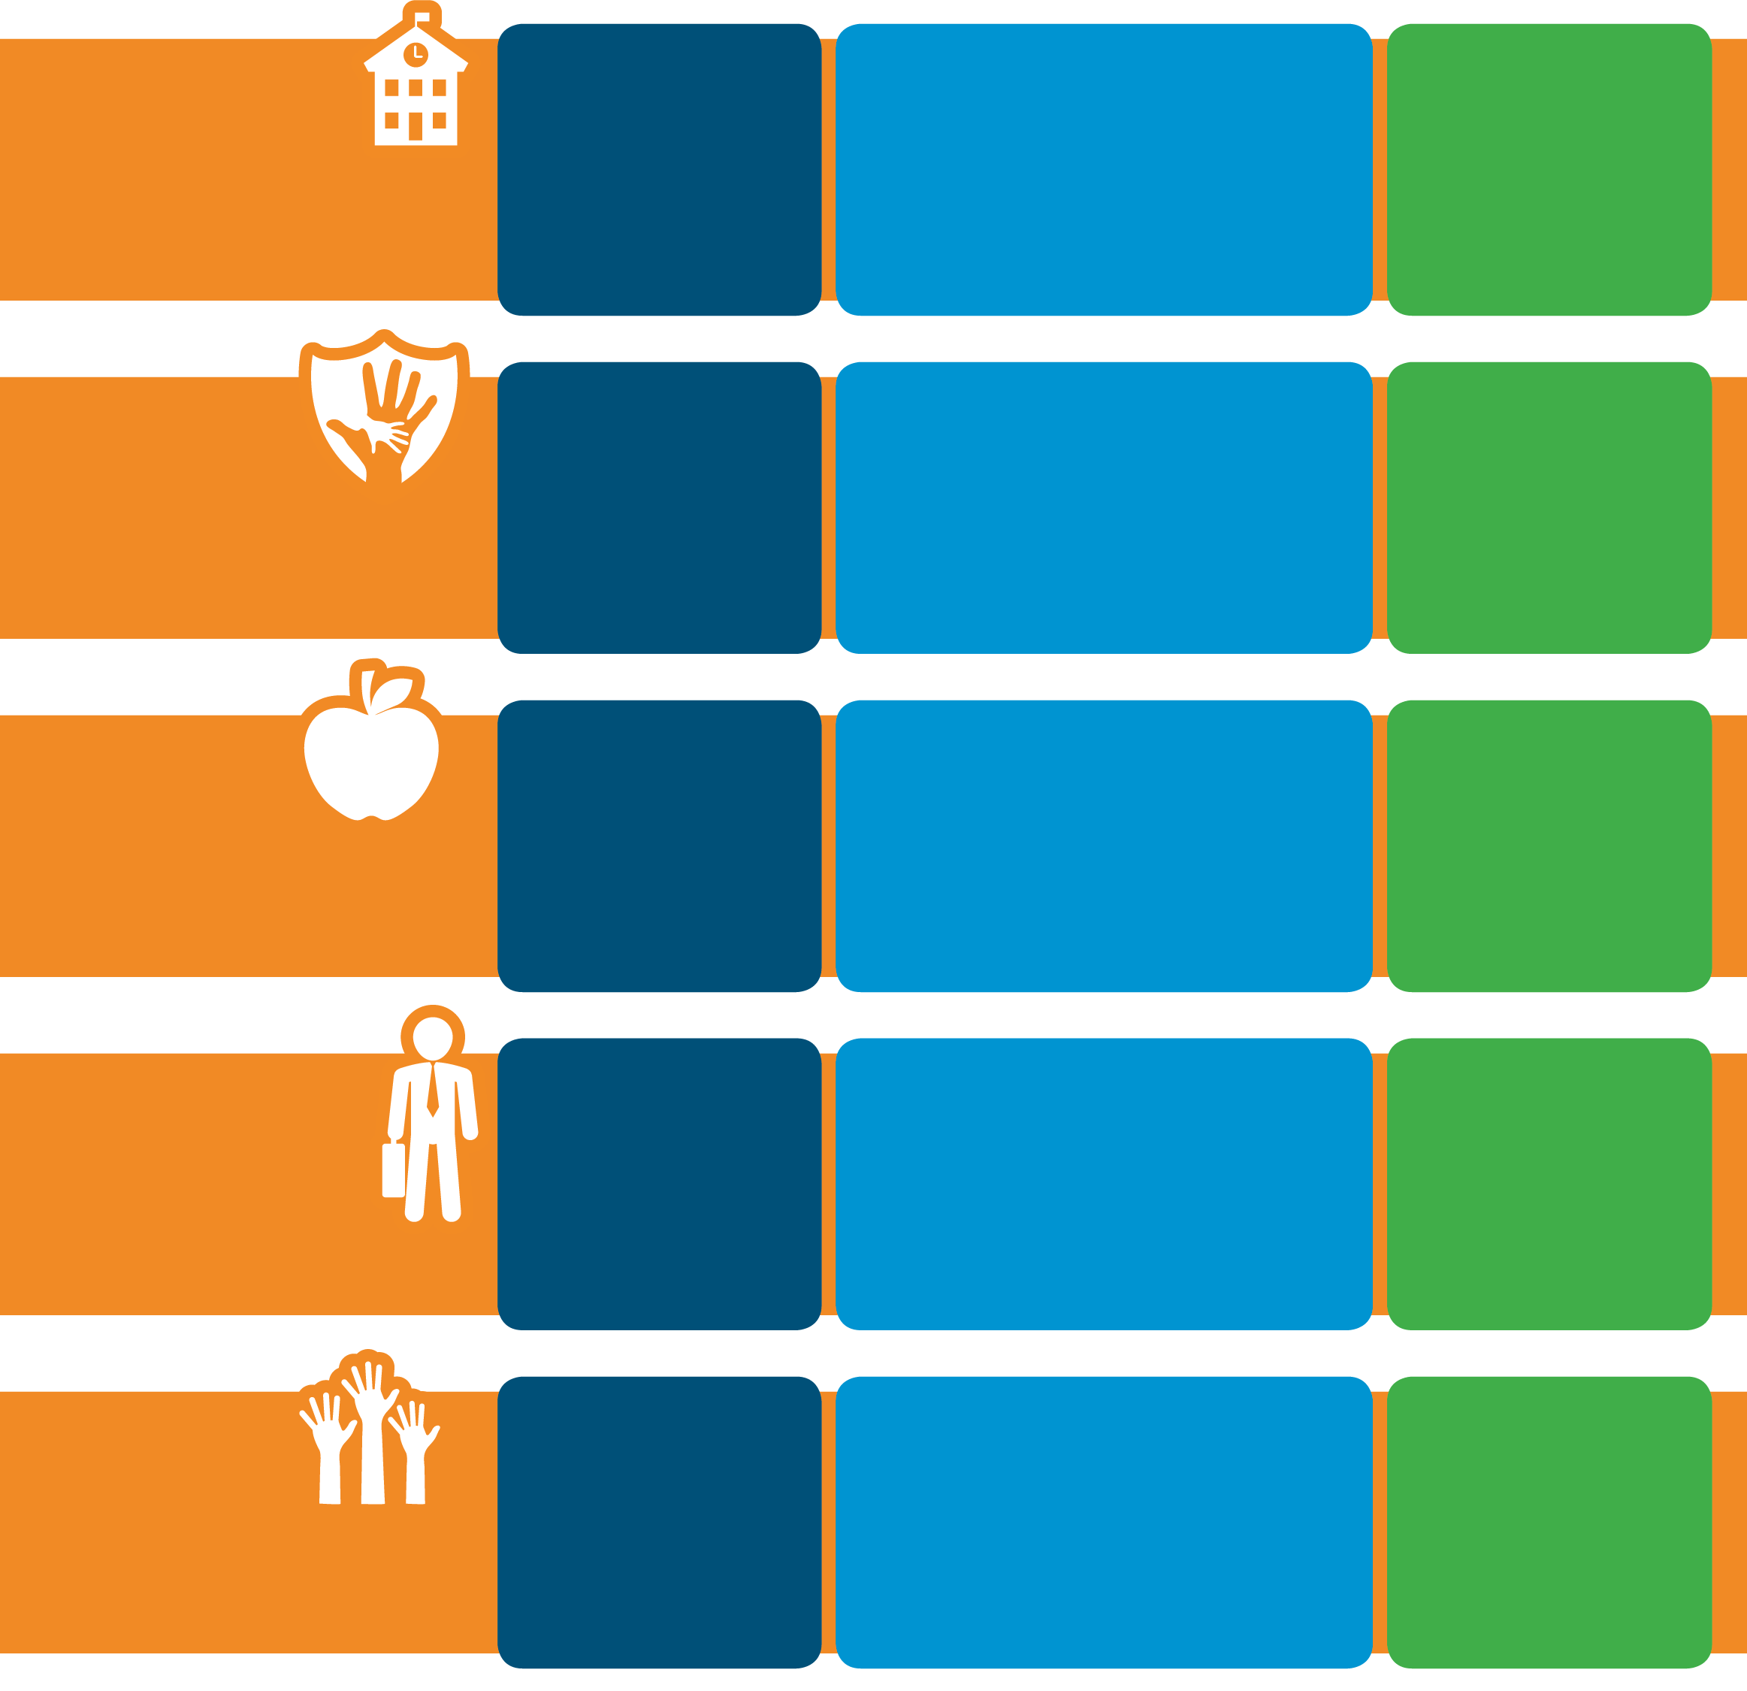
Our Agenda for America’s Youth
At Boys & Girls Clubs of America we believe who you are, where you're from, or the circumstances that surround you shouldn’t determine your access to experiences or opportunities. Our Agenda for America’s Youth focuses on solutions and policies that will have the greatest impact on the youth of this country, and the fight to strengthen them. America’s youth need a voice and with your help, we will close the opportunity gap for all youth in America.
Safer
Childhoods
Every young person has a right to a safe, positive environment in which to learn and grow.

.

Our Impact
Older Club Teens are 41% less likely to get into a physical fight than their peers.​

.

What We Do
Boys & Girls Clubs are committed to supporting communities and local Clubs ensure the safety of all youth especially during out-of-school time when statistics show youth violence escalates in communities between the hours of 3-7 p.m.

.

The Need
Nationally, 49% of youth grades
4–12 reported being bullied at least once during the past month.

.

Our Impact
97% of Club teens expect to graduate on time and 86% expect to attend college.

.

What We Do
Clubs equip youth with the soft and hard skills they need to succeed in the workforce and create access to partnerships for real-life experiences to explore career options.

.

The Need
12% of young people in Kentucky fail to graduate from high school on time.²

.

Our Impact
54% of Club Alumni said the club literally “saved my life”. ​

.

The Need
Nationally, 11.3 million school-age children are home without adult supervision after school.​

.

What We Do
Clubs across the country provide over 4 million young people with a safe place, caring adult mentors, fun and friendship, and high-impact youth development programs on a daily basis during critical non-school hours.​

.

Out-Of-School
Time
Every young person should have access to a high-quality out-of-school time experience.

.

Education, Career
Readiness &
Leadership
Development
Every young person deserves to be well prepared for life and career.

.

Equity &
Inclusion
Every young person has the right to safe, positive and inclusive environments where everyone can reach their full potential.

.

What We Do
Clubs champion opportunities for the unique challenges and circumstances in communities, while respecting and celebrating their strengths and cultures.

.

Our Impact
83% of Club members believe they can make a difference in their community.​

.

The Need
Nationally, nearly 1 in 5 children live in poverty and 50% live in low-income families.

.

Our Impact
Club 12th graders are 26% more likely to abstain from alcohol than their peers nationally.

.

What We Do
Our programs help youth engage in positive behaviors that nurture their well-being. Club members learn how to manage stress, demonstrate good teamwork, eat well, and keep physically fit.

.

The Need
Nationally, 33% of high school students report currently using alcohol and 22% using marijuana in the past 30 days.​

.

Health &
Wellness
Every young person should be equipped to make healthy decisions resulting in positive social, emotional, and physical well-being.

.

©2018 Boys & Girls Clubs of America

For more information, please visit www.bgca.org
(202)507-6670 || advocacy@bgca.org
Matt Watrous || (206) 818-5802 || mwatrous@bgca.org

¹ America After 3PM, Afterschool Alliance, http://afterschoolalliance.org/AA3PM/
² America After 3PM, Afterschool Alliance, http://afterschoolalliance.org/AA3PM/
³ America After 3PM, Afterschool Alliance, http://afterschoolalliance.org/AA3PM/
⁴ America After 3PM, Afterschool Alliance, http://afterschoolalliance.org/AA3PM/

