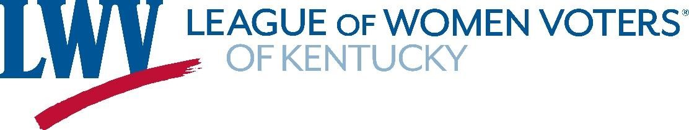

June 15, 2021

Dear Members of the Interim Joint Committee on State Government:

Thank you for this opportunity to share thoughts from the League of Women Voters of Kentucky. We are a nonpartisan organization that promotes the informed and active participation of citizens in government through study and action. Redistricting is a key step in building participatory government and therefore a topic of keen interest for our organization.

As you consider the upcoming redistricting work, the League respectfully asks you to ensure:

- Transparency and opportunities for public input before district boundaries are adopted

- Districts that are:
  - Equal or very close to equal in population
  - Compact and competitive
  - Drawn without preference to parties or incumbent office-holders
  - Free from barriers to effective representation of racial and linguistic minorities

- A redistricting plan that can pass with bipartisan support

As part of our study and advocacy, our League has developed “Possible Maps” using the 2010 Census data, both as a way for us to learn about the challenges and as a way to invite wider public discussion before the 2020 Census is released. That process convinces us that it will be possible to draw simpler, more logical districts. For example, when counties are large enough to be divided, we looked for ways to ensure at least one district that was likely to represent the county seat, and we looked for ways to use major highways as familiar boundaries. We urge the General Assembly to look for similar opportunities to draw maps that will make sense to voters and citizens.

We especially urge opportunities for public input because of Kentucky’s dramatic population shifts over the last decade. The attached “Population Change” map is one of our visuals for understanding both the counties with population declines that may require district changes and the ones with population growth that may require new district lines. With so much of the state facing changes, we recommend a systematic approach to allowing citizens to be heard as the new maps are being developed.

If you have questions, please do not hesitate to contact us at www.lwvky.org, at kentuckylwv@gmail.com, or at 502/875-6481. You can find our “Possible Map” examples of how districts could have been drawn with 2010 data at tinyurl.com/KyFairMaps.

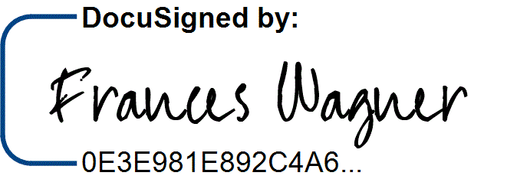
Sincerely,

Fran Wagner
President

Enclosure: County Population Changes Map

