INTERIM JOINT COMMITTEE ON TRANSPORTATION-OCTOBER 20, 2020

Chad LaRue (Kentucky Association of Highway Contractors)
- Presentation on the impact of COVID-19 and the underfunding of transportation has on KAHC members
- We have a transportation funding crisis in Kentucky
  - Impacts of COVID-19
    - There was $74.6 million less state road funding in FY20 than in FY19, $32 million of that is from the drop in motor fuels tax revenue.
    - Through the first quarter of FY21, state road funding is up about $7.8 million compared to the first quarter of FY20, but motor fuels tax revenue is down about $10.8 million.
    - These reduction in revenues hinder KYTC’s ability to deliver the program.
It is important to note that the highway construction account is the balancing account for KYTC; this means that all revenue losses directly impacts their ability to make improvements and repairs to our transportation system.
    - This has a direct impact on KAHC members. We are KYTC’s biggest partner in delivering needed repairs and improvements to our transportation system.
    - The drop in the motor fuels tax I mentioned above also directly impacts county and city governments ability to maintain their transportations systems. That is because 26% of the motor fuels tax revenues goes directly to them for that purpose.
    - The pandemic triggered an incredible slowdown in KYTC’s ability to fund transportation work.
      - Letting numbers 2004-2021 (see chart 1)
      - Historic Asphalt tonnage (see chart 2)
    - While the COVID-19 pandemic has caused a noticeable impact to our industry, it has only exacerbated an already existing transportation funding crisis.
  - Existing Transportation Funding Crisis
    - Motor Fuels Tax dropped in 2015
    - Our historic highs for transportation funding occurred in 2014
    - After the drop in 2015, it took until 2019 to approach previous funding levels last seen in 2014; this does not account for inflation
      - In spite of overall revenues returning to previous highs, motor fuels tax revenues are still $144.5 million less than in 2014. This has a $37.6 million impact to county and city governments. ($313,000/COUNTY)
    - Then, as we have already discussed, COVID-19 hit.
    - FY20 ended with overall state road fund revenues returning to FY16 levels and the motor fuels tax portion returning to FY11 levels.
    - All of this funding information is represented on chart 3.

- I can talk numbers until your eyes glaze over, and I may have already reached that point, but I share these numbers so I can leave you with these facts.
  - KYTC does not have sufficient funding to maintain and improve the current transportation system.
  - What this means for the highway construction industry is that our members will see fewer business opportunities with state, county, and city governments, which puts at risk highway construction companies that employee thousands of Kentuckians in good paying jobs across the Commonwealth.
  - Our industry strongly encourages the administration and legislature to work together to find a solution that will provide the increased funding needed for KYTC and county and city governments to provide a safer, more efficient transportation system for our citizens and for our businesses. These investments will save lives on our roadways and will make our state more attractive to current and future businesses.
  - All of this equates to a better quality of life for the citizens of Kentucky, which I think is we all want
  - And the byproduct of these investments for the highway construction industry is an adequately funded, stable construction program that affords them the opportunity to continue to employee thousands of Kentuckians as they maintain and rebuild our transportation system.

- Mr. Chair, I am happy to answer any questions the committee may have.

- Next, I would like to introduce Lee Lingo, the executive Director for the Kentucky Association of Manufacturers.

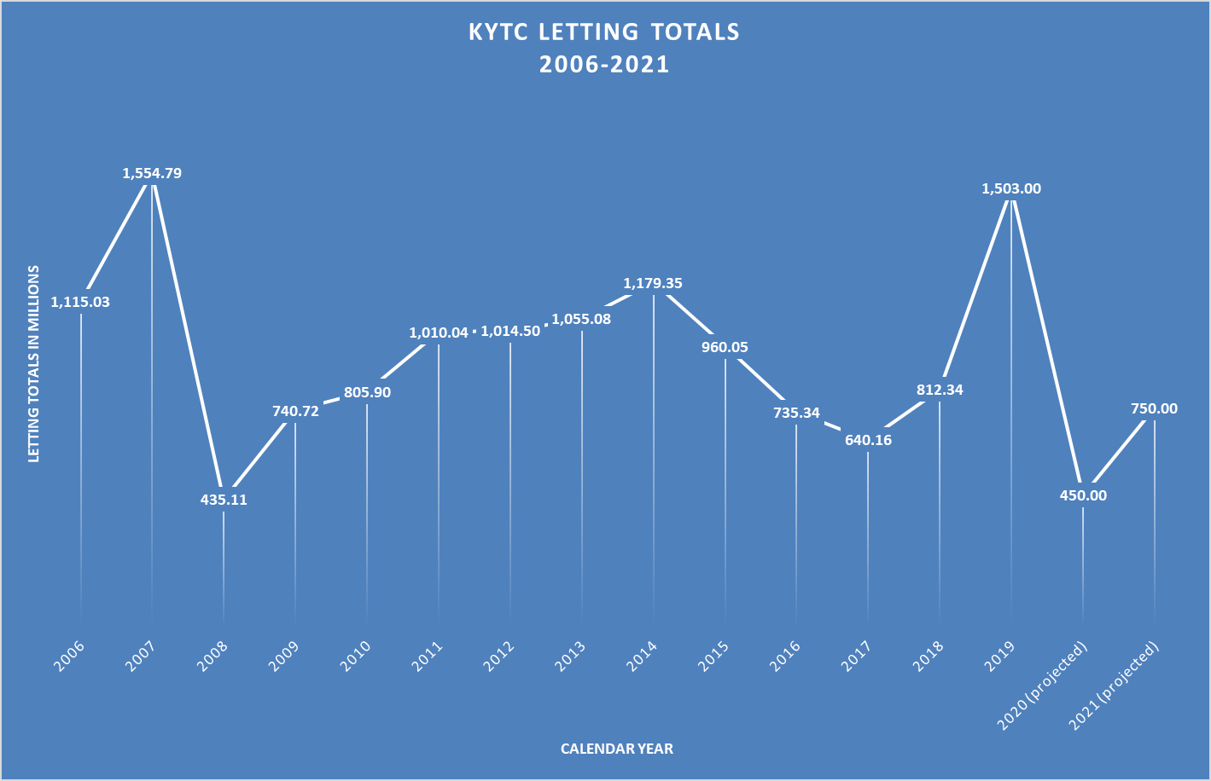

Chart 1

Chart 2
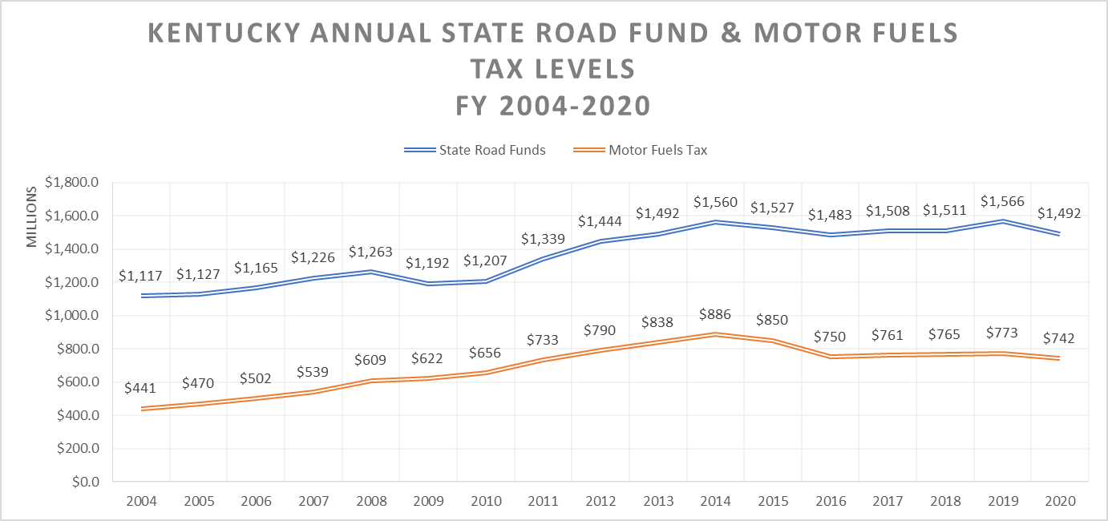

Chart 3

