**Between 2022 and 2023, traffic fatalities increased by 9.27% in Kentucky, resulting in 1,557 fatalities, making Kentucky the 9th  
most traffic-unsafe state in the country!**

**Safe Roads**

40,990 people in the U.S. died in 2023 due to traffic accidents. Local roads see the most speeding, with 87% of all speeding-related traffic fatalities occurring on non-interstate roads. It is proven that a reduction in average speed can reduce the number of road fatalities by 30%, or well over 12,000 lives a year. 14 people died in work zones in KY in 2023, out of which 3 were work zone staff.

Protecting work zones and school zones from speeders is extremely important in Kentucky. These zones are typically marked with signs and/or flashing lights to indicate that drivers must slow down and exercise caution because these zones are areas where workers, pedestrians, bicyclists, and other vulnerable road users are present, making them more susceptible to accidents and injuries from speeding vehicles. To protect our work and school zones from speeders, drivers should obey posted speed limits, pay attention to roadside signs and flashing lights, and be alert for pedestrians and other vulnerable road users. Kentucky can expand efforts to protect these exposed areas by modernizing enforcement techniques and technology while serving as **a Force Multiplier for law enforcement**. Safe Kentucky Coalition: Safe Roads Campaign is dedicated to making our roads, streets, and intersections safe. It is time we use technological advances to protect and keep our students, teachers, parents, workers, officers, and all citizens safe.

Kentucky should use the most advanced and cutting-edge technology available as a new solution for keeping us safe.

Protecting OUR WORKERS

Work Zones are the busiest areas on our roads and can consist of many individuals and equipment working in small, condensed spaces. These zones are especially hazardous for workers, who often work close to fast-moving vehicles. In addition, speeding through a work zone can be deadly for workers, drivers, and passengers in passing vehicles, contributing to 37% of fatal crashes in work zones.

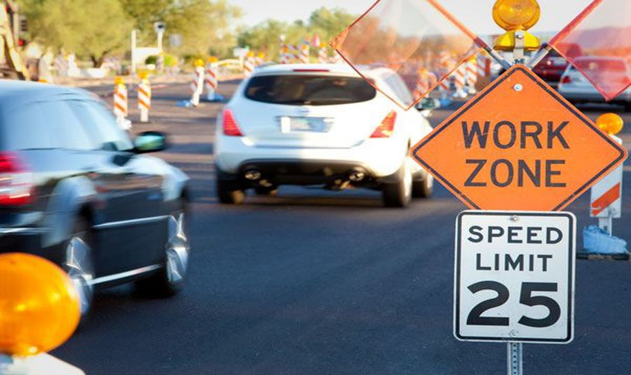

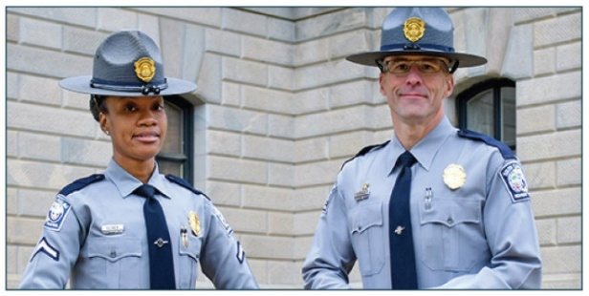

Protecting OUR OFFICERS

Modernizing safety in work and school zones by effectively using proven technology acts as a **Force Multiplier for law enforcement**. With innovation, public safety officers can be deployed more efficiently and effectively. The Safe Kentucky Coalition believes using technological advances for monitoring and enforcing speed and red-light infractions in certain areas allows our peace officers to focus on crime prevention and community engagement. In addition, the use of technology increases officers’ safety by moving officer activities from high-risk, low-yield to low-risk, high-yield interactions. The use of new technology can result in up to 57% reduction in accidents which can save 4.3 hours of an officer’s time – Each Day!

**How technology   
(automated traffic enforcement program)   
can keep Kentucky safe**

* 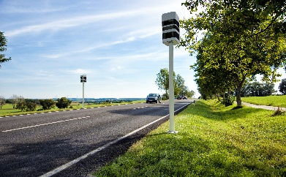**Change driver behavior** which results in Much Safer Traffic!
* Vastly improved safety in **work zones, crosswalks, and work zones**
* Speeding contributes to **37% of fatal crashes** in work zones
* **25,000 children are injured**, annually in the U.S. while walking to school because of speeding.
* Reduction in average speed will **reduce traffic fatalities by up to 30%**
* **Completely unbiased** – A System that only captures actual offending vehicles, ultimately protecting our peace officers and citizens.
* **Force Multiplier for law enforcement** – Allow resources and peace officers to be deployed elsewhere more efficiently
* **Generate new funding** to reinvest in Kentucky communities and programs

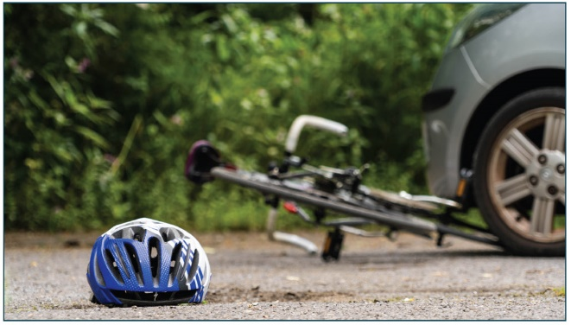**Protecting   
OUR STUDENTS AND TEACHERS**

Kentucky has implemented several measures to ensure safe traffic for students and teachers. The state has increased the presence of school resource officers and crossing guards around school zones to enhance safety. Kentucky has also invested in infrastructure improvements, such as better signage, crosswalks, and traffic signals, to create safer routes to schools. Enforcement of traffic laws in school zones has been heightened, with stricter penalties for speeding and other violations. These efforts collectively aim to provide a safer environment for all school-related traffic.

In Kentucky, pedestrian safety, especially for children walking to school, is a significant concern. On average, over 67,000 child pedestrians are injured annually in the U.S., and a significant number of these injuries occur in school zones due to speeding, distracted driving, and other unsafe behaviors. School zones often lack sufficient safety measures, such as enforced speed limits, proper signage, and marked crosswalks, which contribute to these accidents. Observational studies indicate that unsafe behaviors by both drivers and pedestrians significantly increase the risk of accidents.

TECH SOLUTIONS to keep   
Kentucky safe

* Vastly improved safety in school zones, crosswalks, and **work zones** by helping to change driver behavior to keep overall lower speed
* Reduction in average speed will **reduce road fatalities by up to 30%**
* **Reduction** of up to **30%** of the **3% of KY GDP** spend on traffic accidents each year
* **Completely unbiased** – System only registers actual offenses without focusing on drivers
* **Force Multiplier for law enforcement** – Will allow resources to be deployed elsewhere more efficiently
* **Generate new revenue** for reinvestments in transportation, schools, or city services
* **Generate local jobs & tax revenue** (operational service people, maintenance, administrative, etc.)

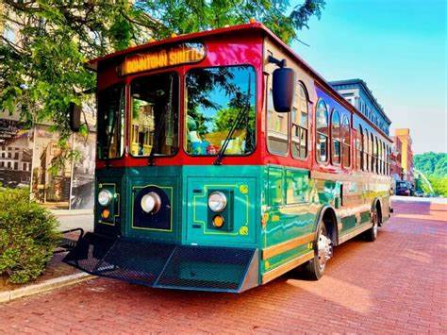

**What’s needed to modernize   
our WORK AND SCHOOL ZONES**

* **Passage of a State ordinance** allowing modernization through automatic traffic monitoring and issuance of citations through advanced technology (e.g., Scanning LiDAR-based System)
* **Allocate funds** generated through innovation for reinvestments in traffic infrastructure, transportation, schools, or city services, etc.

See a sample image of a speeding violation below.

