February 13, 2023

Senator Stephen Meredith, Chair
Representative Kimberley Pooer-Moser, Chair
c/o DeeAnn Wenk
Senate Health Services Committee
House Health Services Committee
Legislative Research Commission
Capitol Annex
Frankfort KY 40601

Re: 908 KAR 1:374. Agency amendment.

Dear Chairs Meredith and Moser:

After discussions with Chairwoman Moser of the issues raised by 908 KAR 1:374, the Department for Behavioral Health, Developmental, and Intellectual Disabilities proposes the attached agency amendment to 908 KAR 1:374.

If you have any questions, please feel free to contact Rachael Ratliff, Regulatory and Legislative Advisor with the Department for Behavioral Health, Developmental, and Intellectual Disabilities at Rachael.Ratliff@ky.gov.

Sincerely,

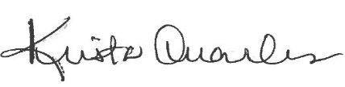

Office of Legislative and Regulatory Affairs

