Audiology Fast Facts
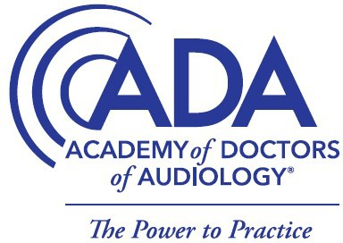

About Audiologists: An audiologist is a highly trained health care professional, licensed to specifically identify, evaluate, diagnose, manage, and treat hearing and balance disorders, and to identify conditions that require a referral to a medical doctor or another specialist. A Doctor of Audiology (Au.D.) degree is required to become a clinical audiologist in the Commonwealth of Kentucky and in all 50 states and U.S. territories. The University of Louisville Medica Center is home to Kentucky’s premiere four-year Au.D program.

Audiologists are trained and licensed to manage many areas of audiologic health care including providing the following services:
- Comprehensive diagnostic audiologic evaluations, including tests of hearing sensitivity, speech understanding, middle ear function, inner ear and auditory nerve function
- Health screenings
- Diagnostic assessments to identify balance/dizziness disorders
- Auditory processing evaluations
- Design, selection and fitting of hearing instruments and assistive listening devices
- Design, selection, installation and monitoring of classroom amplification systems
- Rehabilitation therapy for hearing disorders which might include strategies to improve aided and unaided hearing, speechreading and sign language
- Rehabilitation for auditory processing disorders
- Rehabilitation for vestibular (balance) disorders
- Cerumen (earwax) management
- Evaluation and management of tinnitus (ringing in the ears)
- Patient and family counseling related to diagnosis and treatment
- Development and implementation of hearing conservation programs to prevent hearing loss
- Prevention and monitoring of the ingestion of ototoxic substances
- Research and development of new evaluation techniques and rehabilitation strategies
- Referrals for additional testing and treatment

There are approximately 15,000 practicing audiologists in the United States, including 320 practicing audiologists in the Commonwealth of Kentucky. Audiologists work in a variety of different practice settings, because of their extensive scope of practice, including private practice clinics, hospitals, military clinics, schools, universities and industrial settings. Audiologists help develop professional standards for audiologic health care and are represented on the boards of state and national governmental agencies.

About the Kentucky Academy of Audiology
The Kentucky Academy of Audiology promotes quality hearing and balance care by advancing the profession of Audiology through leadership, advocacy, education, public awareness and support of research. Visit www.kyaudio.org for more information.

About the Academy of Doctors of Audiology:
The Academy of Doctors of Audiology (ADA) is dedicated to the advancement of practitioner excellence, high ethical standards, professional autonomy and sound business practices in the provision of quality audiologic care. For more information, visit www.audiologist.org.

