Supplemental Data for Legislative Testimony

### Joint Interim Licensing, Occupations and Administrative Regulation Committee

June 18, 2025

# National Regulatory Cost Impact

In addition to our local data, national data from the National Association of Home Builders (NAHB) illustrates how regulatory burdens account for nearly one-quarter of the cost of a new home. As shown in the chart below, the 2021 NAHB study found that regulatory costs total $93,870 per home on average, representing 23.8% of the average home price ($394,300 at the time of the study).

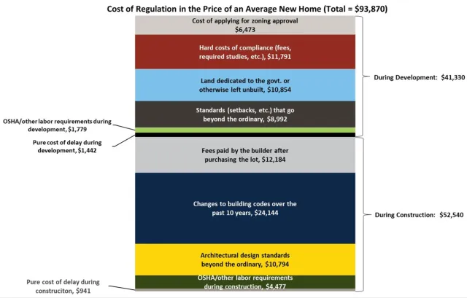

Source: NAHB Special Study for Housing Economics, Government Regulation in the Price of a New Home, Paul Emrath, Ph.D.

# Supplemental Analysis: Impact of Price Increases by Metro Area

The following data illustrates how even modest increases in the cost of a new home—such as $1,000—can price out hundreds or thousands of Kentucky households in various metropolitan areas. This reinforces how regulatory cost increases, even when individually small, have a disproportionate impact on housing affordability across the state.

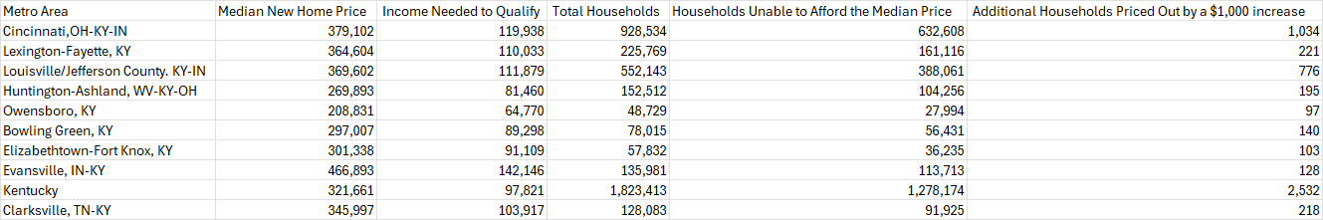

This data shows that in the state of Kentucky, a $1,000 increase in home prices renders approximately 2,532 additional households unable to afford a median-priced new home. In urban areas like Louisville and Cincinnati, hundreds to over a thousand households are priced out by each $1,000 increment. These figures underscore the urgent need to address regulatory burdens and development delays that inflate home prices.

Source: NAHB ‘Priced Out’ Estimates, 2024.

# Regulatory Cost Breakdown

This chart shows the breakdown of regulatory cost components that contribute to the final price of a new home.

Sample Regulations 2009-2024

## Boone County Example

This section provides a detailed breakdown of line-item regulatory cost increases affecting residential development in Boone County. It includes sanitation, water, subdivision, zoning, and building code impacts, reflecting added financial burden since 2009 to present.

# Sanitation District No. 1 (SD1) – Increased Regulatory Costs Since 2015

Estimated cost increases for a typical 40-lot subdivision:

• Increased stormwater retention volume (0.4” to 0.8”): $35,000

• Mandated BMP maintenance agreements: $40,000

• SD1 refusal of basin ownership without enhanced criteria: $25,000

• Expanded detention sizing (0.4 cfs/acre outflow): $30,000

• Developer indemnity (5 years post-turnover): $50,000

• On-site contractor required for warranty inspections: $12,000

• Loss of infrastructure acceptance w/o full parcel separation: $20,000

• Discretionary denial of connection despite payment: $15,000

• Tap fee increase ($3,250 to $3,771): $20,840

• Sewer rate increase ($7.73 to $8.11 per HCF): $15,000

**Total Increased Cost (40-lot development): $262,840**

**Per-lot increase: $6,571**

# Boone County – Subdivision Regulation Increases

• Street ROW width (50' to 60'): $1,500

• Mandatory traffic calming: $1,200

• Flag lot yield reduction (15% to 10%): $2,500

• Compaction testing for driveways/sidewalks: $400

• Mandatory flowable fill for pipe bedding: $1,500

• Fly Ash concrete prohibition: $600

• Increased landscaping standards: $3,500

• Do Not Disturb zone enforcement expansion: $2,000

• Duplicated KPDES buffer rules: $1,000

• Downspout underground control + setbacks: $1,800

**Total Cost per Home (Boone): $16,000**

**Total Development Cost Impact (40 lots): $676,000**

# Northern Kentucky – Building Code Cost Increases Since 2009

• Energy Code (RESCheck): $1,450

• Ground rod re-inspections: $125

• Engineering letters (trusses, bracing): $1,200

• HVAC/Plumbing protection plates: $350

• Garage nailing pattern enforcement: $150

• Permit processing delays (avg. 20 days): $1,750

• Fire-rated assemblies (2-hr requirement): $800

• Plumbing fixture overcounts: $2,500

• Mandatory brick/masonry facades: $5,500

• Stormwater detention above MS4 baseline: $6,200

**Estimated Total Increased Cost per Home (70-foot lot): $20,300**

## Boone/Kenton/Campbell Counties Cumulative Example

This section outlines detailed regulatory cost increases from 2009 to 2024 for Northern Kentucky (Boone, Kenton, and Campbell Counties), including subdivision regulations, zoning requirements, sanitation and stormwater compliance, water district standards, and building code changes.

# 15-Year Cumulative Regulatory Cost Increases (2009–2024)

• EPA Phase II MS4 compliance and SWPPP inspections (2009–2011): $3,500

• Bonded stabilization and phased erosion permits (2010): $2,200

• Mandatory open space minimums and parkland dedications (2012): $4,100

• Design overlay zoning districts in Boone & Kenton (2013): $3,800

• Elimination of by-right zoning options (2014): $2,600

• Water quality volume detention requirements by SD1 (2015): $4,500

• Sidewalk width and poured curb mandates (2016): $1,200

• Fencing, access roads for detention basins (2017): $3,000

• Street tree, median landscaping, and island requirements (2018): $2,750

• Comprehensive plan update – school buffer, slope limits (2019): $3,600

• KPDES buffer enforcement – 25 ft zone (2020): $1,800

• Stormwater BMP ownership and maintenance bonds (2021): $2,400

• Driveway entrance slope standards and permit fees (2022): $950

• Minimum square footage zoning mandates (2023): $4,200

• 2-year post-construction inspections for SD1 basins (2024): $3,600

• Building code: energy upgrades, inspection & truss engineering (2009–2024): $9,500

• Building code: HVAC/plumbing protection, fire-rated walls (2009–2024): $2,800

• Subdivision regs: ROW width (50' to 60') and lot yield cutbacks: $4,000

• Fly ash concrete bans and flowable fill mandates: $2,100

• Tap fee increases and sewer connection fee hikes (SD1): $3,000

• Third-party inspections, indemnity clauses, parcel separation: $3,800

**Estimated Total Cost Increase Per Residential Lot (2009–2024): $69,600**

**Estimated Impact on 40-lot Development: $2,784,000**

# 10-Year Skilled Trades Workforce Projections in Kentucky (2022–2032)

Kentucky’s labor outlook for skilled trades over the next decade shows steady demand with thousands of job openings annually across key occupations. The table below summarizes statewide 10-year projections for select trades – including average annual job openings (due to both growth and replacements) and the total 10-year openings (2023–2032):

|  |  |  |
| --- | --- | --- |
| Occupation | Avg. Annual Openings | Total 10-Year Openings |
| Maintenance & Repair Workers (General) | 1,870 | 18,700 |
| Electricians | 990 | 9,900 |
| Carpenters | 920 | 9,200 |
| Welders, Cutters, Solderers & Brazers | 830 | 8,300 |
| Plumbers, Pipefitters & Steamfitters | 590 | 5,900 |
| HVAC Mechanics & Installers | 530 | 5,300 |
| Heavy Equipment Mechanics (Mobile) | 230 | 2,300 |
| Brickmasons & Blockmasons | 80 | 800 |

As shown above, general maintenance/repair workers lead in demand (~1,870 openings per year statewide), reflecting high replacement needs in that broad category. Electricians and carpenters are next, each projected to have roughly 900–1,000 openings annually in Kentucky. Welders should see about 830 openings per year, while plumbers average around 590. Demand for HVAC (heating, ventilation, A/C) technicians is about 530 openings annually. Smaller in absolute number but still important, mobile heavy equipment mechanics have ~230 openings per year, and brickmasons/blockmasons about 80 per year.

Projected average annual job openings by trade in Kentucky (2022–2032). “Maint. & Repair” refers to general maintenance workers; “HVAC Techs” are heating, air conditioning, and refrigeration mechanics/installers. These figures include openings from both new job growth and the need to replace workers leaving the occupation. The maintenance category has the highest demand, followed by electricians and carpenters. In terms of growth rates, most of these trades are projected to grow modestly in employment. For example, Kentucky electricians are expected to increase from about 10,218 jobs in 2022 to 10,896 by 2032 (approximately +7% growth). Plumbers are projected to grow ~2% (from ~6,640 to 6,800 jobs), and carpenters ~3% (10,690 to 11,000 jobs). Welders may grow around 8% (7,650 up to 8,270 jobs). HVAC mechanics/installers show ~5% growth (5,800 to 6,110 jobs). Some trades like brickmasons are essentially flat (0% growth) – ~940 jobs in both 2022 and 2032 – meaning nearly all openings are due to replacement needs rather than new growth.

**Metro Area Breakdown (Lexington, Louisville, Northern KY)**

Geographically, demand is concentrated in Kentucky’s major metro areas – notably Louisville, Lexington, and Northern Kentucky (the Greater Cincinnati KY counties). The Louisville-Jefferson County region (Kentuckiana Works LWA) is the largest hub for these trades, while Lexington-Fayette (Bluegrass LWA) and Northern Kentucky (Cincinnati KY portion) also contribute a significant share of the workforce:

Louisville Metro: This region accounts for roughly one-third of Kentucky’s skilled-trades employment. For example, the Louisville MSA (including southern Indiana) employs about 3,610 electricians and 2,310 plumbers as of 2023 – by far the most in the state. It also has about 2,930 carpenters, 2,070 welders, 2,260 HVAC mechanics, and 6,490 general maintenance workers in the latest estimates. This existing base suggests Louisville will see the highest number of openings for each trade. Employers in the Louisville area may need to fill on the order of 300+ electrician openings per year and similar high volumes in other trades (carpenters, welders, etc.), given its large share of statewide demand.

Lexington (Bluegrass Region): The Lexington-Fayette metro, while smaller, still sustains strong demand. It currently has around 1,340 electricians and 780 plumbers employed (roughly one-third of Louisville’s count). Lexington’s share of annual openings is accordingly a bit lower – on the order of ~150–200 openings per year for the larger trades like electricians or carpenters. For instance, Lexington has about 1,180 carpenters, 480 welders, 1,090 HVAC techs, and 3,020 maintenance workers employed today. These numbers indicate significant ongoing demand, though not as steep as Louisville’s.

Northern Kentucky (Greater Cincinnati KY portion): The northern Kentucky counties (Covington/Newport area) form another important region. This area’s employment in each trade is comparable to Lexington’s. (For example, the entire Cincinnati MSA employs ~4,350 carpenters and ~3,600 electricians, though only a portion of those are on the Kentucky side.) The Kentucky Center for Statistics projects the Northern KY LWA to be one of the faster-growing regions overall, with about 12% job growth (all occupations) in the coming decade. We can expect robust demand for trades in this region – likely on par with or slightly less than Lexington’s volume.

Bottom line: Across Kentucky, these skilled trades will continue to offer plentiful opportunities. The state is projected to need hundreds of new carpenters, electricians, plumbers, welders, HVAC installers, mechanics, and masons each year to keep up with growth and replacement needs. Over 10 years, Kentucky will have to fill on the order of 5,000–10,000 total openings per occupation in the larger trades (see table above). Louisville/Jefferson County is expected to capture the largest portion of this demand (with roughly 30–35% of openings in many trades), while the Lexington and Northern KY metro areas will also see substantial hiring needs. Overall, the outlook remains positive for these skilled trades. Even in occupations with minimal net growth (e.g. brickmasons), retirements and turnover create a steady stream of job openings. Policymakers and training programs can use these projections to ensure a pipeline of qualified workers – particularly in metro hubs – to meet Kentucky’s construction and maintenance workforce needs over the next decade.

Sources: Kentucky Center for Statistics (KYSTATS) 2022–2032 Occupational Outlook; U.S. Bureau of Labor Statistics Occupational Employment and Wage Statistics (OEWS) for Kentucky and metro areas; O*NET/Projections Central state employment projections. Each cited source provides detailed data on employment levels and projected openings for the occupations and regions discussed.