February 28, 2023

Ms. Katie Carney
Office of Fiscal Statement Review
Legislative Research Commission
Capital Annex, Room 104
Frankfort, KY 40601

RE: House Bill 551 (2023 RS BR 812)
AA Statement Required by KRS 6.350
AA Statement 1 and 2 of 5

Dear Ms. Carney:

House Bill 551 (2023 RS BR 812) proposes to create a new Kentucky Revised Statute Chapter 230 that would, in pertinent part for Kentucky Public Pensions Authority (KPPA), establish a wagering administration fund within the State Treasury. The bill states that amounts deposited in the wagering administration fund in excess of oversight costs and any interest associated to the excess funds would be allocated to the Kentucky permanent pension fund established in KRS 42.205. The bill specifies the funds will be expended at the close of a fiscal year. Any funds not expended at the close of a fiscal year will be carried forward into the next fiscal year. For purposes of this Actuarial Analysis, it is assumed the revenue will continue to be deposited in perpetuity.

KPPA staff members have examined House Bill 551 (2023 RS BR 812). We have determined that the bill will not increase or decrease benefits or the participation in benefits in any of the retirement systems administered by KPPA. House Bill 551 (2023 RS BR 812) could potentially reduce the unfunded actuarial liability of the pension plans administered by KPPA, as passage of the bill would create a new revenue stream for the Kentucky permanent pension fund that could be allocated to the pension plans administered by the KPPA.

In accordance with KRS 6.350(2)(c), KPPA certifies the following:

- The estimated number of individuals potentially affected as of June 30, 2022, are 122,932 active; 162,809 inactive; and 124,341 retired members in the systems operated by the KPPA.

- There is no estimated change in benefit payments.

- The additional revenue generated by House Bill 551 (2023 RS BR 812) could reduce employer costs only if the money were allocated to the systems operated by KPPA.

House Bill 551 (2023 RS BR 812)
AA Statement Required by KRS 6.350
Page 2

- There is no estimated change in administrative expenses.

We have not requested any further actuarial analysis of House Bill 551 (2023 RS BR 812) by the Authority’s independent actuary.

Please let me know if you have any questions regarding our analysis of House Bill 551 (2023 RS BR 812).

Sincerely,
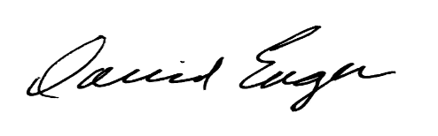
David L. Eager
Executive Director
Kentucky Public Pensions Authority

