Kentucky Department of Insurance
Financial Impact Statement

07 RS HB 410 GA
BR 1634

I. Mandating health insurance coverage of HB 410 GA will not change the administrative expenses of insurers, based upon our experience with health insurance benefits. Most basic health benefit plans currently offer coverage of mammograms as an option, and adding the mandated benefit for mammography should not increase costs.

Mandating health insurance coverage of HB 410 GA will not change premiums, based upon our experience with health insurance benefit. Most basic health benefit plans currently offer coverage of mammograms as an option, and adding the mandated benefit for mammography should not increase premiums.

Mandating health insurance coverage of HB 410 GA will not impact the total cost of health care in the Commonwealth, including any potential cost savings that may be realized, based upon our experience with health insurance benefits. Most basic health benefit plans currently offer coverage of mammograms as an option, and adding the mandated benefit for mammography should not increase total costs.

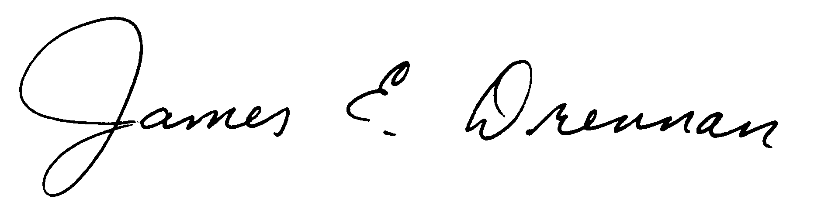

Reden & Anders, Ltd.
James E. Drennan 2170 Satellite Blvd., Suite 150
Fellow, Society of Actuaries Duluth, Georgia 30097
Member, American Academy of Actuaries Phone: (678) 417-4904
Fax: (678) 417-4950
July 31, 2026

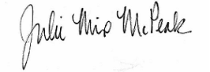
(Signature of Commissioner/Date)

FIS Actuarial Form 6-03

