KENTUCKY JUDICIAL RETIREMENT PLAN
07 RS HB 465/HCS ... ACTUARIAL COST ANALYSIS
BR 1872

I. PROPOSED REVISIONS

KRS 21.580 is amended to modify the “Senior Status Program for Special Judges” as follows:

- Extend the sunset date for this program to any member who retires as a Senior Status Special Judge on or before July 1, 2012

- Modify the eligibility requirements to include the following (in addition to the current requirement of having age plus years of judicial service equal or exceed 75)
- A member under age 60 seeking entry into this program shall have at least 20 years or more of actual judicial service;
- A member who is age 60 or older seeking entry into this program shall have at least 10 years of actual judicial service;
- If the member seeking entry into this program is a retiring District Judge, the member shall not have been defeated at the most recent election for a District Court judgeship;
- If the member seeking entry into this program is a retiring Circuit Judge, the member shall not have been defeated at the most recent election for a Circuit Court judgeship;
- If the member seeking entry into this program is a retiring Judge of the Court of Appeals, the member shall not have been defeated at the most recent election for a Court of Appeals seat;
- If the member seeking entry into this program is a retiring Justice of the Supreme Court, the member shall not have been defeated at the most recent election for a Supreme Court seat; and
- The member shall have been certified by the Judicial Conduct Commission as meeting the qualifications for the program and as being otherwise fit for continued judicial service.

II. COMMENTS RELATIVE TO PROPOSED REVISIONS

This proposal has first raised the issue of what is the underlying cost for the Senior Status Program for Special Judges as it currently exists and then what would be the added cost to that program if this proposed legislation is enacted. The comments in this section have been divided into these two components --- the first part revisiting the cost of the current program and the second part addressing the estimated impact of enacting this proposal.

Estimated Cost of Current Program
This program was originally considered by the 2000 General Assembly. An analysis was originally completed as of October 4, 1999 reflecting the estimated cost of providing the enhanced retirement benefits under the Senior Status Program for eligibility standards of either (i) age plus years of judicial service of 75 or more, or (ii) age plus years of judicial service of 70 or more. The estimated annual cost as summarized in that analysis was $420,000 per year (or 2.0% of plan payroll) for the “Rule of 75” option and $700,000 per year (or 3.3% of plan payroll) for the “Rule of 70” option. These estimates were based on the data and actuarial assumptions as used in the July 1, 1999 valuation to the plan. This cost estimate reflected the best estimate of retirement experience based on the assumptions then in effect. Obviously, the actual number of retirees who ultimately elect to participate in the Senior Status Program will determine the actual cost of that program. To the extent that the actual number of retirees electing to participate in the program is higher or lower than that projected by the valuation assumptions, that will impact the cost and be reflected over time as part of experience gains or losses in future valuations.

The Senior Status Program was enacted with the “Rule of 75” option which had an original cost estimate of $420,000 per year as determined in 1999. Without material gains or losses, this actual amount can be expected to increase over time at roughly the same rate as total plan payroll.

Once this program was implemented, it was reflected in the subsequent valuations of the plan as the retirement experience for Senior Status Judges emerged over the years. For example, the July 1, 2001 valuation was the first funding valuation completed after the implementation of the Senior Status Program. Note that funding valuations are completed in the odd-numbered years and sets the contribution level for the biennium beginning on July 1 of the following year --- so the 2001 funding valuation set the contribution level for the July 1, 2002 through June 30, 2004 biennium. There was no specific adjustment made to the assumed retirement rates used in the valuation to reflect the addition of the Senior Status Program. Rather this added benefit was treated as part of the overall retirement program and was included in the total liability of the plan without any specific segregation of that portion of the liability that was attributable to the Senior Status Program. The interaction of the different benefit features of the plan make it impossible to specifically allocate liability separately for each piece of benefit. There is a definite interaction between the different benefit features of the plan. The Senior Status Program is no exception, as any acceleration of retirements due to that program would be offset in part by the elimination of future benefit accruals for the retiring judge (and as a consequence, the elimination of costs for future service), and the demographic characteristics for the judge ultimately replacing the retiring judge would further impact total plan cost (generally the cost for the replacing judge being lower than for the retiring judge since the replacing judge would tend to be younger).

The actual number of retirees under the Senior Status Program does appear to be higher than that originally anticipated. As such, the ultimate cost for the program will be greater than originally anticipated. How much greater ultimately depends on the actual number of participants in the program. Given that the current program is set to sunset, and combining that with last year’s general election at which time all judges in all courts were up for election, there has been a definite bubble in the number of judges electing to participate in the Senior Status Program over recent months.

It is also important to remember that the plan is funded in total for all benefits being provided, and that the Senior Status Program is part of this overall funding. There has been a significant accumulation of plan assets over the years as this plan has matured, and investment return on plan assets is a significant part of the overall cash flow into the plan. In fact, looking at the past ten years, the amount of cash flow attributable to investment return (actual investment income and realized gains/losses --- does not include unrealized appreciation/depreciation), member contributions and state contributions has averaged as follows:

- Investment Income = 69% of total cash inflow
- State contributions = 23% of total cash inflow
- Member contributions = 8% of total cash inflow

This is significant. The Senior Status Program benefit is not being, and should not be, funded in a vacuum. It is part of the total plan cost and as such, there is significant benefit from the accumulated assets currently in the plan trust. This program is not funded on a “pay-as-you-go” basis where the cash flow out (the actual benefits paid) is matched each year by an equal contribution into the plan. The payments under the Senior Status Program have grown since inception as more judges opted to participate --- as fully expected to be the case, but funding should be determined in a manner so as to spread the cost more evenly over a number of future years.

That being said, the fact of the matter is that the demand for participation in the Senior Status Program has exceeded the original estimate for number of retirees, and as a result, the overall cost for the current program will exceed the original estimate. Isolating as much as possible on the additional benefit provided under the Senior Status Program, we have identified the amount of liability included for these additional benefits in each valuation since this program was enacted (7/1/2001, 7/1/2003 and 7/1/2005). The table below shows the approximate amount of funding attributable to these added benefits after adjustment for how these Senior Status Program retirements have impacted overall valuation results:

Fiscal Year | Valuation Setting Contribution Level | Number of Senior Status Retirements Included | Underlying funding impact for Senior Status retirees included in that valuation
2000/01 | 7/1/1999 | 0 | $ 0
2001/02 | 7/1/1999 | 0 | 0
2002/03 | 7/1/2001 | 2 | 30,000
2003/04 | 7/1/2001 | 2 | 30,000
2004/05 | 7/1/2003 | 13 | 345,000
2005/06 | 7/1/2003 | 13 | 345,000
2006/07 | 7/1/2005 | 26 | 575,000
2007/08 | 7/1/2005 | 26 | 575,000

The cost starts low and builds up as the number of retirees under the program increases. Considering the original cost estimate of 2.0% of plan payroll (initially $420,000 per year), the original cost estimate for this program will be passed by the cumulative actual underlying experience around 2014.

Estimated Cost of Proposed Legislation being Considered
As with the original legislation enacting the Senior Status Program, the ultimate cost will be a direct function of how many judges elect to participate that would not otherwise have been able to participate in this program without this legislation. Looking at the underlying cost for the current program, the cost is approximately $25,000 per year for a single judge. Recognize this is an average, but using this as a guide, it is not unreasonable to assume the cost per year per additional judge participating in this program will be in this same range. Since costs will generally increase as pay is increased, this range could move up slowly over the next few years, but should not be expected to materially change due to salary increase experience between now and the proposed sunset date.

The proposed legislation will definitely limit the number of judges who may be able to participate in the Senior Status Program over just a plain extension of the sunset date without any change in the eligibility standards, but since the current program is about to sunset, there will be a definite increase in the number of retirees under the Senior Status Program if this proposed legislation is enacted. The current average underlying cost per judge per year of $25,000 can be used as a guide. To reflect the change in salary level through the proposed 2012 sunset date, this average should be increased somewhat, so that a range of $25,000 to $30,000 per judge per year could be considered a reasonable estimate for the impact of this proposed legislation.

III. ESTIMATED IMPACT ON FUNDING COSTS

Recognize that the actual cost will be based on the actual number of judges opting to participate in the Senior Status Program as a result of this legislation, as well as the demographic characteristics of these judges. Based on the average cost per year for actual retirees under the current program as adjusted to reflect the 2012 sunset date under this proposal, the expected cost per judge opting into this program would be $25,000 to $30,000 per year. The funding, if 10 judges elect to participate in the Program, is then estimated to be $250,000 to $300,000 per year. As a percent, this represents 0.9% to 1.1% of plan payroll. If 20 judges elect to participate in the Program, the funding would double. This increase in funding would first be reflected in the 2010-2012 biennium based on the timing of additional retirements under the Program as a result of this proposed extension of the sunset provision. Various factors will impact the ultimate funding. It is difficult to predict the number of judges who will elect to participate in the Program, but the sunset date in 2012 may very well trigger another bubble or retirements such as the one experienced in 2006.

It is important to maintain focus on the overall funding required for this plan, and how that changes from one biennium to the next. The Senior Status Program is one part of the overall plan. The overall funding level has remained fairly stable in recent years, even as the retirement experience under the Senior Status Program has been emerging. At this point, actual retirement experience under the Program has been reflected for 26 judges who retired under the Program before the July 1, 2005 valuation and have been reflected in the funding for the 2006-2008 biennium. The ultimate cost of the Senior Status Program will be reflected in the overall plan costs over future funding valuations. The next funding valuation is as of July 1, 2007 which will determine the funding level for the 2010-2012 biennium.

IV. ACTUARIAL CERTIFICATION
Calculations of the estimated cost impact as summarized in Section III have been based on the same data, actuarial assumptions and methods as used in the July 1, 2005 actuarial valuation.

This statement is intended to provide an estimate of the cost impact of proposed revisions noted in Section I, and does not necessarily address the appropriateness of making such revision.
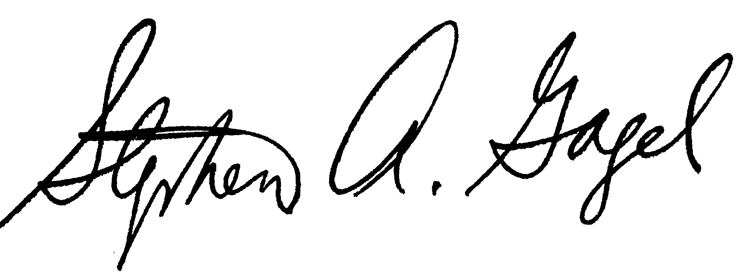

02/27/2006 _
Stephen A. Gagel, F.S.A. Date
Mercer Human Resource Consulting

/tmp/in/input.doc

