March 26, 2010

Mary C. Yaeger
Office of Special Projects
Legislative Research Commission
Capitol Annex, Room 39
Frankfort, KY 40601

RE: 10 RS HB 145 SCS/BR 126

Dear Mary:

House Bill 145 SCS retains the original provisions of the bill and, additionally, amends KRS 15.400 to provide individuals who retired with Peace Officer Professional Standards (POPS) certification on or after July 1, 2008, who are reemployed with a law enforcement agency within 100 days following the effective date of this Act with automatic POPS certification.

Kentucky Retirement Systems’ staff have examined HB 145 SCS and have determined that the bill, as amended, will not increase or decrease benefits or participation in benefits, or change the actuarial liability of the Kentucky Retirement Systems. Consequently, we have not requested any further actuarial analysis of HB 145 SCS by the System’s independent actuary.

Please let me know if you have any questions regarding this communication.

Sincerely,
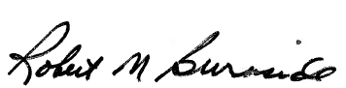
Mike Burnside
Executive Director
Kentucky Retirement Systems

