February 15, 2010

Mary C. Yaeger
Office of Special Projects
Legislative Research Commission
Capitol Annex, Room 39
Frankfort, KY 40601

RE: 10 RS HB 426 GA/BR 29/Rep. Cherry

Dear Mary:

House Bill 426 amends KRS 61.645 to require the Kentucky Retirement Systems Board of Trustees to establish a securities litigation policy.

Kentucky Retirement Systems’ staff have examined HB 426 and have determined that the bill will not increase or decrease benefits or the participation in benefits, or change the actuarial liability of the Kentucky Retirement Systems. Consequently, we have not requested any further actuarial analysis of HB 426 by the System’s independent actuary.

Please let me know if you have any questions regarding this communication.

Sincerely,

Mike Burnside
Executive Director
Kentucky Retirement Systems


TEACHERS’ RETIREMENT SYSTEM
OF KENTUCKY

Robert B. Barnes, JD
Deputy Executive Secretary
Operations and General Counsel
J. Eric Wampler, JD
Deputy Executive Secretary
Finance and Administration

Gary L. Harbin, CPA
Executive Secretary
502/848-8500

SERVING KENTUCKY TEACHERS SINCE 1940

February 19, 2010

Mary C. Yaeger
Office of Special Projects
Legislative Research Commission
Capitol Annex, Room 39
Frankfort, KY 40601

RE: 10 RS HB 426 GA/BR 29/Rep. Cherry

Dear Mary:

House Bill 426 amends KRS 161.250 to require the Kentucky Teachers’ Retirement System Board of Trustees to establish a securities litigation policy.

Kentucky Teachers’ Retirement System’s staff have examined HB 426 and have determined that the bill will not increase or decrease benefits or the participation in benefits, or change the actuarial liability of the Kentucky Teachers’ Retirement System. Consequently, we have not requested any further actuarial analysis of HB 426 by the System’s independent actuary.

Please let me know if you have any questions regarding this communication.

Sincerely,
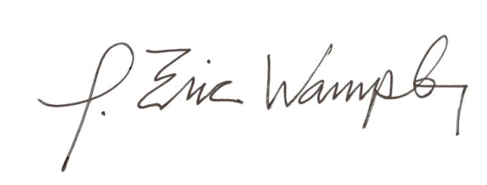

J. Eric Wampler
Deputy Executive Secretary
Finance and Administration

