March 4, 2010

Mary C. Yaeger
Office of Special Projects
Legislative Research Commission
Capitol Annex, Room 39
Frankfort, KY 40601

RE: 10 RS HB 537/BR 392/Rep. Stevens

Dear Mary:

House Bill 537 amends KRS 18A.225 to require that policies provided to state employees or their dependents provide coverage for convergence insufficiency, oculomotor dysfunction pursuit, and strabismus intermittent; create a new section of Subtitle 17A of KRS Chapter 304 to require that all health benefit plans provide coverage for convergence insufficiency, oculomotor dysfunction pursuit, and strabismus intermittent.

Kentucky Retirement Systems’ staff have examined HB 537 and have determined that the bill will create a minor increase in health insurance benefits provided to retirees, but it will not increase or decrease the participation in benefits. The bill will not have any significant impact on the actuarial liability of the Kentucky Retirement Systems. Consequently, we have not requested any further actuarial analysis of HB 537 by the System’s independent actuary.

Please let me know if you have any questions regarding this communication.

Sincerely,
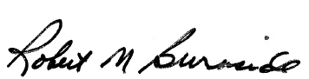
Mike Burnside
Executive Director
Kentucky Retirement Systems


TEACHERS’ RETIREMENT SYSTEM
OF KENTUCKY

Robert B. Barnes, JD
Deputy Executive Secretary
Operations and General Counsel
J. Eric Wampler, JD
Deputy Executive Secretary
Finance and Administration

Gary L. Harbin, CPA
Executive Secretary
502/848-8500

SERVING KENTUCKY TEACHERS SINCE 1940

March 8, 2010

Mary C. Yaeger
Office of Special Projects
Legislative Research Commission
Capitol Annex, Room 39
Frankfort, KY 40601

RE: 10 RS HB 537/BR 392/Rep. Stevens

Dear Mary:

House Bill 537 amends KRS 18A.225 to require that policies provided to state employees or their dependents provide coverage for convergence insufficiency, oculomotor dysfunction pursuit, and strabismus intermittent; create a new section of Subtitle 17A of KRS Chapter 304 to require that all health benefit plans provide coverage for convergence insufficiency, oculomotor dysfunction pursuit, and strabismus intermittent.

The staff members of Kentucky Teachers’ Retirement System have examined HB 537 and have determined that the bill will create a minor increase in health insurance benefits provided to retirees, but it will not increase or decrease the participation in benefits. The bill will not have any significant impact on the actuarial liability of the KTRS. Consequently, we have not requested any further actuarial analysis of HB 537 by the System’s independent actuary.

If you have any questions or concern, please call.

Sincerely,
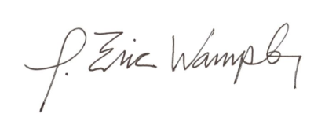

J. Eric Wampler
Deputy Executive Secretary
Finance and Administration

