
TEACHERS’ RETIREMENT SYSTEM
OF KENTUCKY

Robert B. Barnes, JD
Deputy Executive Secretary
Operations and General Counsel
J. Eric Wampler, JD
Deputy Executive Secretary
Finance and Administration

Gary L. Harbin, CPA
Executive Secretary
502/848-8500

SERVING KENTUCKY TEACHERS SINCE 1940

March 26, 2010

Mary C. Yaeger
Office of Special Projects
Legislative Research Commission
Capitol Annex, Room 39
Frankfort, KY 40601

RE: 10 RS HB 545 SCS/BR 1933

Dear Mary:

Kentucky Teachers’ Retirement System’s staff have examined HB 545 SCS and determined that the amendments to the bill will not increase or decrease benefits or the participation in benefits, or change the actuarial liability of the Kentucky Teachers’ Retirement System. Consequently, we have not requested any further actuarial analysis of HB 545 SCS by the System’s independent actuary.

Please let me know if you have any questions regarding this communication.

Sincerely,
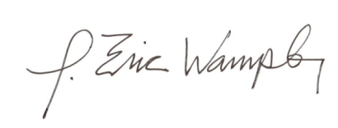

J. Eric Wampler
Deputy Executive Secretary
Finance and Administration

