January 18, 2011

Mary C. Yaeger
Office of Special Projects
Legislative Research Commission
Capitol Annex, Room 39
Frankfort, KY 40601

RE: 11 RS HB 151

Dear Mary:

House Bill 151 creates new sections of KRS Chapter 61 to define terms and to require the Kentucky Retirement Systems Board (KRS) to identify those companies with which it has direct holdings that are doing business in the Sudan, and to compile a list of those companies. The bill requires the KRS to send written notice to the companies on the list that they may become subject of divestment and outline the steps available to the companies to be removed from the list. KRS is required to file a written report with the United States Attorney General detailing the requirements of this Act, and to the Governor, the Legislative Research Commission, and the other Kentucky public retirement funds with information regarding their actions relating to the listed companies. The bill clarifies that the KRS has no obligation to take action under this Act under certain circumstances. KRS is authorized to take any action necessary to comply with the requirements of the bill notwithstanding any other provisions of law. It indemnifies board members, and officers, agents, and employees of KRS for their good faith actions under the bill. It requires the Commonwealth to reimburse KRS for its net losses as a result of compliance with the bill.

KRS staff members have examined this bill and have determined that the bill will not increase or decrease benefits, or increase or decrease participation in benefits of any of the pension plans administered by KRS. Furthermore, HB 151 will not measurably change the actuarial liability of the Kentucky Retirement Systems. Consequently, we have not requested any further actuarial analysis of HB 151 by the System’s independent actuary.

Please let me know if you have any questions regarding this communication.

Sincerely,
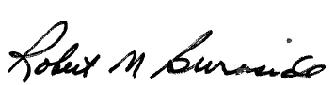
Mike Burnside
Executive Director
Kentucky Retirement Systems

Kentucky Judicial Form Retirement System

JUDICIAL RETIREMENT PLAN
LEGISLATORS RETIREMENT PLAN

Donna S. Early Whitaker Bank Building, Suite 302
Executive Director 305 Ann Street
Frankfort, Kentucky 40601

Phone (502) 564-5310
Fax (502 564-2560
E Mail DonnaS.Early@ky.gov

M E M O R A N D U M

To: Mary C. Yaeger, Office of Special Projects
From: Donna S. Early, Executive Director
RE: 2011 HB 151/BR 108
Date: January 26, 2011

2011 HB 151 is a proposal to require the divestiture of investments in companies doing business in Sudan by the Kentucky Legislators Retirement Plan and the Kentucky Judicial Retirement Plan.

Those members of the Board of Trustees of the Kentucky Judicial Form Retirement System appointed by the President of the Senate, the Speaker of the House and the Governor are the members of the Investment Committee for the Legislators Retirement Fund, and those members appointed by the Chief Justice of the Supreme Court and the Governor are the members of the Investment Committee for the Judicial Retirement Fund. By KRS 21.550 and 21.560, the Committees have the sole authority to make investment transactions for their respective Funds. The statutes further establish the duties of the Committees. Those statutes, together with Investment Guidelines adopted by the respective Committees, and the authorized investments found in KRS Chapter 386 provide the mandates, direction and policy for investing the assets of the Funds. KRS 21.450 provides for fiduciary responsibility by the Board of Trustees and investment advisors.

The Funds’ Operating Statements, Master Lists of Investments, Portfolio Appraisals, Actuarial Valuations, and Audits are filed annually with the Legislative Research Commission. Copies of the Minutes, which include investment reports and performance data, are filed quarterly with the Department of Archives. These filings provide full disclosure and complete transparency of the Funds, and are permanent and retrievable records.

The Judicial Form Retirement System first considered the subject matter of HB 151 in 2006. At its Board meeting of December 8, 2006, the following Resolution was unanimously adopted:

RESOLVED, That the Board of Trustees of the Kentucky Judicial Form Retirement System is aware of the horrendous situation occurring in the Darfur region of the Republic of Sudan, and desires to voluntarily avoid investment in any company doing business in Sudan. The financial advisors to the Investment Committee of the Kentucky Judicial Retirement Fund, consisting of those members of the Board who are judicial and gubernatorial appointees to the Board, and the Investment Committee of the Kentucky Legislators Retirement Fund, consisting of those members of the Board who are the legislative and gubernatorial appointees to the Board, have informed the Board preliminarily that, based on the best-available information, none of the companies in which the Judicial Retirement Fund and Legislators Retirement Fund are currently invested conduct business in the Sudan. The Board resolves to avoid any future investment in companies doing business in Sudan and has so instructed the Funds’ financial advisors, pending a further directive of the Board upon a change of circumstances in Sudan.

The financial advisors/managers of the Legislators Retirement Fund and the Judicial Retirement Fund advise that both funds currently satisfy the directives of the 2006 Resolution. For this reason, and for the reporting practices previously identified, I have formed the opinion that HB 151 will have no impact on the Legislators Retirement Plan or the Judicial Retirement Plan. Consequently, I have not requested any further actuarial analysis by the System’s independent actuary.

Please let me know if you have any questions regarding this communication.



Robert B. Barnes, JD
Deputy Executive Secretary
Operations and General Counsel
J. Eric Wampler, JD
Deputy Executive Secretary
Finance and Administration
TEACHERS’ RETIREMENT SYSTEM
OF KENTUCKY

Gary L. Harbin, CPA
Executive Secretary
502/848-8500

SERVING KENTUCKY TEACHERS SINCE 1940

January 27, 2011

Mary C. Yaeger
Office of Special Projects
Legislative Research Commission
Capitol Annex, Room 39
Frankfort, KY 40601

RE: 11 RS HB 151

Dear Mary:

HB 151, an Act relating to divestiture of investments in companies doing business in Sudan and declaring an emergency, creates eight (8) new sections of KRS Chapters 61. These new sections would, in part, require Kentucky Teachers’ Retirement System (KTRS) to monitor companies in which it has direct holdings to determine whether they meet certain parameters of being a “scrutinized company” doing business in the Democratic Republic of Sudan, notify any companies meeting these parameters of the intent of KTRS to divest in its direct holdings in the companies if they do not take certain corrective actions, and to divest in any companies that do not take appropriate corrective action. Section 8 of HB 151 provides that the Commonwealth shall reimburse each board of a public fund for its net losses, costs, and expenses (offset by any gains) incurred as a result of compliance with this Act. The Secretary of the Finance and Administration Cabinet, in consultation with each board of a public fund, would annually establish a uniform method for the determination of gains and losses.

KTRS staff members have examined HB 151 and determined that the bill request: (1) would not increase or decrease benefits or participation in benefits; (2) would require significant efforts in the identification and continual monitoring of companies that meet the parameters of a “scrutinized company” and thus would require increased administrative costs; and (3) with the required divesture of direct holdings in any companies currently meeting the parameters of a scrutinized company, including those companies that do not at present but that later meet those parameters, and also including those scrutinized companies in which KTRS does not currently have direct holdings, but would otherwise invest in at a later date but for HB 151, there could be not only investment losses, but also lost investment opportunities. Given the financial impact described in the preceding points (2) and (3), the method for reimbursement to KTRS for all losses must ensure full and complete reimbursement, the costs of which are presently undeterminable, in order for this bill to have no significant financial impact on the retirement system. If full reimbursement is provided, this bill would not otherwise have a significant financial impact on the retirement system. In consideration of the foregoing analysis, KTRS has not requested any further actuarial analysis of HB 151 by the retirement system’s independent actuary.

Please let me know if you have any questions or concerns about this matter.

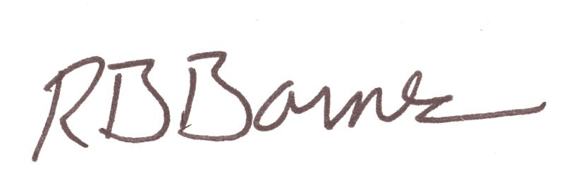
Sincerely,

Robert B. Barnes
Deputy Executive Secretary of Operations and
General Counsel

