February 9, 2011

Mary C. Yaeger
Office of Special Projects
Legislative Research Commission
Capitol Annex, Room 39
Frankfort, KY 40601

RE: 11 RS HB 360

Dear Mary:

House Bill 360 proposes to create a new section of the Constitution of Kentucky allowing the legislative body of a county to abolish the office of constable and proposes to amend Section 99 of the Constitution of Kentucky to conform.

KRS staff members have examined this bill and have determined that the bill will not increase or decrease benefits, or increase or decrease participation in benefits of any of the pension plans administered by KRS. Furthermore, HB 360 will not change the actuarial liability of the Kentucky Retirement Systems. Consequently, we have not requested any further actuarial analysis of HB 360 by the System’s independent actuary.

Please let me know if you have any questions regarding this communication.

Sincerely,
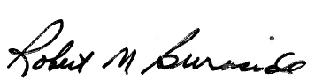
Mike Burnside
Executive Director
Kentucky Retirement Systems

