February 24, 2011

Mary C. Yaeger
Office of Special Projects
Legislative Research Commission
Capitol Annex, Room 39
Frankfort, KY 40601

RE: 11 RS HB 480 GA

Dear Mary:

House Bill 480 GA amends Kentucky Revised Statutes section 61.645 to require that Kentucky Retirement Systems (KRS) financial information to be posted on the KRS or State website; and prohibiting the use of KRS assets to pay placement agents used in KRS investments.

Kentucky Retirement Systems’ staff members have examined HB 480 GA and have determined that the bill will not increase or decrease benefits or the participation in benefits in any of the retirement systems administered by KRS. Furthermore, HB 480 GA will not change the actuarial liability of any of the retirement systems administered by KRS. Consequently, we have not requested any further actuarial analysis of HB 480 GA by the System’s independent actuary.

Please let me know if you have any questions regarding this communication.

Sincerely,

Mike Burnside
Executive Director
Kentucky Retirement Systems

Kentucky Judicial Form Retirement System

JUDICIAL RETIREMENT PLAN
LEGISLATORS RETIREMENT PLAN

Donna S. Early Whitaker Bank Building, Suite 302
Executive Director 305 Ann Street
Frankfort, Kentucky 40601

Phone (502) 564-5310
Fax (502 564-2560
E Mail DonnaS.Early@ky.gov

M E M O R A N D U M

To: Mary C. Yaeger, Office of Special Projects
From: Donna S. Early, Executive Director
RE: 2011 RS HB 480 GA
Date: February 24, 2011

2011 RS HB 480 GA provides that (1) members of the Board of Trustees of the Judicial Form Retirement System, who are not subject to legislative or judicial branch code of ethics, will submit to the executive branch code of ethics, (2) assets of the Judicial Form Retirement System cannot be used to pay placement agents, and (3) the Judicial Form Retirement System shall make system expenditures and employee salaries available on a Web site.

Inasmuch as these proposals do not have any impact on retirement benefits in either the Judicial Retirement Plan or the Legislators Retirement Plan, and that any administrative costs to implement the proposals will most likely be negligible, I have not requested any further actuarial analysis by the System’s independent actuary.

Please let me know if you have any questions regarding this communication.



Robert B. Barnes, JD
Deputy Executive Secretary
Operations and General Counsel
J. Eric Wampler, JD
Deputy Executive Secretary
Finance and Administration
TEACHERS’ RETIREMENT SYSTEM
OF KENTUCKY

Gary L. Harbin, CPA
Executive Secretary
502/848-8500

SERVING KENTUCKY TEACHERS SINCE 1940

February 24, 2011

Mary C. Yaeger
Office of Special Projects
Legislative Research Commission
Capitol Annex, Room 39
Frankfort, KY 40601

RE: 11 RS HB 480 GA

Dear Mary:

House Bill 480, an Act relating to retirement, in part, amends KRS 11A.010 to statutorily place the board of trustees of Kentucky Teachers’ Retirement System (KTRS) under the provisions of the Executive Branch Code of Ethics, amends KRS 161.250 to require KTRS to establish and maintain a searchable database on agency expenditures and employee salaries, and amends KRS 161.430 to statutorily prohibit the use of placement agents.

KTRS staff members have examined House Bill 480 and determined that the bill request will not increase or decrease benefits, or increase or decrease participation of benefits. Nor will it increase administrative costs so much as to impact the actuarial liability of KTRS. Accordingly, KTRS has not requested any further actuarial analysis of this bill by the Retirement System’s independent actuary.

Please let me know if you have any questions.

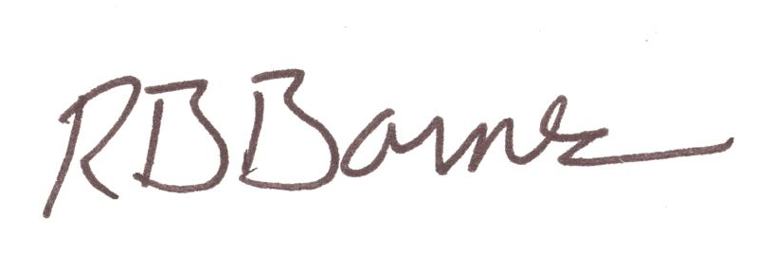
Sincerely,

Robert B. Barnes
Deputy Executive Secretary of Operations and
General Counsel

cc. Katie Carney

