January 18, 2011

Mary C. Yaeger
Office of Special Projects
Legislative Research Commission
Capitol Annex, Room 39
Frankfort, KY 40601

RE: 11 RS SB 3 GA

Dear Mary:

Senate Bill 3 GA establishes new sections of KRS Chapter 160 to authorize the creation of charter county schools and specifies that classified school employees shall participate in the County Employees Retirement System administered by Kentucky Retirement Systems.

Kentucky Retirement Systems’ staff members have examined this bill and have determined that the bill will not increase or decrease benefits in CERS. The bill may increase participation in benefits, if charter county schools are created and new employees begin participating in CERS as a result of the passage of SB 3 GA; however, the bill will not change the actuarial liability of the Kentucky Retirement Systems, since the employee and employer contributions, along with investment earnings, will pay for expenses and the normal cost of benefits. Consequently, we have not requested any further actuarial analysis of SB 3 GA by the System’s independent actuary.

Please let me know if you have any questions regarding this communication.

Sincerely,
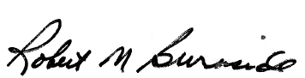
Mike Burnside
Executive Director
Kentucky Retirement Systems


Robert B. Barnes, JD
Deputy Executive Secretary
Operations and General Counsel
J. Eric Wampler, JD
Deputy Executive Secretary
Finance and Administration
TEACHERS’ RETIREMENT SYSTEM
OF KENTUCKY

Gary L. Harbin, CPA
Executive Secretary
502/848-8500

SERVING KENTUCKY TEACHERS SINCE 1940

January 6, 2011

Mary C. Yaeger
Office of Special Projects
Legislative Research Commission
Capitol Annex, Room 39
Frankfort, KY 40601

RE: 11 RS SB 3 GA/BR 440

Dear Mary:

SB 3, an Act relating to schools, amends and creates new sections of KRS Chapters 156, 159, 160 and 161 for the establishment of charter schools. Section 6, subsection (1) of SB 3 provides that, “Teachers and employees in a charter school shall participate in the Kentucky Teachers' Retirement System and the Kentucky Employees Retirement System.”

KTRS staff members have examined SB 3 and determined that the bill request: (1) will not increase or decrease benefits; and (2) requires contributions be made to KTRS only from “Teachers and other certified personnel”, when elsewhere in the district KTRS would receive contributions from any position requiring either certification or a four-year degree (KRS 161.220(4)) and from substitute or part-time positions in which teaching services are provided that are the same or similar to teaching services that are provided by certified, full-time teachers (KRS 161.612). Consequently, SB 3 could have some adverse impact on the plan. However, staff believes that the overall impact of this legislation on the retirement system would not be significant. As such, KTRS has not requested any further actuarial analysis of SB 3 by the Retirement System’s independent actuary.

Please let me know if you have any questions or concerns about this matter.

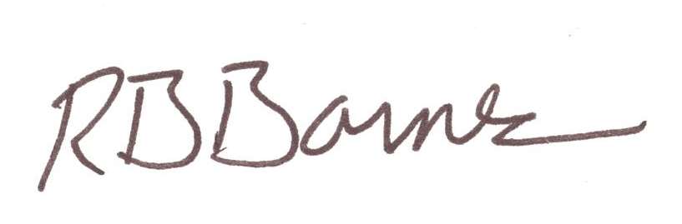
Sincerely,

Robert B. Barnes
Deputy Executive Secretary of Operations and General Counsel

