MEMORANDUM REPORT
TO: | Donna S. Early
FROM: | BPS&M, LLC
DATE: | January 27, 2012
RE: | Actuarial Analysis of Proposed Legislation BR 149 (SB 26)

BPS&M, LLC was asked to prepare an actuarial analysis in compliance with KRS 6.350 with regard to the recent proposed legislation (“BR 149 (SB 26)”) that makes changes to the Kentucky Legislators Retirement Plan (“KLRP”).
It is our understanding that, effective December 31, 2014, BR 149 (SB 26) makes the following changes to KLRP:
- Limits reciprocity for non-legislative salary to those individuals of KLRP who have service in another state-administered system prior to the effective date of the Act.
Comments
Limiting reciprocity for non-Legislature salary:
- Shall limit the ability of active and terminated vested members to use non-legislative pay for purposes of calculating their benefit in KLRP to those members that have service in another state administered system prior to the effective date of the Act.
- Shall not impact active or terminated vested members who have service in another state administered system prior to the effective date.
- Of the current 124 active members considered in the July 1, 2011 Actuarial Valuation, 42 (34%) have prior non-legislative service and so will not be impacted by this change. The current valuation assumes a 40% increase (loading factor) to be applied to active and terminated vested liability and normal cost to estimate the additional liability which is likely to occur based on members with non-legislative service using pay from those non-legislative periods towards their final salary when calculating their KLRP pension benefit. Although only 34% of current members are eligible for this provision, it is likely that much of the additional liability (as estimated by use of the 40% loading factor) is due to this group that already has non-legislative service. As a result, the loading factor should be reduced but only to the extent current members that do not already have prior non-legislative service would have earned future non-legislative pay. Though it is uncertain how much impact this change will have, we believe a reduction in the loading factor from 40% to 30% would reasonably estimate the impact of such change. The actual impact on future liability may be more or less, based on the actual future experience.
Actuarially Sound
KRS 6.350 requires us to comment on whether the proposed changes would make KLRP actuarially unsound or, if already actuarially unsound, if such changes would make KLRP “more unsound”.
We would suggest, a plan that has adopted a reasonable funding method, that adopts reasonable assumptions and which contributes at a rate at or above the recommended contribution rate (based on these reasonable methods and assumptions) could be considered to be actuarially sound. Whether or not the changes reflected in this study are or are not adopted, will not necessarily impact the “actuarial soundness” of KLRP.
In order to ensure KLRP is funded in an “actuarially sound manner”, we would recommend:
- Reflect a 1.5% future COLA assumption when calculating the funding requirement for KLRP (only a minimal COLA, as described in the July 1, 2011 valuation report, is currently assumed),
- Revise the actuarial funding method to amortize all past unfunded as well as new liabilities over a period not more than 30 years (in accordance with Governmental Account Standards 25 and 27) and amortize future gains and losses over a period not more than 15 years.
- Contribute at least the minimum recommended contribution each year.
Deviations from these recommendations will result in an “actuarially unsound” approach to funding KLRP and may eventually result in KLRP becoming insolvent – that is, exhausting assets at which time all future benefits would be made on a pay as you go basis.
Although the Actuarial Standards of Practice 4 “Measuring Pension Obligations” allows for plan liabilities to be calculated under a legally prescribed method, the statement goes on to say,
“If, in the actuary’s professional judgment, such an actuarial cost method or amortization method is significantly inconsistent with the plan accumulating adequate assets to make benefit payments when due, assuming that all actuarial assumptions will be realized and that the plan sponsor or other contributing entity will make contributions when due, the actuary should disclose this.”
It is our professional actuarial opinion that the current legally prescribed method which requires contributions of normal cost plus interest on the unfunded liability plus 1% of or the unfunded liability (per KRS 21.525) and which (per KRS 21.405) does not recognize cost of living increases effective after the most recent valuation, is inconsistent with the plan accumulating adequate assets to make benefit payments when due, assuming all actuarial assumptions are realized.
Assumptions
Future results will vary from projections to the extent future experience varies from the assumptions used in the projections. The longer the period of the forecast, the more variation is likely to occur and the less likely future results will match projections.
- Data for projections is as of July 1, 2011.
- Assets for projections are as of June 30, 2011.
- A valuation will be performed July 1 of each odd numbered year (2011, 2013, etc). The dollar amount of recommended contribution will be contributed each year for two plan years beginning one year after the valuation date.
- Except as mentioned herein, all assumptions are consistent with the assumptions and methods used for the July 1, 2011 valuation report
- Although future valuation assumptions used in the projections of the defined benefit plan do not reflect the current 1.5% COLA increases, those increases have been reflected in rolling data forward to future years. Other experience assumptions are consistent with the July 1, 2011 valuation assumptions.
- It is assumed the total population remains constant over the period of the forecast.
- Since the changes under BR 149 (SB 26) are effective December 31, 2014, the first year a valuation will be impacted is July 1, 2015.
- Certain changes under BR 149 (SB 26), such as the ability to limit current members (either active or terminated vested) from using future non-legislative salary may or may not be allowed under state law. Whether or not all changes under BR 149 (SB 26) are permissible is a legal issue, and we provide no opinion in this regard. For purposes of the attached projections, we have assumed such changes are allowable.
Definitions
Accrued Liability – based on the methods and assumptions used, the amount of assets that would be needed to satisfy future projected benefit payments based on service as of the valuation date.
Normal Cost – cost of benefits earned in the year following the valuation for current active members
Actuarial Asset Value – A smoothed asset value which smoothes in asset gains and losses over a 5 year period (for purposes of this study). For projection years 5 or more years in the future, the actuarial and market value would be the same (assuming assets earn the 7% rate of return which is assumed). As the Plan experienced significant losses over the past few years, the current Actuarial Asset Value is larger than the Market value since all prior losses have not yet been recognized.
Current – projections reflecting current rules and regulations, without regards to BR 149 (SB 26)
Proposed – projections reflecting item 1 above from BR 149 (SB 26)
Conclusions
Adopting the changes put forth under BR 149 (SB 26) item 1 will:
- Reduce the Accrued Liability for KLRP approximately $2.4M as of July 1, 2015,
- Reduce future benefit accruals under KLRP,
- Reduce future recommended employer contributions (as shown on the attached forecast),
- Lead to a slower increase in the total unfunded accrued liability, and
- Not significantly impact the funding ratio.
Professional Qualifications
This report has been prepared under the supervision of Alan C. Pennington and C. Thomas Axford. Both are members of the American Academy of Actuaries, Fellows of the Society of Actuaries, and consulting actuaries with Bryan, Pendleton, Swats and McAllister, LLC who have met the Qualification Standards of the American Academy of Actuaries to render the actuarial opinions herein. To the best of our knowledge this report has been prepared in accordance with generally accepted actuarial standards, including the overall appropriateness of the analysis, assumptions, and results and conforms to appropriate Standards of Practice as promulgated from time to time by the Actuarial Standards Board, which standards form the basis for the actuarial report. We are not aware of any direct or material indirect financial interest or relationship, including investment management or other services that could create, or appear to create, a conflict of interest that would impair the objectivity of our work.

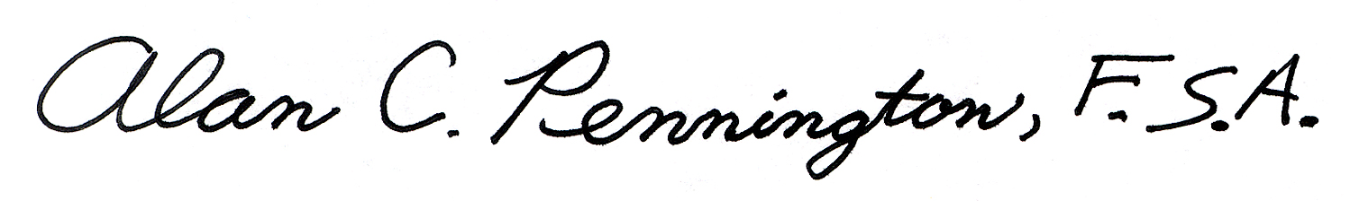
January 27, 2012
Alan C. Pennington Date
Fellow, Society of Actuaries
Enrollment No. 11-05458
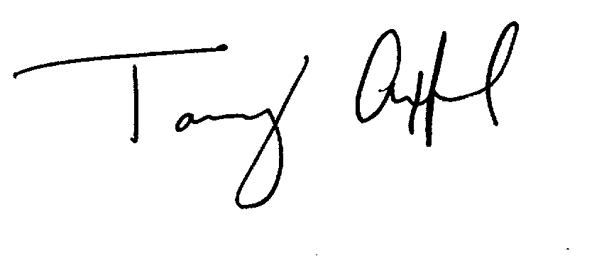
Phone 615.665.5363

January 27, 2012
C. Thomas Axford Date
Fellow, Society of Actuaries
Enrollment No. 11-07336
Phone 615.665.5321

/tmp/in/input.doc

