

Robert B. Barnes, JD
Deputy Executive Secretary
Operations and General Counsel
J. Eric Wampler, JD
Deputy Executive Secretary
Finance and Administration
TEACHERS’ RETIREMENT SYSTEM
OF KENTUCKY

Gary L. Harbin, CPA
Executive Secretary
502/848-8500

SERVING KENTUCKY TEACHERS SINCE 1940

January 24, 2013

Mary C. Yaeger
Office of Special Projects
Legislative Research Commission
Capitol Annex, Room 39
Frankfort, KY 40601

RE: 13 RS HB 76

Dear Mary:

HB 76, an Act relating to charter schools and making an appropriation therefore, in part, creates new sections of KRS Chapters 157, 159 and 160 for the establishment of a five (5) year pilot charter school program. Section 13 of HB 76 provides that, “Teachers and employees in a charter school shall participate in the Kentucky Teachers' Retirement System or the County Employees Retirement System, as determined by their eligibility for participation in the appropriate system.” HB 76 also, in part, amends KRS 161.220(4) to include “Qualified Teachers” in public charter schools as members of Kentucky Teachers’ Retirement System (KTRS).

KTRS has examined HB 76 and determined that the bill request: (1) will not increase or decrease benefits, except as noted as immediately follows; (2) could potentially increase the final average salaries for retirement calculation purposes for those KTRS members who are employed in a charter school authorized by an authorizer other than a local board; (3) requires contributions be made to KTRS only from “Teachers and other certified personnel”, when elsewhere in a school district KTRS would receive contributions from any position requiring either certification or a four-year degree (KRS 161.220(4)) and from substitute and part-time positions that provide teaching services that are the same or similar to teaching services that are provided by certified, full-time teachers (KRS 161.612); and (4) provides that only “qualified teachers” in public charter schools shall be members of KTRS which does not include non-certified, non-teaching positions requiring only a four-year degree that are otherwise part of the KTRS membership in the school districts.

Although HB 76 could have some adverse impact on the plan, staff believes that the bill would not materially affect the funded status of the retirement system.

Please let me know if you have any questions or concerns about this matter.

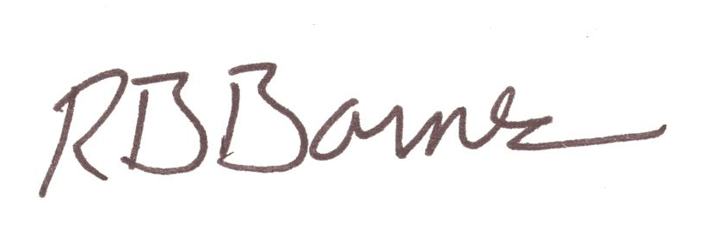
Sincerely,

Robert B. Barnes
Deputy Executive Secretary of Operations and
General Counsel

February 11, 2013

Mary C. Yaeger
Office of Special Projects
Legislative Research Commission
Capitol Annex, Room 39
Frankfort, KY 40601

RE: House Bill 76/BR 182

Dear Mary:

House Bill 76 establishes new sections of KRS Chapter 160 to authorize the creation of charter county schools and specifies that classified school employees shall participate in the County Employees Retirement System administered by Kentucky Retirement Systems.

Kentucky Retirement Systems’ staff members have examined this bill and have determined that the bill will not increase or decrease benefits in CERS. The bill may increase participation in benefits, if charter county schools are created and new classified employees begin participating in CERS as a result of the passage of HB 76; however, the bill will not change the actuarial liability of the Kentucky Retirement Systems, since the employee and employer contributions, along with investment earnings, will pay for expenses and the normal cost of benefits. Consequently, we have not requested any further actuarial analysis of HB 76 by the System’s independent actuary.

Please let me know if you have any questions regarding our analysis of HB 76.

Sincerely,

William A. Thielen
Executive Director
Kentucky Retirement Systems

