

Robert B. Barnes, JD
Deputy Executive Secretary
Operations and General Counsel
J. Eric Wampler, JD
Deputy Executive Secretary
Finance and Administration
TEACHERS’ RETIREMENT SYSTEM
OF KENTUCKY

Gary L. Harbin, CPA
Executive Secretary
502/848-8500

SERVING KENTUCKY TEACHERS SINCE 1940

November 14, 2013

Mary C. Yaeger
Office of Special Projects
Legislative Research Commission
Capitol Annex, Room 39
Frankfort, KY 40601

RE: 14 RS BR 252/HB 48
AA Statement 1 of 4

Dear Mary:

BR 252, an Act relating to the disclosure of public retirement information, in part, amends KRS 161.585 to require Kentucky Teachers’ Retirement System (KTRS) to disclose members’ names, their status in the retirement system, their retirement allowances and their last employers. The bill would also require the retirement system to perform retirement estimates for individuals who are not members of the retirement system. All of the foregoing information would be required to be posted on a searchable database.

KTRS has examined BR 252 and determined that the bill: (1) will not increase or decrease benefits; (2) will increase administrative costs.

Although BR 252 would result in an increase in administrative costs, it would not increase the actuarial liability of the retirement system. Accordingly, KTRS has not requested any further actuarial analysis of this bill by the Retirement System’s independent actuary.

Please let me know if you have any questions or concerns about this matter.

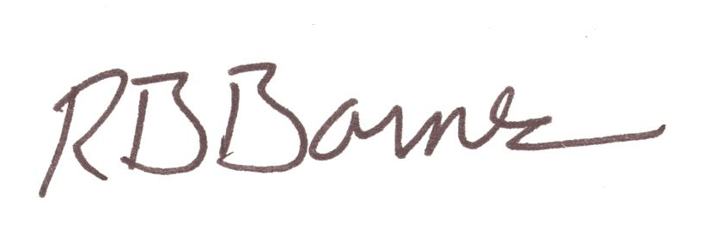
Sincerely,

Robert B. Barnes
Deputy Executive Secretary of Operations and
General Counsel

Kentucky Judicial Form Retirement System

JUDICIAL RETIREMENT PLAN
LEGISLATORS RETIREMENT PLAN

Donna S. Early Whitaker Bank Building, Suite 302
Executive Director 305 Ann Street
Frankfort, Kentucky 40601

Phone (502) 564-5310
Fax (502 564-2560
E Mail DonnaS.Early@ky.gov

M E M O R A N D U M

To: Mary C. Yaeger, Office of Special Projects
From: Donna S. Early, Executive Director
RE: 2014 HB 48/BR 252
AA Statement 2 and 3 of 4
Date: January 15, 2014

I have examined 2014 HB 48 and have formed the opinion that it will not increase or decrease the benefits or increase or decrease participation in the benefits or change the actuarial accrued liability of the Judicial Retirement Plan or the Legislators Retirement Plan. Consequently, I have not requested an actuarial analysis by the System’s independent actuary.

Please let me know if you have any questions regarding this communication.

January 16, 2014

Mary C. Yaeger
Office of Special Projects
Legislative Research Commission
Capitol Annex, Room 39
Frankfort, KY 40601

RE: HB 48 BR 252
AA Statement 4 of 4

Dear Mary:

House Bill 48 amends KRS 61.661 to require the Kentucky Retirement Systems (KRS) to disclose upon request the names, status, projected or actual benefit payments, and other retirement information of each member or recipient of a retirement allowance of the systems. The bill also requires KRS to make the information available on a searchable database on the systems' Web site or on a Web site established by the executive branch to inform the public about executive expenditures and public employee salaries and wages.

KRS staff members have examined HB 48 and have determined that the bill will not increase or decrease benefits or the participation in benefits in any of the retirement systems administered by KRS. Furthermore, although HB 48 will impose some administrative cost on the Systems, that cost is actuarially insignificant; therefore, HB 48 will not change the actuarial liability of any of the retirement systems administered by KRS. Consequently, we have not requested any further actuarial analysis of HB 48 by the System’s independent actuary.

Please let me know if you have any questions regarding our analysis of HB 48.

Sincerely,

William A. Thielen
Executive Director
Kentucky Retirement Systems

