401 KAR 61:145. Existing petroleum refineries.

RELATES TO: KRS Chapter 224

STATUTORY AUTHORITY: KRS 224.10-100

CERTIFICATION STATEMENT:

NECESSITY, FUNCTION, AND CONFORMITY: KRS 224.10-100 requires the Environmental and Public Protection Cabinet to prescribe administrative regulations for the prevention, abatement, and control of air pollution. This administrative regulation provides for the control of emissions from existing petroleum refineries.

Section 1. Applicability. The provisions of this administrative regulation shall apply to each affected facility commenced before the classification date defined below.

Section 2. Definitions. As used in this administrative regulation, all terms not defined herein shall have the meaning given them in 401 KAR 50:010.

(1) "Affected facility" means sulfur recovery units, fluid catalytic cracking unit regenerators, fluid catalytic cracking unit incinerator-waste heat boilers and fuel gas combustion devices at a petroleum refinery in any county classified VA with respect to sulfur dioxide.

(2) "Petroleum refinery" means any facility engaged in producing gasoline, kerosene, distillate fuel oils, residual fuel oils, lubricants, or other products through distillation of petroleum or reforming of unfinished petroleum derivatives.

(3) "Petroleum" means the crude oil removed from the earth and the oils derived from tar sands, shale and coal.

(4) "Process gas" means any gas generated by a petroleum refinery process unit, except fuel gas and process upset gas as defined in this section.

(5) "Fuel gas" means any gas which is generated by a petroleum refinery process unit and which is combusted, including any gaseous mixture of natural gas and fuel gas which is combusted.

(6) "Process upset gas" means any gas generated by a petroleum refinery process unit as a result of start-up, shutdown, upset or malfunction.

(7) "Refinery process unit" means any segment of the petroleum refinery in which a specific processing operation is conducted.

(8) "Fuel gas combustion device" means any equipment, such as process heaters, boilers and flares used to combust fuel gas, but does not include fluid coking unit and fluid catalytic cracking unit incinerator-waste heat boilers, facilities combusting coke oven gas in a by-product coke manufacturing plant, or facilities in which gases are combusted to produce sulfur or sulfuric acid.

(9) "Classification date" means June 11, 1973 for any fluid catalytic cracking unit catalyst regenerator or fuel gas combustion device; October 4, 1976 for any sulfur recovery unit; and June 6, 1979 for fluid catalytic cracking unit incinerator-waste heat boilers.

Section 3. Standard for Sulfur Dioxide.

(1) No owner or operator subject to the provisions of this administrative regulation shall burn in any fuel gas combustion device any fuel gas which contains hydrogen sulfide in excess of 230 mg/dscm (one-tenth (0.10) gr/dscf), except as provided in subsection (2) of this section. The combustion of process upset gas in a flare, or the combustion in a flare of process gas or fuel gas which is released to the flare as a result of relief valve leakage, is exempt from this section.

(2) The owner or operator may elect to treat the gases resulting from the combustion of fuel gas in a manner which limits the release of sulfur dioxide to the atmosphere if it is shown to the satisfaction of the cabinet that this prevents sulfur dioxide emissions as effectively as compliance with the requirements of subsection (1) of this section.

(3) No owner or operator subject to the provisions of this administrative regulation shall discharge or cause the discharge into the atmosphere from any Claus sulfur recovery plant any gases containing in excess of:

(a) 0.025 percent by volume of sulfur dioxide at zero percent oxygen on a dry basis if emissions are controlled by an oxidation control system, or a reduction control system followed by incineration; or

(b) 0.030 percent by volume of reduced sulfur compounds and 0.0010 percent by volume of hydrogen sulfide calculated as sulfur dioxide at zero percent oxygen on a dry basis if emissions are controlled by a reduction control system not followed by incineration.

Section 4. Monitoring and Reporting.

(1) For any fluid catalytic cracking unit catalyst regenerator which utilizes an incinerator-waste heat boiler to combust the exhaust gases from the catalyst regenerator, the owner or operator shall record daily the conversion factors used to convert monitored data (ppm) into units of the standard (lb/hr), the data used to calculate the conversion factor and the hourly emission rate in pounds per hour of sulfur dioxide.

(2) For the purpose of reports under 401 KAR 61:005 periods of excess emissions that shall be reported for sulfur dioxide are defined as follows:

(a) Any three (3) hour period during which the average concentration of hydrogen sulfide in any fuel gas combusted in any fuel gas combustion device subject to Section 3(1) of this administrative regulation exceeds 230 mg/dscm (one-tenth (0.10) gr/dscf), if compliance is achieved by removing hydrogen sulfide from the fuel gas before it is burned; or any three (3) hour period during which the average concentration of sulfur dioxide in the gases discharged into the atmosphere from any fuel gas combustion device subject to Section 3(2) of this administrative regulation exceeds the level specified in Section 3(2) of this administrative regulation if compliance is achieved by removing sulfur dioxide from the combusted fuel gases.

(b) Any twelve (12) hour period during which the average concentration of sulfur dioxide in the gases discharged into the atmosphere from any Claus sulfur recovery plant subject to Section 3(3) of this administrative regulation exceeds 250 ppm at zero percent oxygen on a dry basis if compliance with Section 3(3) of this administrative regulation is achieved through the use of an oxidation control system or a reduction control system followed by incineration; or any twelve (12) hour period during which the average concentration of hydrogen sulfide or reduced sulfur compounds in the gases discharged into the atmosphere of any Claus sulfur plant subject to Section 3(3) of this administrative regulation exceeds ten (10) ppm or 300 ppm, respectively, at zero percent oxygen and on a dry basis if compliance is achieved through the use of a reduction system not followed by incineration.

(c) Any six (6) hour period which the average emissions (arithmetic average of six (6) contiguous one (1) hour periods) of sulfur dioxide as measured by a continuous monitoring system for a fluid catalyst cracking unit exceed 640.0 pounds per hour.

Section 5. Test Methods and Procedures (filed by reference in 401 KAR 50:015).

(1) For the purpose of determining compliance with Section 3(1) and (2) of this administrative regulation, Reference Method 11 shall be used to determine the concentration of hydrogen sulfide and Reference Method 6 shall be used to determine the concentration of sulfur dioxide.

(a) If Reference Method 11 is used, the gases sampled shall be introduced into the sampling train at approximately atmospheric pressure. Where refinery fuel gas lines are operating at pressures substantially above atmosphere, this may be accomplished with a flow control valve. If the line pressure is high enough to operate the sampling train without a vacuum pump, the pump may be eliminated from the sampling train. The sample shall be drawn from a point near the centroid of the fuel gas line. The minimum sampling time shall be ten (10) minutes and the minimum sampling volume 0.01 dscm (0.35 dscf) for each sample. The arithmetic average of two (2) samples of equal sampling time shall constitute one (1) run. Samples shall be taken at approximately one (1) hour intervals. For most fuel gases, sample times exceeding twenty (20) minutes may result in depletion of the collecting solution, although fuel gases containing low concentrations of hydrogen sulfide may necessitate sampling for longer periods of time.

(b) If Reference Method 6 is used, Reference Method 1 shall be used for velocity traverses and Reference Method 2 for determining velocity and volumetric flow rate. The sampling site for determining sulfur dioxide concentration by Reference Method shall be the same as for determining volumetric flow rate by Reference Method 2. The sampling point in the duct for determining sulfur dioxide concentration by Reference Method 6 shall be at the centroid of the cross section if the cross-sectional area is less than five (5) square meters (fifty-four (54) square feet) or at a point no closer to the walls than one (1) meter (thirty-nine (39) inches) if the cross-sectional area is five (5) square meters or more and the centroid is more than one (1) meter from the wall. The sample shall be extracted at a rate proportional to the gas velocity at the sampling point. The minimum sampling time shall be ten (10) minutes and the minimum sampling volume 0.01 dscm (0.35 dscf) for each sample. The arithmetic average of two (2) samples of equal sampling time shall constitute one (1) run. Samples shall be taken at approximately one (1) hour intervals.

(2) For the purpose of determining compliance with Section 3(3) of this administrative regulation, Reference Method 6 shall be used to determine the concentration of sulfur dioxide and Reference Method 15 shall be used to determine the concentration of sulfur dioxide and reduced sulfur compounds.

(a) If Reference Method 6 is used, the procedure outlined in subsection (1)(b) of this section shall be followed except that each run shall span a minimum of four (4) consecutive hours of continuous sampling. A number of separate samples may be taken for each run, provided the total sampling time of these samples adds up to a minimum of four (4) consecutive hours. Where more than one (1) sample is used, the average sulfur dioxide concentration for the run shall be calculated as the time weighted average of the sulfur dioxide concentration for each sample according to the formula in Appendix A of this administrative regulation.

(b) If Reference Method 15 is used, each run shall consist of sixteen (16) samples taken over a minimum of three (3) hours. The sampling point shall be at the centroid of the cross section of the duct if the cross-sectional area is less than five (5) square meters (fifty-four (54) square feet) or at a point no closer to the walls than one (1) meter (thirty-nine (39) inches) if the cross-sectional area is five (5) square meters or more and the centroid is more than one (1) meter from the wall. To insure minimum residence time for the sample inside the sample lines, the sampling rate shall be at least three (3) liters/minute (one-tenth (0.1) cfm). The sulfur dioxide equivalent for each run shall be calculated as the arithmetic average of the sulfur dioxide equivalent of each sample during the run. Reference Method 4 shall be used to determine the moisture content of the gases. The sampling point for Reference Method 4 shall be adjacent to the sampling point for Reference Method 15. The sample shall be extracted at a rate proportional to the gas velocity at the sampling point. Each run shall span a minimum of four (4) consecutive hours of continuous sampling. A number of separate samples may be taken for each run provided the total sampling time of these samples adds up to a minimum of four (4) consecutive hours. Where more than one (1) sample is used, the average moisture content for the run shall be calculated as the time weighted average of the moisture content of each sample according to the formula in Appendix A of this administrative regulation.

Section 6. Compliance Timetable.

(1) The owner or operator of a sulfur recovery plant shall be required to complete the following:

(a) Submit a final control plan for achieving compliance with Section 3(3) of this administrative regulation no later than September 1, 1979.

(b) Award the control system contract no later than December 1, 1979.

(c) Initiate on-site construction or installation of emission control equipment by October 1, 1980.

(d) On-site construction or installation of emission control equipment shall be completed no later than May 1, 1981.

(e) Final compliance shall be achieved no later than July 1, 1981.

(2) The owner or operator of a fuel gas combustion device shall be required to complete the following:

(a) Submit a final control plan for achieving compliance with Section 3(1) of this administrative regulation no later than August 1, 1980.

(b) Purchase control equipment no later than September 1, 1980.

(c) Initiate on-site construction or installation of emission control equipment by October 1, 1980.

(d) On-site construction or installation of emission control equipment shall be completed no later than August 1, 1981.

(e) Final compliance shall be achieved no later than October 1, 1981.

(3) The owner or operator shall be required to demonstrate compliance with all other provisions of this administrative regulation no later than June 6, 1979.

Section 7. Appendix A - Time Weighted Average of SO2 Concentration.

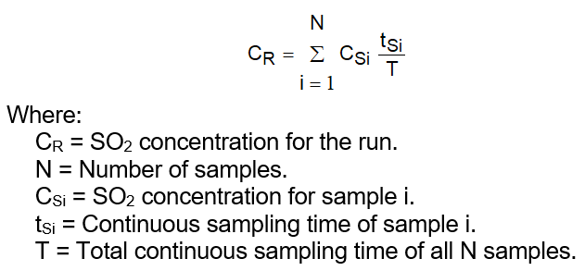

Section 8. Appendix B - Equation for the Time Weighted Average of the Moisture Content.

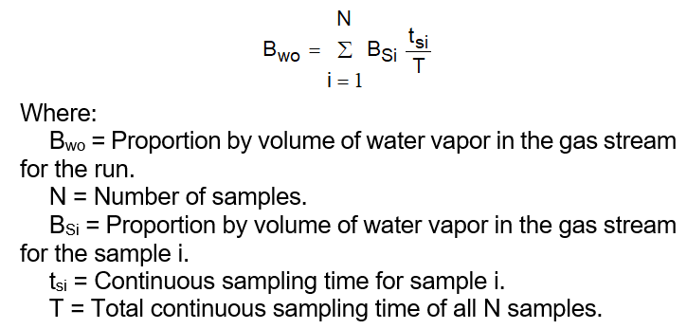

(5 Ky.R. 508; 1062; eff. 6-6-1979; 7 Ky.R. 240; 476; eff. 1-7-1981; TAm eff. 8-9-2007; Crt eff. 1-25-2019.)