805 KAR 4:155. Ground vibration standards for surface coal mines.

RELATES TO: KRS 351.330

STATUTORY AUTHORITY: KRS Chapter 13A, 351.335

CERTIFICATION STATEMENT:

NECESSITY, FUNCTION, AND CONFORMITY: KRS 351.330 requires that the Department for Natural Resources prescribe rules to ensure that the restrictions on maximum peak particle velocity be consistent with federal statutes and regulations. This administrative regulation effects those provisions.

Section 1. Blasting operations conducted as part of surface coal mining, or as part of the surface operations of an underground coal mine, shall comply with the standards contained in this section.

|  |  |
| --- | --- |
| TABLE 1. PEAK PARTICLE VELOCITY LIMITS | |
| Distance from blastingsite in feet | Maximum peak particlevelocity in inches/second |
| 0 to 300 | 1.25 |
| 301 to 5000 | 1.00 |
| 5001 and beyond | 0.75 |

(1) The maximum allowable peak particle velocity for ground vibration measured at the location of the nearest dwelling, public building, church or commercial building shall not exceed the limits established in Table 1 as follows:

(2) The peak particle velocity specified in this section shall be measured in three (3) mutually perpendicular directions, and the maximum allowable limits shall apply to each of these measurements.

(3) The ground vibration limits shall not apply to property owned by the coal mine, or to property on which the owner gives a written waiver to exceed the maximum allowable limits.

Section 2.

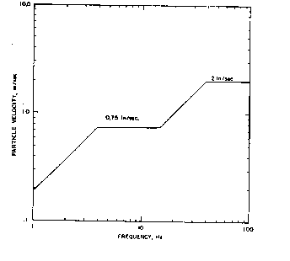

(1) In place of the limits established in Section 1 of this administrative regulation, a blaster may elect to comply with the following graph limiting peak particle velocity based upon the frequency content of the blast vibration. If this criterion is chosen to limit vibration levels, the method of monitoring the vibrations and calculating the frequency content shall be approved by the department before its implementation by the blaster.

(2) Unless the blaster uses a seismograph on every blast to demonstrate compliance with the maximum allowable limits established in section 1, or has been granted a modified scale distance factor by the department, he must comply with the scale distance equations in Table 2 as follows:

|  |  |
| --- | --- |
| TABLE 2. SCALE DISTANCE EQUATIONS | |
| Distance from blastingsite in feet | Scale distanceequations |
| 0 to 300 | W = (D/50)2 |
| 301 to 5000 | W = (D/55)2 |
| 5001 and beyond | W = (D/65)2 |

where:  
W = the maximum weight of explosives that can be detonated per delay period.  
D = the distance in feet from the blast to the nearest dwelling, public building, school, church, commercial or institutional building.

(3) If a blaster considers the table of scale distance equations in subsection (2) of this section too conservative, he may petition the department for a modified table for blasting operations at a particular site. Such a petition shall include seismograph reports demonstrating that any modified scale distance equations would not cause the predicted ground vibration to exceed the peak particle velocity limits established in Section 1 of this administrative regulation.

(805 KAR 004:155. 17 Ky.R. 3338; eff. 6-26-1991; TAm eff. 8-9-2007; Crt eff. 6-27-2018; Crt eff. 6-2-2025.)